Cub Scout
Pack 136

Operations Manual

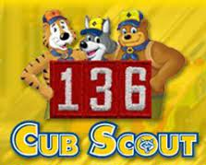

Preface

This began as a seemingly simple objective to get the Cub Scout Program back in line with the type of program it was intended to be, focusing on providing a sustainable source of information for succession to incoming Cubmasters, Assistant Cubmasters, Den Leaders and Committee members. It became a Wood Badge ticket intending to give new leadership and leaders in the years coming a source of information on Pack 136 itself, some aspects of the history of the Pack, practices that have worked in the past, and other information that was in danger of being lost due to the retirement, and passing, of previous leaders who did not pass on all of their previous knowledge.
Credit needs to be given to the Adult Leaders of Pack 136, others in the Istrouma Council of Louisiana, for their assistance in sharing the methods that help them run their own units. A thank you to Wendi Pounders who began a preliminary manual for Pack 136 seven years ago, and to Wood Badge Session 7-211-22 for presenting the opportunity and motivation to create this manual.
Suggestions were gratefully received from Mr. Rob Bourgeois, District Chair of Sewell-Eagle District; Dr. Will Freeman, District Commissioner; Kristin Bourgeois, District Vice Chair and Patrol Guide to Wood Badge Beaver Patrol, and Mrs. Wendi Pounders, Mr. Cletus Robinson and Mr. Peter Davidson, longtime leaders of the units at St. George Catholic Church who provided a wealth of previous scouting experience and suggestion.
This document is intended to be revised as needed to accommodate future practices and better suggestions, as well as changes in BSA unit operations and advancement, and practices in dealing with youth.

S1-211-11-1 Wood Badge Ticket Item of Cubmaster Jeff Worley – 2012 v.1
S1-211-18 Wood Badge Ticket Item of Cubmaster Wendi Pounders – 2018 v.2
7-211-22 Wood Badge Ticket Item of Cubmaster Ashley Michel – 2020 v.3

This work is dedicated to the memory of former Pack 136 Cubmaster, Mr. David Sneed.

Table of Contents
Preface 2
Introduction 13
Pack 136 Summary 15
Pack Organization 17
Pack Mission 18
Chartered Organization 19
Training for Leaders 20
Mandatory 20
WEBELOS Leaders 20
Encouraged 20
The Pack Committee 21
Position-specific responsibilities: 22
Pack Committee Chair 22
Secretary 24
Treasurer 25
Advancement Chair 26
Pack Trainer 27
Outreach Chair 28
Outings Coordinator 29
Quartermaster 30
Pinewood Derby Coordinator 31
Cub Scout Ideals 32
Scout Oath 32
Scout Law 33
Cub Scout Motto 33
Pack Operations 34
Calendar of Events 34
Recruitment Event 36
Classroom Visits 36
New Scout/Parent Orientation Night 38
Returning Scout Night Event 40
Summertime Activities 41
Pack Communications 41
Rank Advancement 42
Belt Loop Program 42
Rank Awards 43
Activity Bead Totem Program 46
Original Bead Program 47
Sample Bead Totems 48
Suggested Cub Scout Bead Color Awards 49
FOR LEADERS 50
For Scouts 51
ARROW OF LIGHT CAREER ARROWS 52
Pack Events 55
Committee Meetings 55
Pack Meeting – General Details 56
Camping 57
Fall Campout 58
Spring Campout 58
District Camping Events 58
Fire Safety 59
Blue & Gold and Awards Banquet 60
Charter Renewal (Recharter) 62
Rain Gutter Regatta 63
The Basics 63
Tracks 63
Boats 64
Rules 64
Straws and Water 65
Awards 65
Entertainment 66
Treats 66
Invites and Brackets 66
Running A Race 67
Design Contest 68
To Summarize 68
GENERAL RULES 70
CONSTRUCTION RULES 70
RACE RULES 71
MATERIALS NEEDED 71
Scout Olympics 72
Adventure Loop-A-Looza 73
Parent/Scout Cake Contest 74
Pack 136 500 Cardboard Box Race 75
Halloween Spooktacular 78
Food Drive (Church) 80
Pinewood Derby 81
7) Extra Events for Siblings/Non-Racers 86
a) Face Painting booth 86
b) Hot Wheels track with Hot Wheels cars in a closed off area 86
c) Coloring station, printed out coloring sheets of race cars, word searches 86
d) Photo Booth 86
e) Carnival games 86
f) Pin the wheel on the car blindfold game 86
g) Tower building with red solo cups 86
h) Clips of Indy 500 races on a screen 86
i) have car themed playlist playing music. (Route 66, Shut up and Drive, Drive my car) 86
j) Lego building table 86
k) Have local troops set up a snack table to sell snacks and drinks as a fundraiser. 86
USS Kidd Overnight 87
POPCORN AND FUNDRAISING 88
UNIT POPCORN KERNEL POSITION DESCRIPTION 88
PACK CEREMONIES 90
Arrow of Light and Crossover Ceremony 94
AOL Ceremony 94
Bridging 97
AOL Bridging for Two Troops 101
Flag Retirement Ceremony 104
Rank Awards Ceremony 109
Baden-Powell Promotion Ceremony 109
Lion Promotion: 110
Tiger Promotion: 111
Bear Promotion: 112
Webelos Promotion: 113
Scout Songs 116
Little Green Frog Song 116
Boom Chicka Boom Song 116
Don't Wear No Socks Song 118
I Met a Bear Song 119
Ain't No Bugs on Me Song 120
America, the Beautiful Song 124
Announcements Song 126
Back to Gilwell Song 128
Be a Good Scout Song 128
How I Hate to Get Up in the Morning Song 130
Scout Vespers Song 131
Scout WETspers Song 132
Pack Resources List 133
Appendix 1: Pack Handbook 135
Basic Scout Definitions 135
Cub Scout 135
Scout BSA 135
Pack 135
Den 135
Cub Scout Organization 136
Cubmaster 136
Assistant Cubmaster 136
Treasurer 136
Advancement Chairperson 136
Event Chairpersons 136
Den 136
Den Leader/Assistant Den Leader 136
Den Chief 136
Denner 137
Responsibilities 138
Pack 138
Den 138
Parent 138
Cub Scout 139
Meetings & Activities 140
Registration 140
Pack Fees 140
Den Dues 140
Fund Raising 140
Popcorn 140
Crossing over to Scouts 140
Uniform 141
Unit Numerals 141
Required Elements 141
Lion 141
Tiger 141
Wolf 141
Bear 141
Webelos 142
Arrow of Light 142
Pack Code of Conduct 143
Consequences 143
Appendix 3: Informational Links 144
Appendix 4: Pack Meeting Agenda 145
Appendix 5: Campfire Program 146
Elements of a Campfire Program 146
Stories 150
Songs (for harmonica) 152
Appendix 6: Advancement Chair How-To 157
APPENDIX 7 Blue and Gold 213
Resource Links 215

Introduction

Character development, civic engagement training, and personal fitness can be found in every Scouting unit. Part of the process of providing such a focused and effective youth program lies in the training of its adult leaders. Adult leaders of Cub Scouts and BSA Scouts have access to top-notch training.
Training does provide guidance on how to complete certain aspects of the job for which it is designed; however, it does not always explain why something works or the history that brought Scouting to this point in time, despite the fact that it may suggest the Who, What, Where, When, and How. To replace the old faces with new ones, the memories of what hasn't worked or why procedures have been changed fade as well.
However, this document will focus on ensuring that the culture and best practices of the operations of Pack 136 are retained in writing. While every year, new activities are added to Pack endeavors, and occasionally old ones fade away, the organizational culture of the Pack should remain. This involves such aspects as songs, favorite skits, Pack lore and stories, as well as the succession of leadership to the next generation through mentoring and the handing down of customs. While these things can be altered or replaced at any time for more modern entertainment and education, having some sense of the past is also beneficial.
The goal of this work is to take what has been left by previous Cubmasters of Pack 136, and to incorporate new methods of doing things, new activities, while also documenting past operations for the future generation of leaders who will follow us. The culture and history of the Pack will be preserved, while also serving as a sort of digital mentor to future leaders, should the situation arise where a large number of leaders leave, transfer or otherwise lose involvement in such a way as the customs of succession for each leadership position are somehow broken.
This document serves to fill in this potential gap, while also providing needed materials for Pack leaders to conduct the Pack and its operations in the best way possible. While the BSA provides generous amounts of general training for each position, this manual will help future leaders incorporate BSA training into the traditions and activities of Pack 136, chartered by St. George Catholic Church in Baton Rouge, Louisiana.

Pack 136 Summary

For more than 50 years St. George Catholic Church has been the charter organization for Cub Scout Pack 136. Our pack currently serves nearly 50 first through fifth grade boys and girls from St. George parish and beyond. Each year our pack holds many fun activities for the scouts. These include our Pack 136 500 cardboard box race where the scouts decorate and race a scout powered race car, Halloween Spooktacular where the dens decorate a vehicle and participate in games, Spring and Fall Campouts, Scout Olympics where the scouts compete in fun athletic events, Pinewood Derby where the scouts build and race a small gravity powered car, Global Wildlife Center trip, New Orleans Air Show, Overnight Aboard the USS Kidd and Blue and Gold Banquet. We hold regular pack meetings with topics like fire safety and personal safety to present important information to the scouts about what to do in emergency situations, along with guest speakers and games.
We also strive to give back to the community by donating competition cakes to the St. George Fair, holding an annual Thanksgiving Food Drive, participating in work projects to restore trails at public parks and at the Avondale Scout Preserve in Clinton, and helping with clean up after the St. George Parish Fair and picnic.
During the five years the scouts spend in Cub Scouts they learn many useful skills by following the Boy Scouts of America Cub Scouting program. These range from improving personal fitness to first aid, arts and crafts to robotics, outdoors and survival skills and just about everything in between. The scouts also have the opportunity through the BSA Academic and Sports Adventure Loop programs to learn about and earn awards in electives in 25 Academic areas ranging from Art to Wilderness Conservation and 31 Sports areas from Archery to Volleyball. In addition, scouts also have the opportunity to advance in STEM education through pursuit of the NOVA awards, and crisis response through the Emergency Preparedness awards. All of this is done with the aid of dedicated, trained volunteer leadership, in a spiritual and supportive atmosphere and through a program that encourages the entire family to get involved. From the building of the Pinewood Derby cars to setting up camp and cooking meals the scouts work with their parents and leaders to learn valuable skills and build self-confidence.
The Cub Scout Motto “Do Your Best” is emphasized so that each scout can be proud of their accomplishments. Scouting is an important ministry which teaches important life skills. We are proud to be sponsored by St. George and look forward to continuing our association with them for many years to come.

Pack Organization
The Pack is made up of Scouts, Scout Parents, and Adult Leaders. Scouts are drawn from Elementary School age boys and girls from the Kindergarten through 5th Grades. Lion Cubsa are children in Kindergarten. Tiger Cubs are generally children in 1st Grade. Wolf Cubs are in 2nd Grade. Bear Cubs are in 3rd Grade. WEBELOS Scouts are typically youth in 4th and 5th Grade. Scouts usually cross over into Scouts BSA Troops (Boy troops for boys, girl troops for girls) in the Winter/Spring of 5th Grade. There are occasions when a child is held back for scholastic reasons when he may be in a school grade lower than the majority of the scouts in his Cub Scout rank.
Boy Scouts of America (BSA) provides the details of the age limits for boys in Scouting. Adult Leaders (called “Scouters”) are generally recruited from the pool of Scout Parents, though there is no requirement that an Adult Leader be a Scout Parent. The Adult Leaders form two groups. One group is referred to as the Pack Committee. The leader of the Pack Committee is the Committee Chair. The other group is made up of Scout-facing Leaders. The leader of this group is the Cubmaster. Scout-facing leaders are not considered to be Committee Members by BSA. They provide input to the Committee at Committee (Akela) meetings, but have no vote.

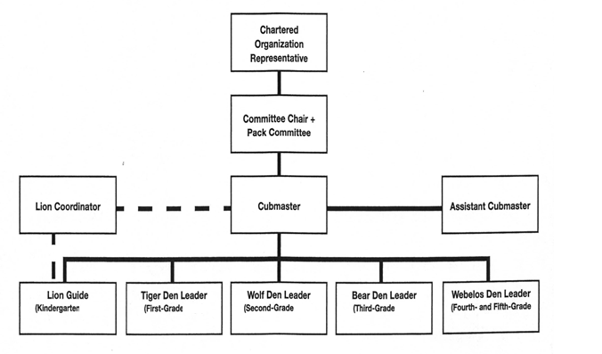

Pack Mission
Our mission is to teach the scouts, using moral principles and the scouting code:
- Respect for God
- Respect for country
- Respect for self
- How to be a good citizen
- How to be self-reliant
- How to be prepared for any situation

Chartered Organization

Our Charter has been held with St. George Catholic Church since May 1, 1965. Scouting falls under the Ministries of Family & Community Life.
Our Chartered Organization Representative is Michael Nolan. He is the first line of defense if there is a problem with the Pack. He is also a direct link to our Chartered Organization Leader, Father Paul Yi. Mr. Nolan can be reached at: (225) 229-1624 michaeljnolan@cox.net
The St. George charter includes other units that are here to help the Cub Scouts if anything is needed. The Scouting BSA units at St. George also include:
Scouts BSA Troop 136, (boys) Contact: Peter Davidson at pdavid1@lsu.edu or Paul Fontenot at gpeaglesr736@bellsouth.net
Scouts BSA Troop 1136, (girls) Contact: Wendi Pounders at wendi@pounders.org or Anna Washington at prowlingowlsr960@aol.com
Venture Crew Troop 136, (coed) Contact: (Currently inoperable)

Training for Leaders

All Adult Leaders are expected to become fully trained for their duties within 30 days of assuming their duties. The first thing the Pack owes the scout in Scouting is a trained leader and there is no excuse for not becoming trained. All required training is available via the internet. To begin, visit this website:

https://www.scouting.org/programs/cub-scouts/adult-leader-training/

Then visit Pack 136 Leader Resources page for links to the necessary training and leader orientation video.

https://scoutpack136.wordpress.com/leader-resources/

or

https://scoutpack136.com/

Mandatory
- Youth Protection
- Diocese YPT
- Cub Scout Leader Fast Start
- Position specific

WEBELOS Leaders
- Outdoor skills for WEBELOS Leaders (OWLs) All Webelos leaders need to take this course. Watch the Istrouma Area Council website for dates. www.iacbsa.org

Encouraged
- BALOO - At least one adult must be BALOO trained for the Pack to attend a camping event. It is best to have as many BALOO-trained adults as possible in the Pack.
- Pisachi - University of Scouting workshop held in January, watch the calendar at www.iacbsa.org for dates. This is a one-day workshop that any registered scouting adult may attend.
- Wood Badge – an advanced, national leadership course open only to Scouting volunteers and professionals. According to Lord Baden-Powell, “One of the purposes of Wood Badge training is to get Scouters to think about the practice of Scouting, to meet together, to exchange experiences, and to live together in the spirit of the Scout Oath. “

The Pack Committee
Cub Scout Pack 353 is administered by a committee of adult volunteers. Members are selected by the chartered organization, and are registered as adult leaders of Scouts BSA. One of these members is designated as pack committee chair.
QUALIFICATIONS
All committee members and adult leaders must have the following:
- Is at least 21 years old and agrees to abide by the Scout Oath or Promise and the Scout Law.
- Has completed and is current with Youth Protection Training
- Must complete position-specific training through the Scouts BSA Training program
- Agrees and consents to an enhanced background check as administered through Scouts BSA.
- Possesses the emotional qualities that Scouts BSA deems necessary to afford positive leadership to youth.
RESPONSIBILITIES
Regardless of the size of the pack committee, these responsibilities must be performed by committee members:
- Make recommendations to the chartered organization for final approval of pack leadership.
- Recruit the Cubmaster and one or more assistant Cubmasters, with the chartered organization's approval.
- Coordinate with the chartered organization to provide adequate and safe facilities for pack meetings.
- Coordinate the pack's program and the chartered organization's program through the
- chartered organization representative.
- Help with pack charter renewal.
- Help stimulate the interest of adult family members through proper programming.
- Supervise finances and equipment.
- Work closely with the Cubmaster. Cubmaster and Assistant Cubmasters are not part of the committee and have no vote on committee matters.
- Ensure that all Scouts, regardless of rank, receive a year-round, quality program.
- Maintain and keep current all training requirements for the position.
- Conduct, with the help of the Cubmaster, periodic training for parents and guardians.
- Cooperate with other Scouting units in the District and be available for roundtable meetings when appropriate.

Position-specific responsibilities:

Pack Committee Chair
- Maintain a close relationship with the chartered organization representative, keeping this key person informed of the needs of the pack that must be brought to the attention of the organization or the district.
- Report to the chartered organization to cultivate harmonious relations.
- Confer with the Cubmaster on policy matters relating to Cub Scouting and the chartered organization.
- Supervise pack committee operation by
  - Calling and presiding (if necessary) at pack leaders' meetings.
  - Assigning duties to committee members.
  - Planning for pack charter review, roundup, and reregistration.
  - Approving bills before payment by the pack treasurer.
- Conduct the annual pack program planning conference and pack leaders' meetings.
- Complete and maintain Position Specific Training for the position.
- Ask the committee to assist with recommendations for Cubmaster, assistant Cubmasters, and Den Leaders, as needed.
- Recognize the need for more dens, and see that new dens are formed as needed.
- Work with the chartered organization representative to provide adequate and safe
- facilities for pack meetings.
- Cooperate with the Cubmaster on council-approved money-earning projects so the pack
- can earn money for materials and equipment.
- Work with the Treasurer to manage finances through adequate financial records.
- Maintain adequate pack records and take care of pack property.
- If the Cubmaster is unable to serve, assume active direction of the pack until a successor is recruited and registered.
- In the absence of a Training Coordinator on the pack Committee, appoint a committee member or other registered adult to be responsible for Youth Protection training, as well as provide a training program for adult family members.
- Develop and maintain strong pack-troop relationships, sharing with area troop committees the need for graduations into local troops.
- Support the policies of Scouts BSA.

Secretary
- Keep informed of all Cub Scouting literature, materials, records, and forms to help leaders function effectively. Help new den leaders by telling them what resources are available.
- Acquaint den leaders with Scoutbook and its use by the pack to record advancement.
- Maintain up-to-date information on membership, leadership, attendance, and advancement in Scoutbook.
- Maintain an inventory of pack property.
- Handle official correspondence for the pack. This may include writing letters of appreciation and requests for reservations, or ordering supplies through the local council service center.
- Maintain and keep current the pack353.net pack website. Work with the outreach chair to ensure current information is available.
- Keep notes on business conducted at pack leaders' meetings. Record only key items such as things needing follow-up or action items for future meetings/initiatives.
- Notify leaders of pack leaders' meetings and other activities.
- Assist den leaders with recording den-specific information

Treasurer
- Help the pack committee and Cubmaster establish a sound financial program for the pack with a pack budget plan.
- Work with the Cubmaster and Committee Chair to define annual pmembership dues, and maintain a breakdown of costs from dues.
- Open or maintain a bank account in the pack's name and arrange for all transactions to be signed by any two of the Cubmaster, pack committee chair, secretary, or treasurer.
- Approve all budget expenditures. Check all disbursements against budget allowances, and pay bills by check. The pack committee chair should approve bills before payment.
- Collect dues from den leaders at the pack leaders' meeting. Give receipts for these funds where appropriate, and deposit the money in the bank account.
- Keep up-to-date financial records.
- Credit each Cub Scout with payment of dues. From time to time, compare the records with those of the den leaders to make sure they agree. Give leadership in developing a coordinated record-keeping system in the pack.
- Be responsible for thrift training within the pack: Encourage each den leader to explain the pack financial plan to each Scout and their family so that Scouts will accept responsibility for paying dues and family members will be alert to opportunities for their Scout to earn dues money and develop habits of thrift.
- Periodically report on the pack's financial condition at the pack leaders' meetings. Make regular monthly reports to the pack committee at the pack leaders' meeting, and report to the chartered organization as often as desirable on the financial condition of the pack.
- Provide petty cash needed by leaders strictly on an as-needed basis. Keep a record of expenditures.
- Guide the pack in conducting council-approved pack money-earning projects.

Advancement Chair
- Have a working knowledge of the advancement plans for each Cub Scout rank.
- Help plan and conduct induction and crossover ceremonies.
- Train parents, guardians, and pack committee members in ways to stimulate advancement.
- Arrange for Arrow of Light crossover ceremonies with the Cubmaster, Webelos den leader, and Scoutmaster(s), where applicable.
- Promote the use of Scoutbook to record advancement and maintain advancement records.
- Generate monthly Pack Advancement Reports and coordinate with den leaders to ensure that they are current. Coordinate the ordering of badges and insignia from the local council service center.
- Help build or obtain advancement equipment for use in making advancement ceremonies more effective.

Pack Trainer
- Remain current with training material and program updates
- Assist the Cubmaster and Committee Chair in identifying suitable adults for leadership positions.
- Conduct orientation of new families.
- Ensure that new leaders complete position-specific training.
- Encourage pack leaders to attend or complete, as appropriate:
  - Cub Scout Leader position-specific training
  - Youth Protection Training
  - Roundtable
  - University of Scouting
  - BALOO
  - Outdoor Leader Skills for Webelos Leaders
  - Wood Badge
- Maintain pack training records

Outreach Chair
- Stimulate pack service projects in the chartered organization, school, and community.
- Promote family participation in all pack events, such as blue and gold banquets, pack
- picnics, and other special events.
- Urge pack participation in appropriate programs of the chartered organization.
Suggest ways of showing interest in the chartered organization's overall program.
- Circulate Cub Scout recruiting fliers and leaflets to invite Scouts to join. Work with the pack committee to promote new membership. Attend start of school year open houses in area as a representative of Pack 353 to drum up interest in the unit.
- Use communications media such as social media to maintain communications with the pack families. Work with the pack secretary to ensure up-to-date communications of pack activities on the Pack 353 Facebook account.

Outings Coordinator
- Help the Cubmaster plan and arrange for outdoor activities.
- Arrange for property and tour permits when required.
- Arrange for safe transportation when needed.
- Work with pack quartermaster as needed to secure and use equipment for outings.
- Plan first aid for emergencies.
- Complete Basic Adult Leader Outdoor Orientation (BALOO) training. Ensure that at least one additional adult leader has completed Basic Adult Leader Outdoor Orientation (BALOO) before any pack campout.
- Help Webelos den leaders plan Webelos overnight campouts.
- Plan outings to help pack and dens qualify for the National Summertime Pack Award.
- Help inform parents and guardians about opportunities for family camping.
- Help promote day camp and resident camp opportunities.
- Be aware of BSA health and safety requirements and see that they are implemented.
- Know and carry out BSA outdoor program policy related to Cub Scouting. Review all activities to ensure that unit leaders comply with BSA policies in the Guide to Safe Scouting.

Quartermaster
- Periodically inventory and maintain pack equipment
- Inventory and maintain pack trailer and space in the pack closet. Recruit individuals to assist in this project annually.
- Plan first aid for emergencies
- Help Webelos den leaders plan Webelos overnight campouts
- Coordinate with Outings Coordinator(s) to plan events
- During overnight campouts, work with Outings Coordinator(s) to plan menus and secure foodstuffs for events.
- Setup, secure, and maintain outdoor cooking space, and keep ordered and neat as applicable.
- Assist pack in obtaining and securing additional equipment as necessary
- Coordinate transport of pack equipment trailer to outdoor activities, as necessary.

Pinewood Derby Coordinator
- Coordinate with Treasurer on number of cars to purchase and have cars ready for handout
- Discuss with Troop 353 about Boy Scouts helping run the derby and provide dates.
- Check track to ensure it is in working order.
- (Optional) Set up track for demonstration purposes to pack parents. Talk to new scouts about what to expect and provide tips on designing cars.
- Recruit 4-5 adult volunteers to assist with set up and cleanup of derby.
- Ensure at least one volunteer has a computer that can be used to run the races. Troop 353 Scouts normally check the cars in and run the races. Adults run the computer and supervise scouts.
- Coordinate with treasurer on trophy budget and purchase trophies and participation medals.
- Develop categories for pack-wide and den-specific awards.
- Coordinate with Webelos den leader to run concession stand
- Update Scoutbook calendar with event details and provide email to pack
- Oversee and help with setup and cleanup of Derby.
  - Ensure all stations are properly covered (check-in/inspection station, computer, car runners, announcers…)
  - Give pointers and tips to scouts and parents whose cars don’t pass inspection
  - Post-race, take notes on successes and areas of improvement for next year’s derby
- Check district website calendar for details on district derby. Once posted pass information on to winners in pack.

Cub Scout Ideals

Scout Oath

On my honor I will do my best
To do my duty to God and my country
and to obey the Scout Law;
To help other people at all times;
To keep myself physically strong,
mentally awake, and morally straight.

On my honor I will do my best Saying “On my honor” is like saying “I promise.” It means that you will do your best to do what the Scout Oath says.
To do my duty to God and my country and to obey the Scout Law A duty is something you are expected to do. At home, you might be expected to make up your bed or take out the trash. You also have duties to God and to your country. You do your duty to God by following the teachings of your family and religious leaders. You do your duty to your country by being a good citizen and obeying the law. You also promise to live by the 12 points of the Scout Law.
To help other people at all times Many people need help. A friendly smile and a helping hand make life easier for others. By helping other people, you are doing a Good Turn and making our world a better place.
To keep myself physically strong, mentally awake, and morally straight The last part of the Scout Oath is about taking care of yourself. You stay physically strong when you eat the right foods and get plenty of exercise. You stay mentally awake when you work hard in school, learn all you can, and ask questions. You stay morally straight when you do the right thing and live your life with honesty.

Scout Law

A Scout is Trustworthy. A scout tells the truth. A Scout is honest and keeps promises. People can depend on a Scout.
A Scout is Loyal. A Scout is true to family, friends, Scout leaders, school, and country.
A Scout is Helpful. A Scout volunteers to help others without expecting a reward.
A Scout is Friendly. A Scout is a friend to everyone, even people who are very different.
A Scout is Courteous. A Scout is polite to everyone and always uses good manners.
A Scout is Kind. A Scout treats others as they want to be treated. A Scout never harms or kills any living thing without good reason.
A Scout is Obedient. A Scout follows the rules of their family, school, and pack. They obey the laws of the community and country.
A Scout is Cheerful. A Scout looks for the bright side of life. They cheerfully do tasks that come their way. They try to make others happy.
A Scout is Thrifty. A Scout works to pay their own way. They use time, property, and natural resources wisely.
A Scout is Brave. A Scout can face danger even if they are afraid. They stand for what is right even if others laugh.
A Scout is Clean. A Scout keeps their body and mind fit. They keep their home and community clean.
A Scout is Reverent. A Scout is reverent toward God. They are faithful in religious duties. They respect the beliefs of others.

Cub Scout Motto

Do Your Best.
A motto is a guiding principle and a rule for living. Do Your Best means trying your hardest, not just a little bit. Do your best all the time. Do your best in school and at home. Do your best when you play a game and help your team. Do your best as you work on your rank adventures!

Pack Operations

Calendar of Events

The Calendar of Events needs to be compiled at the end of summer as soon as the new school year calendar is available, usually done at a planning meeting held by the committee and parents prior to August. Using the school calendar, the Committee can plan dates for events and not interfere with the Church Fair, second grade religious events such as First Reconciliation and First Eucharist, and retreats. Events also need to be arranged around LSU home games, for the sake of encouraging participation in scout events and not conflict with major events in the area. Also recommended is that the committee take into account the event calendars of surrounding councils, for events to which our scouts can attend.

The Calendar will need to include the following standard events:

- Kindergarten and First Grade Classroom Visits
- New Scout/Parent Orientation
- Returning Scout Event
- Committee Meetings
- Pack Meetings
- Parent/Scout cake contest (to coincide with the Church Fair- Cake Walk booth)
- Popcorn distribution day
- Outdoor Fall Event (Rain Gutter Regatta, Cub Scout Olympics, Pack 136 500, or Adventure Loop-A-Loosa)
- Spooktacular
- Money collection deadline for Popcorn sales
- Food collection drive
- Food Bank visit
- Fall Campout
- Scout Sunday (this is a national event but also check with the Church Office)
- AOL Crossover
- Sewell-Eagle Roundtable meetings
- District events of interest
- Night of the Frozen Dead campout for Webelos and AOLs
- Pisachi (University of Scouting workshop)
- Spring campout
- USS Kidd sleepover
- “Down and Derby” movie night
- Pinewood Derby Race
- Sewell-Eagle District Pinewood Derby Race
- Blue and Gold/Awards Ceremony
- Summer events

When the dates for events taking place on the School/Church campus are “penciled in,” they need to be confirmed with Missy Gregoire at the Church Office. She will check to see if the venues are available and confirm scheduling of facilities.

At minimum, the calendar for the first part of the school year through December needs to be compiled and printed for distribution during the New Scout/Parent Orientation night. It then it should be posted on the website or other social media for the returning scouts to view. The Pack Google Calendar serves as the primary point for the pack’s schedule of events. It is available on the website, and is accessible by members of the committee. Any changes to times, dates and locations for events will first be noted in the Google calendar, and then updated in any other calendars, such as the newsletter, Scoutbook or social media.

A copy of the calendar can also be sent to Charlene Lauman to be posted on the school website. The Cub Scout calendar can be found by clicking on the Activities link.

Recruitment Event

Classroom Visits

- One Month Before School Starts
  - Be sure to have representatives from the Pack attend the July Round Table meeting. Materials for recruitment and the New Parent Orientation will be distributed at that time.
  - Contact St. George school office to reserve a date and time for the classroom visits. This is usually done during the second week of the new school year. At the same time book the cafeteria and scout room for the New Parent Orientation which generally takes place on Wednesday of the week after the classroom visits.
  - Once the date is set, update the New Parents Night flyer document provided by the Council.
  - Add the New Parent Orientation Night event to the pack calendar and send reminder e-mails.
  - Get with existing den leaders regarding preferred nights for den meetings, and send the coming year’s calendar of den meeting reservations to Missy Gregoire. missyg@st-george.org
  - Confirm details and order needed supplies for Back to the Pack welcome party at the end of August.

- Two Weeks Before Classroom Visits
  - Contact St. George school office to get New Parent Orientation Night in the Dragon Tales newsletter. Ask for Charlene Lauman. dragontales@st-george.org
  - Contact Missy Gregoire at the St. George Church office at (225) 293-2212 to get New Parent Orientation Night in the parish bulletin. missyg@st-george.org
  - Contact the St. George School office and ask for a count of the number of children in each class from 1st through 5th grades. Charlene Lauman was able to provide this info in the past. Use this information to separate the fliers into stacks by class.
  - Meet with the pack committee to determine who will give the classroom presentations. Normally this is the Cubmaster and Committee Chair’s responsibility but any leader can volunteer. Also line up volunteers for manning the registration tables and running the adventure loop event on Orientation night. It is critical to have at least three adults, at least one of whom is male, to be in the room with the kids during the adventure loop event.
- One Week Before Classroom Visits
  - Proofread the New Parents Night flyer document and make any necessary corrections.
  - Have 300 to 400 copies printed. This can be done at the Council, please contact the Account Executive, Juan Prado.
  - Prepare any props (pinewood derby cars, slide show on a zip drive, patch vests, etc) for the classroom presentations.
  - Contact the leaders who volunteered to do the classroom visits to remind them of the date and times.

- Day of Classroom Visits
  - Arrive 15 minutes prior to start of classroom presentations. Visit first grade classrooms to tell about scouting and distribute the New Parent/Scout Orientation flyers to all of the first grade students.
  - Give sets of flyers for second through fifth grade classrooms to school office personnel for distribution to teachers.

New Scout/Parent Orientation Night

- Two Weeks Prior to Event
  - Cubmaster updates the New Parent Orientation Powerpoint presentation and arranges for a laptop and projector to display it. St. George does have a projector available which can be reserved by contacting the school office but check if someone in the pack has one that you might be able to use instead.
  - Call St. George school office and verify that the cafeteria and scout room are booked on the date for the New Parent Orientation event.
  - Make sure we have enough pack t-shirts available for the new scouts.
- One Week Prior to Event
  - Contact all leaders to remind them about New Parent orientation and invite them to assist with registration.
  - Prepare the “yard signs” the Council provides in the recruiting packet. Call the school office and ask for one of the assistant principals, ask for permission to display the signs. I have talked to Angele Fontenot in the past. Write the time, date and mention that cub scouting is for boys and girls in grades 1-5. Place the signs in the grass along the old church parking lot carpool for parents to see while they are waiting in line.
  - Make sure you have about 60 new scout packets from the Council. These will include the applications for adults and youth.
  - Pick up adventure loop awards for new scouts. We have done the Tiger Tag adventure loop in the past, but there are other choices as well.
  - Print about 50 copies of the Calendar of Events (at least the first part of the school year)
  - Contact the volunteers to remind them about the event.
- Day of New Parent Orientation
  - Arrive at St. George 45 to 60 minutes prior to the scheduled start of the event to set up the tables, set up and test the projector and make sure the scout room is ready to go for the adventure loop event.
  - Remember to clean up after the event and set the cafeteria back up for school the next day. Also pick up the “yard signs” from the carpool line.

Returning Scout Night Event

- Four Weeks Prior to Event
  - Contact a venue such as Skate Galaxy, trampoline park, or a Laser Tag location, to book the date and time for the event. The event is generally held one to two weeks after the New Parent Orientation Night but the sooner it can be held the better.
  - Request group pricing for this event. Each scout pays their own way.
  - Invite new scouts to this event, or any scouts who could not make it to the New Scout/Parent Orientation.
  - Arrange for volunteers to assist with registration. Usually two or three are sufficient. This is normally done at the previous months’ pack committee meeting. This is where you collect dues for returning scouts.
- One Week Prior to Event
  - Contact leaders to remind them about the event and make sure they remind their dens.
  - Stop by Scout Council office to pick up extra Scout registration forms if needed.
  - Send reminder to all registered users about the event.
  - Send reminder to volunteers about the event.
- Day of Event
  - Arrive at the venue about 20 to 30 minutes prior to the start of the event to set up the tables and prepare for the registration. Bring pens and paper clips to be used for registration.
  - Bring New Scout and New Adult Volunteer forms for any scouts who could not make it to the New Parent Night event.
  - Bring pack t-shirts.
  - Clean up following event.

Pack Tee Shirts

The gold Pack tee shirts can be reordered from www.classb.com by using the following account:
User name: pounders04@hotmail.com (can be changed if needed)
Password: DragonsRock
The shirt design can be edited here if needed. The link also includes our order history. While tee shirts may be ordered from anywhere, this is an official BSA approved vendor.

Summertime Activities

Summertime is a time when many Packs take a break, but we try to maintain our Pack retention through summertime events. Try to plan a Pack or Den activity for the months of June, July, and August. Activities we have planned in the past include a water event at the Scout House back yard, movie day at a movie theater, morning hike around the LSU lakes, bike rides, and trips to the Rural Life Museum at Burden.
For more information: https://www.scouting.org/awards/awards-central/national-summertime/

Pack Communications

Pack Email & Google Drive: pack136.stgeorge@gmail.com, Dragons2019
Pack Groupme: “Pack 136 Cub Scouts” https://groupme.com/join_group/68839372/KQ3g5wpi
Pack Website: https://scoutpack136.wordpress.com/ or https://scoutpack136.com/
Pack Website Management login: pack136.stgeorge@gmail.com, Dragons2019

Rank Advancement

Belt Loop Program
Cub Scouts earn adventures that are specific to their grade and rank. A number of adventures must be completed to earn the badge of rank for each grade level. Adventures may be earned in any order. Completion of adventures is how the aims of character, citizenship, leadership, and personal fitness are developed. Once earned, a metal belt loop representing each achievement is awarded to the scout to be worn on the belt to symbolize achievement. The required achievements for each rank are listed below.

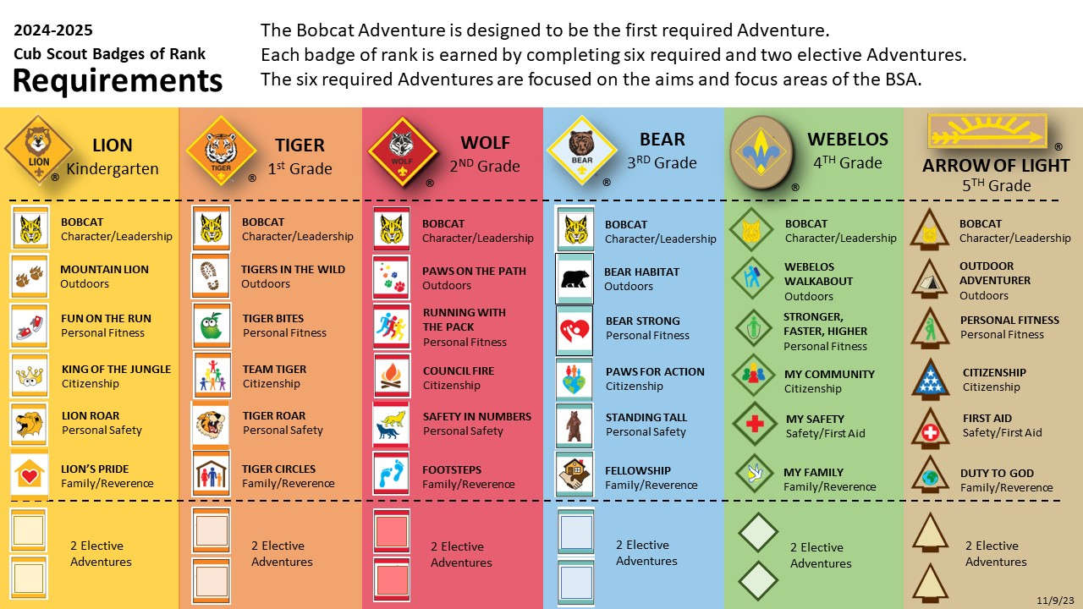
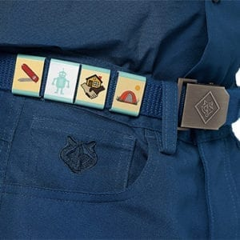
Belt loops displayed

Rank Awards

Each age (grade) level is represented by an animal (K-3rd grade) or the Webelos rank (4th & 5th grade) Each rank works to accomplish requirements and electives during the scouting year. Each requirement or elective is awarded a belt loop upon completion. All requirements must be completed to receive the rank patch for that level. Below are the current requirements for the year.
Or can be viewed here: https://www.scouting.org/wp-content/uploads/2018/08/Required-Adventures-Chart-for-Ranks.pdf

On the advancement trail, a Cub Scout progresses towards a badge of rank based on their grade. They need not have earned the previous rank in order to earn the next. Each of the ranks in Cub Scouting has its own requirements that are age appropriate, so earning a rank below a Cub Scout’s current grade is not permitted. As a Cub Scout advances through the ranks, the requirements get more challenging, to match the new skills and abilities they have learned.
Awards are presented at the end of the year during the rank awards ceremony, typically at the last Pack meeting of the school year. Belt loops are awarded as they are earned.
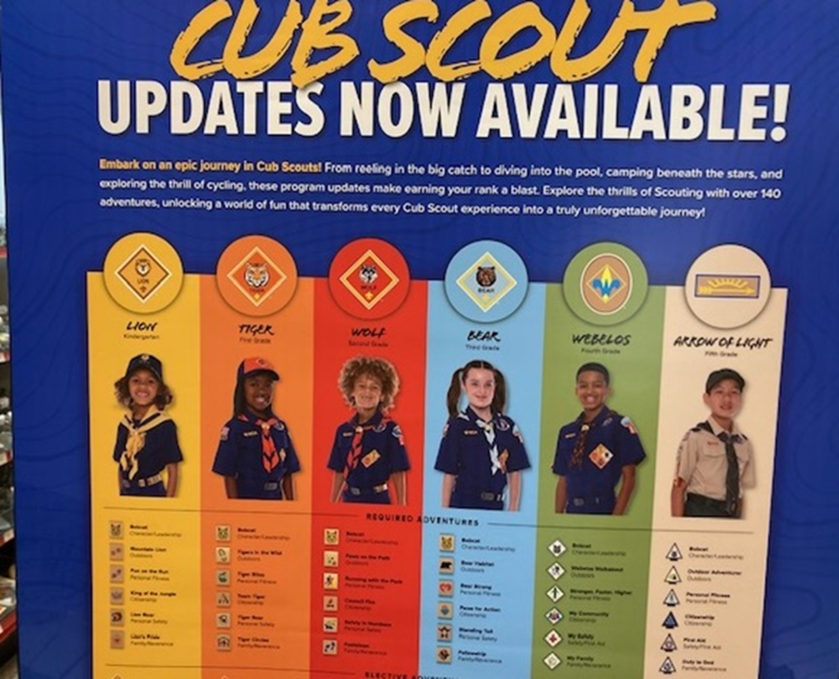
See the Appendix section on ceremonies for suggested Rank Awards ceremony ideas.
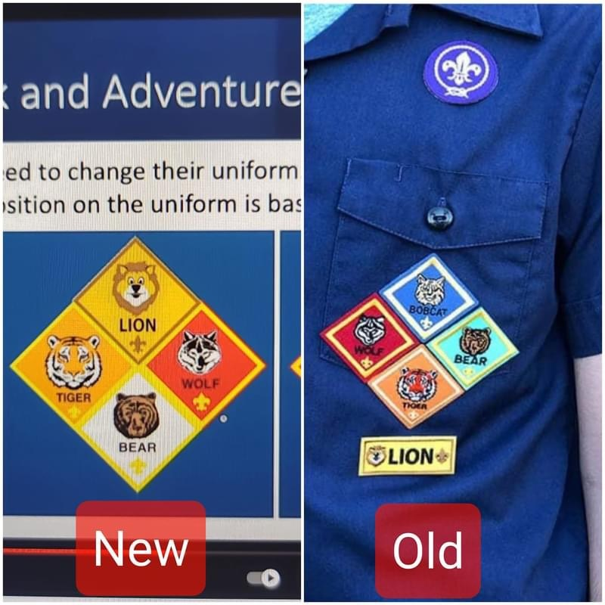

Activity Bead Totem Program

The activity bead totem program was started in the 1950s by the Great Rivers Council, and was intended for scouts at the Troop level to encourage meeting and activity attendance. The idea behind it is that while scouts are working on merit badges, which of course they display on their person once earned, that other visual representations serve as a motivator to keep the scout going in between earning badges. The colored beads on a custom leather medallion are a visual representation of smaller, though just as important, achievements. The practice evolved and migrated down to the Cub Scout level, culminating in the Tiger Beads program that was phased out in 2015 in favor of the belt loop program, which serves a similar purpose. Still, many units, both Packs and Troops, still make use of this program, and can serve as a great motivator especially for younger scouts. While belt loops are awarded at Den meetings following the completion of an Adventure, beads can be awarded at any time, such as Pack meetings when the scout’s name is called out and recognized for an Achievement, during Pack events where attendees get a special bead for attending, campouts for doing work such as firewood gathering and water patrol or cleanup, or for a reward for demonstrating an aspect of the Scout Oath or Law, such as helping out a friend or neighbor or doing a good deed. Totems worn on right pocket of shirt.
Example Bead Totem Used by Pack 136 (2013)
- Each rank gets a pipe cleaner of its color (Tigers = orange, Bears = blue)
- A bead of the same color is awarded for every Requirements fulfilled. A different color awarded for electives. Requirements and Electives go on the same strand for the rank.
- A purple pipe cleaner is attached at the start of every Scouting year.
- Specialized beads for Pack events, activities and recognition awarded by Cubmaster and Den leaders through year in addition to rank beads.
- Scouts with the highest number of beads for current rank and extra activities in May get a prize or special recognition.
- Large arrowhead bead for major recognition (religious emblem, summer camp)
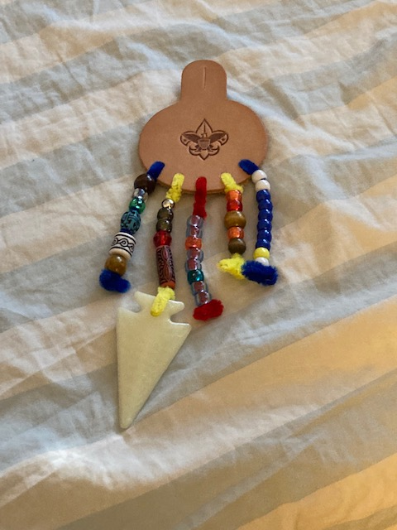
Bead Totem as instructed by
T1136 ASM Kayla Matens

Original Bead Program

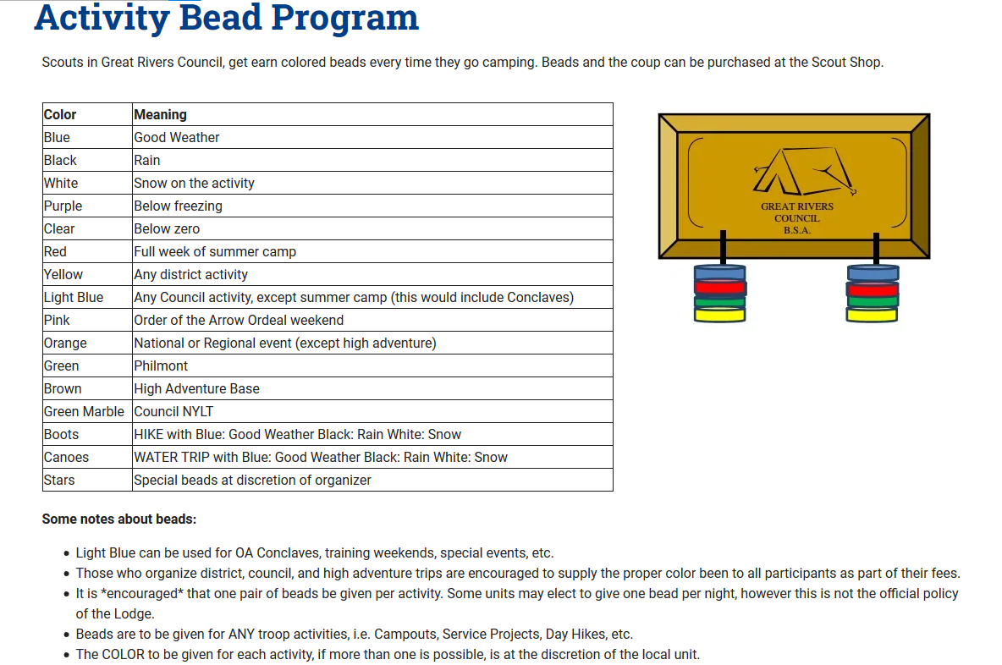

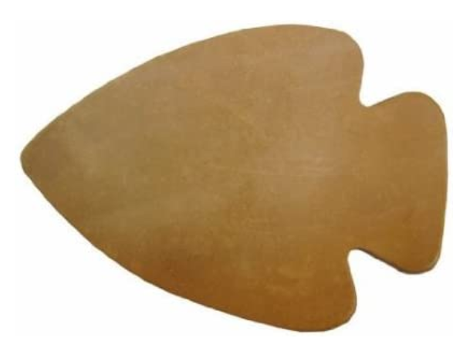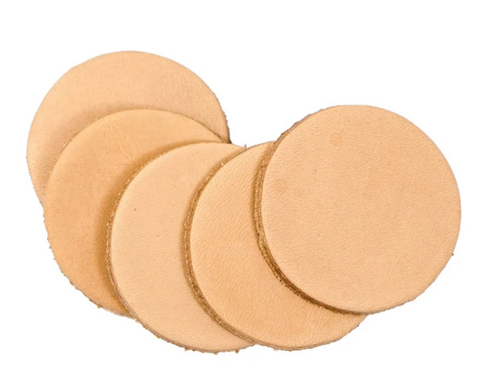
Leather blanks can be had from Hobby Lobby or Etsy, pre-made with Pack number with some left for personalized decorating, holes punched ahead of time, and cord and pipe cleaners included for the scout to attach.

Sample Bead Totems

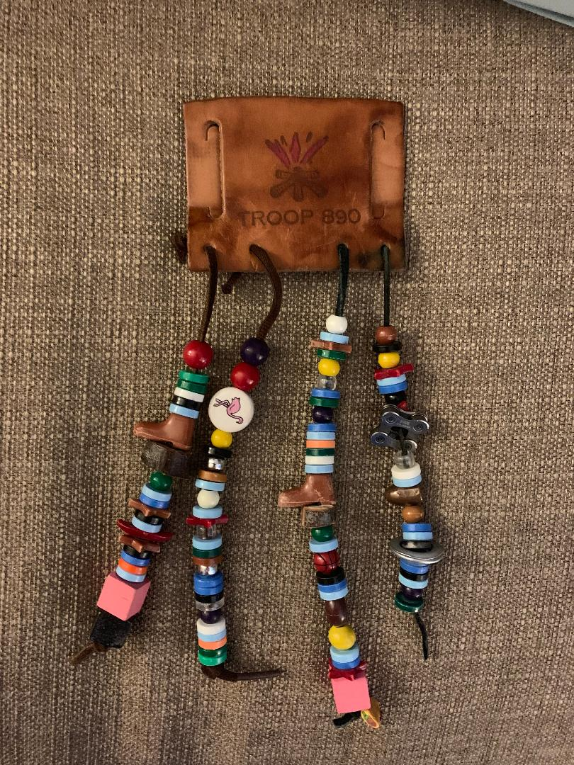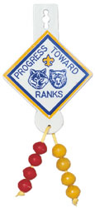
Troop Level Bead totem Older Cub Scout Totem
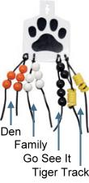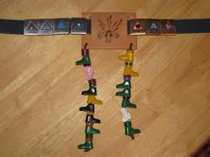
Tiger Level Beads Cub Scout Beads with Belt Loops

Suggested Cub Scout Bead Color Awards

Required Adventure | 1 bead per rank color (Lion = yellow, Tiger = orange, Wolf = red, Bear = light blue, Webelos = wood, AOL = forest green
Electives | Purple
Pack meeting | Gold
Den meeting | Dark blue
Pack event | Designer or wood shape
Pack campout | White
Hike | Clear green
Water activity | Clear blue
Campout chore (clean up, firewood gathering) | Clear yellow
Perform skit or song | Clear red
District activity | Circle
Summer camp | Arrowhead
Den campout | Square
Do a good deed | Turquois
3.5 or above on report card (or note from teacher stating best effort) | Star
Polar Bear campout | Iridescent white
Service project | Heart
Fundraiser | Designer bead or clear orange

FOR LEADERS
The activity bead totem is meant to foster creativity and participation in scouting. It began originally as a program for Troop Scouts to earn visual reminders of achievements and skill mastery in between earning merit badges, and grew into a program for both Cub Scouts and BSA Scouts. Although entirely optional, those who utilize the program find it is great fun, the kids love it, and it is very successful in encouraging participation. As the Den leader, it is up to you to decide when a bead is deserved for any activity not outline in the chart, and remember that the Cub Scout motto is “Do your best,” so effort should be rewarded as well.

- Pass out the totem kits to each scout. Inside each kit is a leather medallion, several pipe cleaners, and a length of cord.
- Explain the program to the scouts and remind them that while the beads are meant to be fun, scouting is about growing as a person, and that we should be doing the activities for the skills we learn, not just the beads.
- Provide the scouts with materials to decorate the medallions. Scouts should write their name somewhere on the medallion, and some sort of indication of their rank. (Draw a Lion or a Tiger, or a bear claw, for example) They can be as simple or as elaborate as they want.
- The cord ties at the top and is meant to allow the medallion to be worn over a button on the right side of the shirt, or for the Lions, on a belt loop. Have the parents help the scout secure it.
- Each rank starts with a pipe cleaner the color of that rank (Lions = Yellow, Tigers = Orange, Wolves = Red, Bears = Light Blue, Webelos = Light brown, Arrow of Light = Forest Green) On this pipe cleaner, Scouts will wear beads of the same color for every requirement they complete towards their rank.
- The second pipe cleaner Dark Blue and Scouts are awarded a yellow bead on this length for every Pack meeting they attend.
- The third and fourth pipe cleaners are Yellow, and scouts are awarded a Dark Blue bead for every den meeting they attend.
- The fifth pipe cleaner is purple, and it is on this length that scouts are awarded specialty beads given out at pack events, campouts, hikes, or service projects.

Included in the Leader’s kit are a select number of beads to hand our when you feel it is appropriate. Pack leaders will hand out beads at pack events. If there are any questions, please email pack136.stgeorge@gmail.com

For Scouts
Your Activity Bead Totem
This is a fun program to help you keep track of your journey through your rank in Cub Scouts! This craft allows you to construct your own activity bead totem to be worn on your uniform. You earn beads for your activities and accomplishments, along with your achievement belt loops and rank patch.
- First decorate the leather medallion. Put your name on it somewhere, and maybe draw the animal of your rank or some other art.
- Tie the cord through the top hole. This will go over the button on your right shirt pocket.
- Tie the pipe cleaners on in this order = Your rank color (Lions = Yellow, Tigers = Orange, Wolves = Red, Bears = Light Blue, Webelos = Light brown, Arrow of Light = Forest Green), Dark Blue, Yellow, Yellow, Purple.
- A single bead goes on your rank line for every requirement you complete, one on the dark blue line for every pack meeting you attend, one on the yellow lines for every den meeting you attend, and one on the purple line for every Pack event or campout or special event you attend.
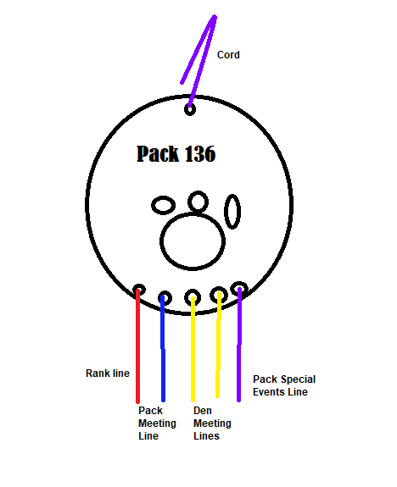

ARROW OF LIGHT CAREER ARROWS

At the end of the Cub Scout journey, when the Scout is prepared to cross over to the Troop and/or receive the Arrow of Light award, it is customary for the parent to present the Scout with a Career Arrow, which is a handmade arrow decorated with colored embroidery thread, each color and segment representing an achievement and award for each rank. Click the picture below for detailed instructions on how to make one, and the symbolism behind each color. It is recommended that the parent start work on this at the beginning of the Webelos 2/Arrow of Light Scout year.
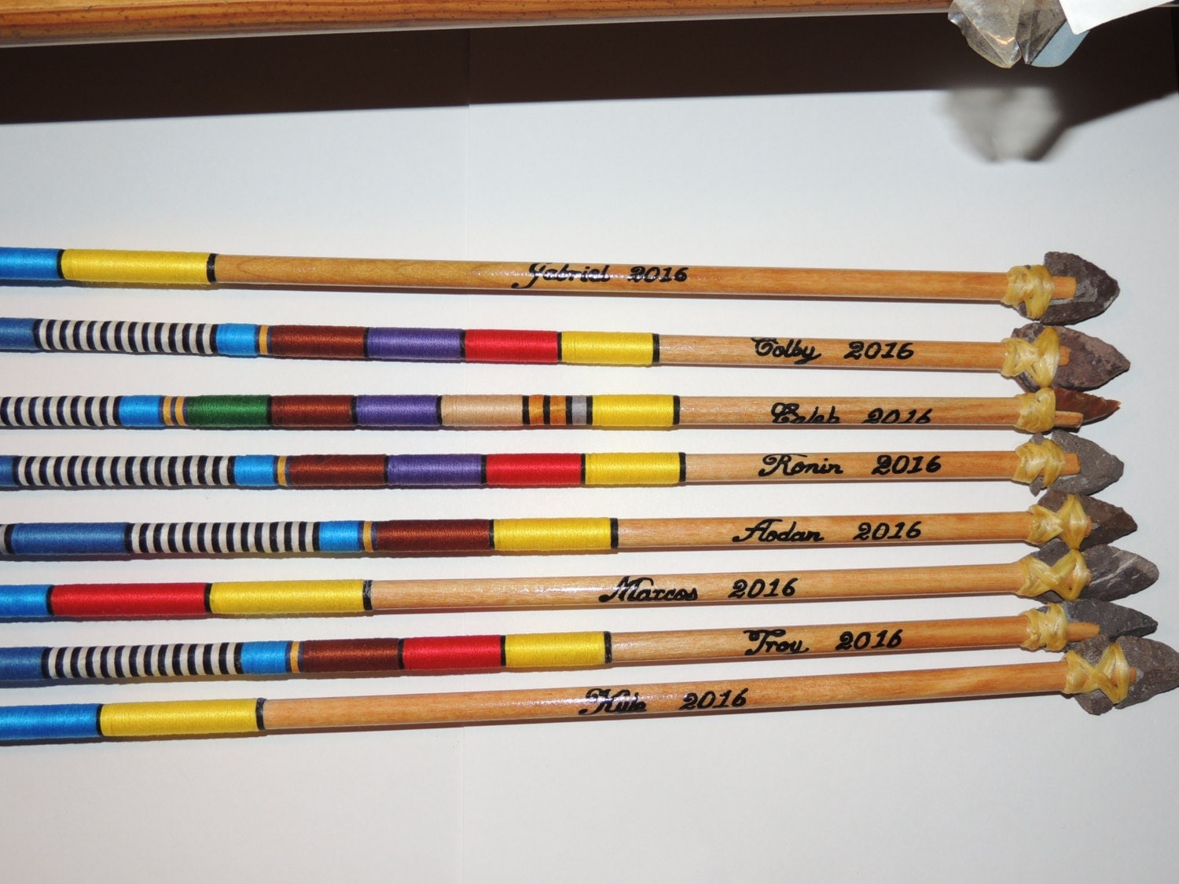
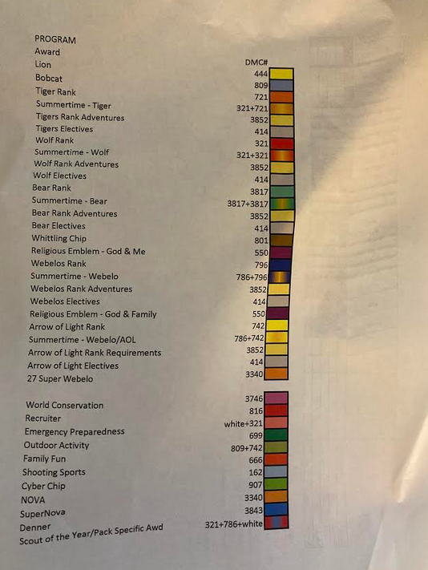
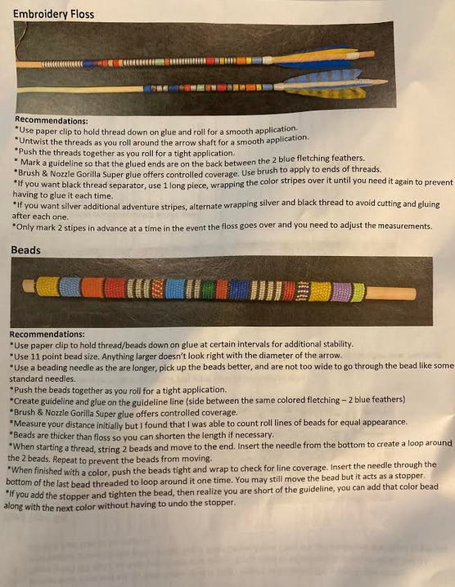

Pack Events

Committee Meetings

Committee Meetings are held once a month on the 1st Wednesday of the month unless there is a holiday or other event that causes conflict. The Pack meeting is generally held on the 2nd Wednesday of the month. The Committee Meeting is used for general planning of events and organizing volunteers.
- One Week Prior to Event
  - Committee chair should prepare an agenda.
  - Committee chair should contact all leaders and remind them about the event. Attach copy of the agenda to the email.
- Day of the Event
  - Print the Agenda for those who attend.
  - Contact the church office to arrange to pick up the key for the Scout House. If arriving after the church office closes, be sure the office staff will leave the key in the lock box outside. You may need to ask for the code for the lock box (in the vestibule on the side of the Church office facing the Scout House) where the meeting room key will be. The code for the lock box is usually hand written on the flyer taped to the inside of the window of the vestibule facing out.
  - Arrive at St. George at least 15 minutes prior to the meeting to open up the Scout House. Someone should be designated to record the minutes of the meeting. The meeting minutes should be typed up and sent out to the pack leaders within a couple of days after the meeting.
  - Clean up and reset the tables following the meeting.
  - Make sure the lights are turned out, air condition temperature readjusted, and the doors are locked.
  - Return the key by slipping key and envelope through the mail slot on the door of the church office.

Pack Meeting – General Details

Pack Meetings are for the entire family, including siblings, not just the Scouts. The regular date/time for these meetings is the 2nd Wednesday of each month at 6:30 p.m. at St. George in the cafeteria. There may be months where a special activity will replace the Wednesday night meeting. These activities may be on a day other than Wednesday to accommodate the function.
Remind the scouts that St. George School allows them to wear their Cub Scout uniforms to school the days of Pack meetings.
It is the parent’s responsibility to monitor the behavior of their children (including their Scout) at all pack meetings, events, and functions. This is very important in maintaining the order of the meeting.
Parents need to set an example for their children during pack meetings and programs by being considerate and not talking during the meeting or program.
- Three to Four Weeks Prior to the Event
  - Cubmaster should choose the theme for the meeting.
  - If there is going to be a special guest speaker at the meeting they should be contacted and booked.
- Two Weeks Prior to Event
  - Cubmaster should prepare an agenda. Some of the meetings will have major themes; such as the cake competition, food drive, showmen, fire safety, etc.
  - Special guest speakers, if any, should be contacted to confirm the time they will need to be at the meeting.
- One Week Prior to Event
  - Pack committee meetings are usually held one week prior to pack meetings.
  - Email agenda to leaders.
  - Send out reminder to all registered users about the event.
- Day of the Event
  - Arrive at St. George at least 30-45 minutes prior to the meeting to set up the cafeteria and check the sound system. This includes getting the Pack and American flags from where they are stored. The American flag goes to the left of the stage.
  - Cubmaster needs to make sure that any props are available and ready.
  - Clean up and reset the tables following the meeting.
  - Return the flags to their storage place.
  - Return the key by slipping it through the mail slot on the door of the old church office.

Camping

Pack camping is usually done at Avondale Scout Reservation in Clinton, LA. After choosing possible dates for the Pack spring and fall campouts, go to this link: https://www.iacbsa.org/tentaroo to check availability and to schedule the date. The Cub Scouts use Camp McGee.
General schedule and meal plans
Friday night is set up for each family to arrive at Avondale when they can. Families can either eat dinner on their own, before they arrive, or as a den. Families with Saturday morning sports activities may arrive when they can, they need to let their den leaders know ahead of time. Families who don’t wish to camp overnight may come for the day only.
Saturday breakfast is cooked and eaten with the dens. After breakfast has been cleared, dens can work together on rank requirements, often including hiking. Lunch is generally hotdogs or sandwiches, dens coordinate with the Pack and eat together. Dinner on Saturday has been a Pack meal, usually a jambalaya or pastalaya prepared in the Pack jambalaya pot. In the past, $5 per adult has been collected for the cost of dinner, unless the Pack can fund it.
Saturday afternoon is when a Pack activity takes place, coordinated by a designated leader or the Cubmaster. In the past we have done a scavenger hunt, capture the flag, or kickball. Be sure to make teams with all ranks on each team.
Sunday morning is a morning of reverence. A simple non-denominational religious service can be held in a beautiful location near Lake McGee as the sun comes up. This service may include a few simple readings and hymns and songs the scouts are familiar with. Keep it simple!
Breakfast on Sunday morning is done on a den level. After cleanup, be sure to extinguish all fires and have all scouts police the campsite for litter. This can be made into a contest as incentive!

Fall Campout
This campout is generally scheduled after the St. George Fair and the fall activity. Traditionally, the fall campout has been used for distribution of the Bobcat awards for new scouts who have earned them.
On Saturday afternoon during the fall campout, a bonfire is constructed by the Webelos parents away from the camping area. Jeff Worley, a fantastic previous Cubmaster, jworley.yfncg@gmail.com has been gracious enough in the past to wear the Akela costume and make an appearance to present the Bobcat patches. After dinner, when the sun is setting, all scouts and family members move to the area of the bonfire. Each scout earning the Bobcat award is asked to bring a small twig, about the length of their finger. The Cubmaster has the scouts call for Akela, who appears with his drum from over a hill or another unexpected location. Akela calls all Bobcat recipients forward and collects the twigs from them. He then throws them in the fire together so they burn and turn to ash. Another leader can have a small dish of ashes from a previous fire (not hot) on hand for Akela to use to make the mark of the Pack on the forehead of each scout as they receive their award and are officially welcomed into the Pack. Akela often tells stories and has the Pack sing Boom-chicka-Boom or another loud song before he departs.
All trash can be bagged and disposed of at the exit gate at the Avondale front entrance. Have the last person who leaves check out at the Ranger’s station.

Spring Campout
Spring campout is usually scheduled after the last possible really cold weather, around the end of March. Be careful not to schedule the weekend of the 2nd grade First Communion weekend!
The activities of the Spring campout usually include skits at the evening bonfire (constructed by the Webelos parents) and a flag retirement ceremony. We have asked at the Pack meeting before the campout if anyone has flags at home they need to retire. There are also flag shops in town who have many flags that need to be retired.

District Camping Events
Each fall, Sewell-Eagle District has a special district camping event. These events usually happen on the weekend of our Church Fair, because they are dodging the LSU home game weekends. If this is not the case, please make all efforts to register the Pack and attend. If possible, search the Council calendar for another district’s event, they are usually happy to have Pack 136 attend regardless of the district.

Fire Safety

A fire safety Pack meeting is conducted in the fall just before the first campout to alert the parents and scouts of the rules. We have previously enjoyed making edible campfires as a Pack activity.

Some fire safety rules include:

- Observe the fire warning level posted at the front gate of Avondale upon arrival
- Keep campfires inside existing fire rings at the campsite
- Have a means to extinguish the fire nearby, such as a 5-gallon bucket of water or sand and a shovel
- Keep the number of campfires to a minimum so they can be monitored easily
- Do not build a fire under a shrub or low-hanging branches
- Keep the campfire small
- Scouts may not light a fire unless they have adult supervision
- Fires may not be left to burn overnight
- Campfires must be fully extinguished and cold to the touch before the last person goes to bed for the night
- Do NOT leave any fire unattended, an adult must be present at all times
- If it goes in the fire, it stays in the fire!

Blue & Gold and Awards Banquet

Here’s what Scouting.org has to say: Most Cub Scouts celebrate Scouting Anniversary Week in February with a “birthday party” called the blue and gold banquet… It brings families together for an evening of fun and cheer. It’s often the pack meeting for February. Blue and gold banquets are a tradition within packs, celebrating the leaders and parents who volunteer to make Cub Scouting fantastic. Sometimes former pack members return to blue and gold banquets. Often special Scouting or community leaders are invited to attend or speak to Cub Scouts in attendance. Some packs also use the banquet as a chance to celebrate the accomplishments of Scouts, themselves. A pack meeting can be used to host a blue and gold banquet. But sometimes the banquet is a separate event. One misconception is that blue and gold banquets are intended to celebrate the Boy Scouts of America’s birthday (Feb. 8). And while the BSA’s birthday may be an additional reason to host the banquet, the theme of the day is celebrating the pack’s anniversary and everyone involved in making Scouting possible for members of the pack. There’s no lack of clarity on this, however: blue and gold banquets, from small to large, bring on creative decor, exciting entertainment, and delicious food. The months of planning that go into a successful blue and gold banquet are the perfect time to scour Pinterest and Instagram for kids’ party inspiration.
Pack 136 has, for many years, held an Awards ceremony in May with a Blue and Gold Cub Scout theme. Skits and other scouting activities along with blue and gold decorations and dinner have been rolled up to celebrate scouts “ranking up” to the next level. Scouts get to jump through the wolf’s mouth, then given the rank they just earned, and also given the neckerchief for the next rank they will achieve. The parents are responsible for purchasing the book for the next rank. The ceremony has been held in the school cafeteria in the past.
Advancement Reports
The Advancement Chair will need to generate Advancement reports in ScoutBook before the Pack can purchase rank patches and awards from the Scout Shop for advancing scouts. These reports can be printed out and taken to the Scout Shop to use as proof and an accurate count. The awards may be paid for from the account held by Pack 136 at the Council Office.
Adult Recognition
Scouts aren’t the only ones who need awards! Adult leadership involvement is the key to a successful Pack. Being recognized for your work is priceless.
Adult Recognition nomination forms can be located at: https://www.scouting.org/programs/cub-scouts/what-cub-scouts-earn/adult-awards-and-recognition/ Forms can be filled out and turned in to the District Executive for Sewell-Eagle. When approved, awards can be purchased at the Scout Shop.
In the early spring, the Sewell-Eagle district holds an awards ceremony and banquet for all adult leaders in Scouting. Watch for the date on the Sewell-Eagle calendar at: https://www.iacbsa.org/calendar/district/652/Sewell-Eagle There will be a link to purchase tickets.
If the Pack Leadership decides not to attend the district ceremony, adult awards can also be given out at the Pack Blue and Gold event.
If there are volunteers who didn’t earn Leader Knots and need to be recognized, consider making certificates. Certificates can be deeply honoring or silly. Also scan Pinterest for clever recognition gift ideas.
Investment in Character
A representative from the Council will ask to address the audience during the Awards Ceremony. They will be asking for individuals to make donations to Istrouma Area Council. In the past, Pack 136 has made an annual donation to the Council for $300-500. At one time, it was discussed to raise the Pack dues to $60 per year to cover a $10 donation per scout during the campaign during the Blue and Gold. Learn more at this link: https://www.iacbsa.org/investment
Food for the Banquet
Food for the banquet has been supplied by the Pack. It may be a jambalaya or pastalaya prepared in the Pack jambalaya pot or a catered event. Drinks have also been included, with one 5-gallon dispenser being filled with ice water and the other with a powdered lemonade mix with ice. The 5-gallon dispensers are stored in the Cub Scout closet of the Scout House. Desserts are pot luck. Select several families from each den to bring a dessert to share with the Pack.

Charter Renewal (Recharter)

The Internet Charter Renewal packet is completed online by the Committee Chair or someone designated by the Committee Chair. This task may be initiated at this link where you will find a tutorial: https://www.scouting.org/commissioners/internet-rechartering/ The BSA will release the Charter Renewal packet around mid-fall, it is usually due to be completed and sent back in the beginning of the following calendar year.

Be sure to review the Journey to Excellence (JTE) worksheet at the beginning of the year with the Committee Members so everyone knows what tasks need to be done to achieve a good score.

Once the Charter Renewal process has been started, the Committee Chair will:

- Email the Cubmaster to let them know the renewal has begun
- Email den leaders to verify the list of active scouts
- Verify a list of active adult leaders along with their current Youth Protection status
- Push to get any missing leadership training gaps complete
- All data will need to be verified with the Pack files, make changes as needed
- Test and verify
- Make last-minute updates to files for updated den leader information
- Submit the packet electronically
- Print the files and bring them to the Unit meeting to be held at the beginning of the calendar year

The Unit meeting will be arranged with Father Yi, the head of our Charter Organization. It is usually held at the Church Office. Also attending will be the Charter Organization Representative, (Mike Nolan) Scoutmaster and Committee Chair of the Scouts BSA, Venture Crew Leader and Committee Chair, and Girl Scouts Leaders. At this meeting, the Charter Organization Leader will ask how things are going with each unit and sign the paper form to be retuned to the council with a check to include a registration fee for each scout being registered. This fee should be $33 per scout this year, which covers registration and insurance.

Membership cards are no longer printed by the BSA, you can find a tutorial for printing at this link: https://i9peu1ikn3a16vg4e45rqi17-wpengine.netdna-ssl.com/wp-content/uploads/2019/01/Membership_Card_Printing-DETAILED_INSTRUCTIONS.pdf Membership cards will need to be printed and distributed to scouts and leadership in the Spring after the Charter Renewal has been approved.

Rain Gutter Regatta

The Basics
Keep it simple, make it fun! The basics of a great Raingutter Regatta are tracks, boats, rules, straws, water, and awards. Races can be run with the official boat kits, or as a “Recycle Regatta” where boats are made from recycled materials so long as they fit set parameters for size to fit in the tracks.

Tracks
Traditionally, and as the name implies, the race takes place in water-filled raingutters. These can be the official inflatable tracks or actual raingutters. If you choose to go with the traditional raingutters, a vinyl, flat-bottomed product that can be easily cut to length, then capped and sealed if necessary. You will need two to run a race for a smaller unit, 4 in total if you have a tremendous amount of Scouts.
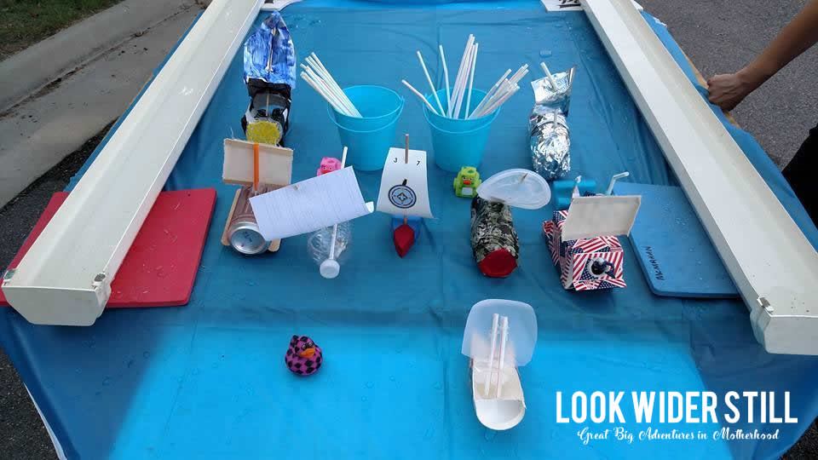
Alternatively, the Pack can make use of the official BSA Inflatable Raceways. The raceways are about 10 feet long, requiring two 6 foot tables placed end-to-end for support. One track includes two lanes. They hold about 4 gallons of water in each lane, but have extra water on hand in case a Scout leans against and collapses the vinyl or overturns a rigid raingutter track. Be near a water source, ideally. You will also want a pump of some sort, you don’t want to manually fill one of these with your own two lungs.
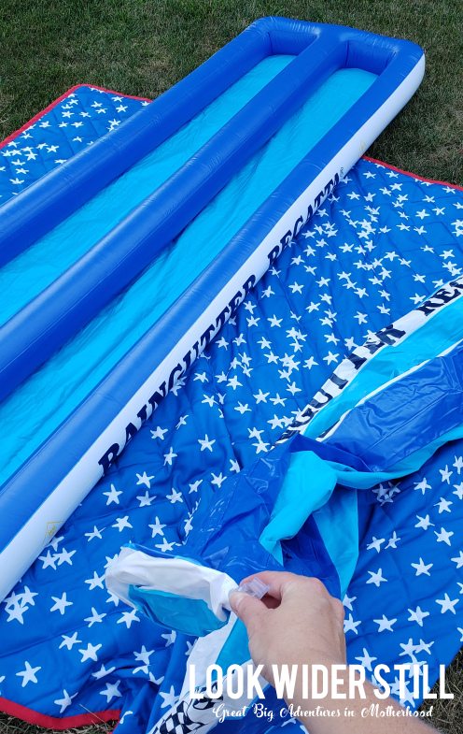

Boats
There are two great options when it comes to building your boats for the big race. Traditionalists purchase the official Raingutter Regatta Racing Trimaran Kit online or from their local Scout Shop. These kits cost around $6 each and have everything a Scout needs to build a beautiful boat. They are built to fit a raingutter track lane and can be customized with cool decals like a Pinewood Derby car.
A fun and thrifty alternative is to make yours a Recycled Raingutter Regatta. Provide your Scout families with boat specs and encourage them to raid their recycling bin for fun boat materials. To suit the inflatable tracks, we require that our boats are no more than 3″ wide and 10″ long and that they are built to be powered entirely by the child’s own breath. Don’t allow the official kits to be raced along with the recycled boats.

Rules
Try to remember that the Regatta isn’t your annual Pinewood Derby. It’s definitely worthy of a lot of great planning, but it shouldn’t be taken too seriously. Keep the rules simple and fair, saving yourself a lot of frustration on race day.
What are the rules? Each boat will be powered by each child’s own breath. Straws will be provided. The only time hands can be used is to right an overturned vessel. Captains who use their hands to move their boat along will be disqualified and the competing Captain will be declared the winner of that race. Vessels will be sailed in pairs based on age.
Who builds the boat and what are the specs? This is a family project! Please give the Scout the opportunity to build their boat with your guidance and support. Boats need to fit in the racing lane, therefore they cannot be wider than 3″ or longer than 10″. Raid your recycling for materials – if it can float, it’s a boat.
What isn’t allowed in Recycled Regattas? BSA Raingutter Regatta boat kits. A Scout is thrifty – using recycled materials aligns with this point of the Scout Law and helps us to be conservation minded. We love recycling, but we don’t allow boats to be reused year-to-year. Please don’t make a craft from paper or styrofoam!

Straws and Water
In the spirit of being conservation-minded and running a Recycled Regatta, try using paper straws. Some use plastic bendy straws and where they work like a total charm you want to be able to recycle what you can and lead by example. There are drawbacks to paper straws, of course, primarily that the Regatta involves lots and lots of water and paper straws fall apart after a while. Make sure each child has their own straw, we ask that they Do Their Best not to chew on them in between heats and that they don’t intentionally dip them into the water.
If you’re using the inflatable tracks, you will need 4 gallons of water for each lane, and again it is suggested that you have plenty of water on hand to refill tracks when a racer inadvertently (or intentionally) presses on the side and empties a lane.

Awards
The best part is the awards. Decide early what kind of awards you want to present to your winners.
Do you want certificates for appearances, first, second, and third place? Try visiting TheMormonHome.com and printing their beautiful, FREE certificates that cover everything from ranked placement to appearance awards like “Least Likely to Capsize” and “Most Ready to Sail the Seven Seas.”
Do you want official, engravable trophies for your rank placements? Crown Awards has great options for around $8 that your Scout would be thrilled to display along with their boat.
What about medals that can be worn around their neck? The Scout Shop has beautiful options available for 1st, 2nd, and 3rd place (around $4 each), and you can find a set of all three on the All Quality Amazon shop for a total of $11.00. You can also pick-up participation ribbons from the Scout Shop, which come in packs of 10 for $7.00.
Perhaps you’re feeling creative and want to make your own! Hit your local Dollar Store and find fun items you can put together to build interesting and fun awards. Hobby Lobby and the Dollar Store often have fleur de lis items that can be painted as trophies.

Entertainment
Pack 136 is filled with many talented people with resources! Have someone sing the National Anthem, or play music. Have backyard games for the siblings. Have sailing themed contests or treats.

Treats
This is a good time to start off selling popcorn, and even Country Meat Sticks. As the regatta typically happens in September at the start of the Scouting year, along with the onset of the popcorn fundraiser, getting the kids geared up for popcorn can start at the regatta. Or have the parents bring nautical themed treats to donate to the concession stand.

Invites and Brackets
Create an Evite invitation with your regatta rules and expectations, then create a link that you share via ScoutBook email or social media. This will help you to plan for the right amount of straws, treats, and other materials. Knowing the number of participants will also help you to prepare for your bracket building the day of the race. We normally have upward of 60 children participating in our annual race, which includes both Scouts and their siblings, so we use a dual-sided bracket for our event. FreeBracketGenerator.com has an easy to use template that allows you to create and print a FREE blank bracket to your own specifications. This is what our 2019 bracket looked like.
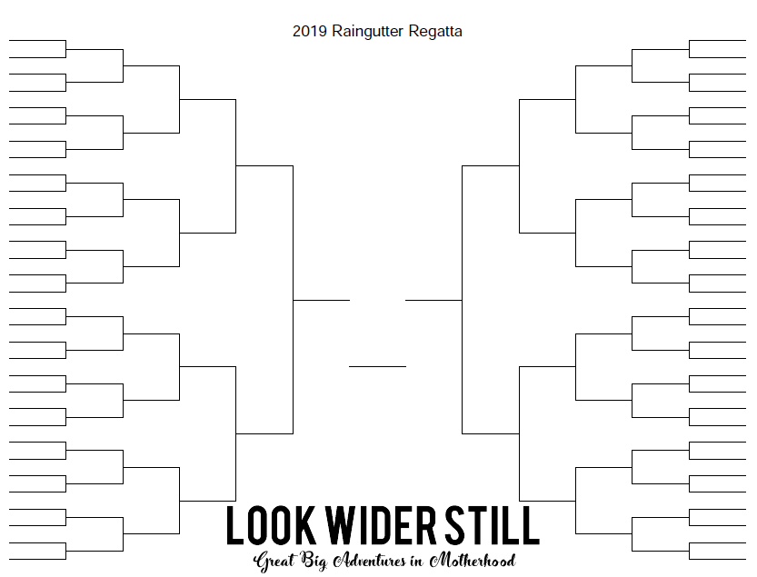
Challonge.com has several templates available for you to use, which can be used electronically OR printed and manually filled.
The Pack also has a spreadsheet on the Google Drive that tracks race data automatically for various derbies. It can also be used to track regatta winners on a laptop.

Running A Race
First and foremost, kick off your race with an opening ceremony. Invite Scouts to perform a flag ceremony. Remind everyone that this is a fun race built around the 12 Points of the Scout Law. Trustworthy, loyal, helpful, friendly, courteous, kind, obedient, cheerful, thrifty, brave, clean, and reverent.
We run a timed race, with adults at the end of each lane using stopwatches to record times. The best three top times in each grade level receive places. We register our racers for the event by marking them off of the list, noting the name of their boat, taking down their age or Cub Scout rank, and providing them with their straw or a hand fan. We use the registration list to fill the far ends of the bracket, creating pairs of children based on age or rank, one from each unit. Each side of the bracket represents an inflatable track… we use two tracks because we have so many participants that it would take a significant amount of time for everyone to race on one single track. Make sure you balance your bracket as you go, keeping equal numbers of participants on each side so each track has boats racing on it.
If using the spreadsheet, simply enter in the scout’s name and boat number (written on the boat along with the name and date) in the spreadsheet in the correct rank column, and record the time in one of the time columns. Use the sort feature to determine the rankings of each level.
Each of our tracks have two to four volunteers, and at each end of the track, to ensure a fair race. The Cubmaster is automatically the event emcee, so having those extra eyes on the race will help keep kids in check. Those volunteers will also confirm with you who won each heat so you can maintain an accurate bracket.
At the end of your bracket races, hand out certificates and/or awards! If you have a grand prize or something similar, award it to the pack overall best time winner. Scout handshakes all around, and of course, a group photo are a given.

Design Contest
Awards can also be given based on design. The fastest way to do this the day of the race is to create a Survey Monkey survey with the various design categories, and have everyone vote on their phones at the race by entering the number of the boat in the category. A sign with a QR code to the onlink link for the survey should be displayed at the check in table. The survey is closed at the end of the races and the winners are calculated for each category.

To Summarize

The Pack owns two inflatable Rain Gutter Regatta lanes, and four rigid raingutter lanes, all are kept in the Cub Scout closet. The council also owns an inflatable rain gutter which can be loaned out, contact your council district executive if it is needed.
In the past, we have run the regatta under the covered walkway that is over the driveway between the first grade building and the cafeteria. This provides cover in case of rain. If you conduct the regatta in that location, call the church office ahead of time and arrange for access to water to fill the regatta lanes. You may need to bring your own hose.
There are several types of regatta boats we have used, one is Styrofoam and can be purchased at the following link: http://www.pinewoodderbycars.com/Rainspout-Sailboat-p/wc-106.htm?gclid=EAIaIQobChMItfLxkMCP5AIVmh-tBh343gEhEAQYAyABEgINNvD_BwE
This type worked well but had to be done at home, the hull can be shaped using sand paper. Be sure the scouts do NOT use water-based paints such as tempera or finger paints. These paints leave a colorful trail in the water and on the rain gutter lanes.
We have also used boats similar to these, which were purchased at the scout shop. They may not carry them any more, but can be ordered online: http://www.activepowersports.com/pinecar-sailboat-racer-kit-sr470/?gclid=EAIaIQobChMItfLxkMCP5AIVmh-tBh343gEhEAQYDCABEgLUAvD_BwE
The Trimaran kits can be purchased from the scout shop. We have not used these because of the cost. https://www.scoutshop.org/raingutter-regatta-racing-trimaran-kit-612513.html?gclid=EAIaIQobChMItfLxkMCP5AIVmh-tBh343gEhEAQYASABEgJOi_D_BwE

GENERAL RULES
The rules for the Raingutter Regatta are fairly simple. The Scouts build boats from standard BSA kits supplied by the pack. Please follow the assembly directions on the package and allow the children to decorate in any manner they choose.

CONSTRUCTION RULES
The boat must be newly built for the current Cub Scouting year. As much as practical, the boat should be substantially built by the Scout with parental supervision.
- Boats must be made from the official BSA Raingutter Regatta Trimaran Boat Kit. All parts (2 outriggers, polymer hull, mast, sail and 4 screws) provided in the kit must be used in the boat construction. (NO substitutions are allowed!)
- Additional parts, decals, paint, and glue are permitted. Only boats with dried paint, decorations, glue (adhesives) will be allowed to compete.
Outriggers/Hull: The Outriggers must be no longer than 7" or shorter than 6 1⁄2". The finished boat must be 3-1/4" wide, which is the dimension of the molded hull. The outriggers must be solid and not split into multiple parts and must be evenly placed. The outriggers should be cut on the leading edge as shown in the enclosed instructions.
The mast may not be higher than 7” from the deck, nor shorter than 6” from the deck.
Basically, the Trimaran Boat should look like a Trimaran Boat displayed on the box. The boat requires no keel or rudder and none may be added.
Sail: Must use the sail provided in the kit. It may be trimmed, but cannot be enlarged or added to, but may be decorated. The sail may only be attached to the mast by glue (this is highly recommended), no mechanical fasteners will be allowed and the sail may not be in contact with any part of the boat except the mast. No CUP or BOX sails will be accepted. It should look like the boat on the box.
The mast hole is molded into the top of the plastic hull and is the only placement allowed for the mast. No deviations will be allowed and no modifications to the hole are allowed. The mast MUST BE perpendicular (90 degrees) to the hull, angling the mast in any direction is not allowed.
Modifications above the waterline for creative or decorative purposes are allowed as long as they do not alter sail performance. Details such as figures, decals and paint are permissible as long as these details are securely glued or fastened to the boat. The scouts are encouraged to decorate their boat, as this adds to the experience.

RACE RULES

- Two scouts will race against each other at a time.
- Each boat must start with the back of the boat touching the end of the rain gutter lane; the scout must hold it there with one hand.
- When the starter says go, the Scouts will propel the boats by blowing on the sail using a straw, or making use of identical battery powered hand fans set at the same speed.
- At no time shall a Scout touch the boat with any body part (nose, ear, etc.) during the race, except to upright it.
- The Scout may use his hand only to upright his boat or to remove an impediment (i.e. if the boat is stuck on the gutter). THE SCOUT MAY NOT ADVANCE THE BOAT WITH HIS HAND AT ANY TIME. If a Scout does so, he will be given a warning and the race rerun if that scout wins. If the Scout is judged to have pushed his boat a second time, he automatically loses the race.
- The race may be rerun if the judges find a reason that merits it.

MATERIALS NEEDED
- Sharpie
- Sawhorses or tables
- Hand pump for tracks
- Bullhorn or microphone system
- Batteries
- Fans
- Hose
- Bucket
- Racing lanes
- Heat sheets or Spreadsheet
- Registration/sign in sheets (always keep a paper copy)
- Award ribbons and certificates

Scout Olympics

This event is generally held on Sunday in late September or early October. Note that the Scout Olympics, Rain Gutter Regatta, Adventure Loop-A-Looza or the Pack 136 500, are normally rotated every couple of years, but more than one of the events can be done as well.
- Two Weeks Prior to Event
  - Choose the events and update the Scout Olympics Scoresheet document.
  - Make sure that you have all of the equipment necessary for the event. (Marking paint, measuring tape, Frisbees or balls, etc.)
  - Purchase first, second and third place ribbons to award each rank at the event. We have used Crown Trophy in the past.
- One Week Prior to Event
  - Email Scout Olympics score sheet document to all leaders and remind them about the event. Ask them to remind their dens about the event.
  - Send out reminder to all registered users about the event.
- Day of the Event
  - Arrive at least 60 minutes prior to the start of the event to set up. Mark all of the event locations and make sure any required equipment is distributed to the event area and ready to go.
  - Make sure there are bathrooms available and water for scouts and families to drink. Five-gallon dispensers are kept in the cub closet of the Scout House. Encourage scouts and families to bring their own water bottles.
  - Remember to police the grounds and dispose of any trash.

Events we have used that work well include sit-ups, push-ups, 50 yard dash, Frisbee throw, softball throw, football throw, tennis ball throw, crab crawl, standing broad jump, sack race, balloon between the knees race, plastic Easter egg and spoon relays. *These activities can be used for rank requirements.
Some that did not work well include basketball shot and soccer shot. Keep youngest scouts in mind when choosing activities.

Adventure Loop-A-Looza

This event is generally held on Sunday in late September or early October. Note that the Scout Olympics, Rain Gutter Regatta, Adventure Loop-A-Looza or the Pack 136 500, are normally rotated every couple of years, but more than one of the events can be done as well.

- Two Weeks Prior to Event during a Committee Meeting
  - Choose the belt loops to be earned at the event. Some good ones are the marbles belt loop, the Ultimate Frisbee belt loop, the kickball belt loop
  - Make sure that you have all of the equipment necessary for the event. (Marking paint, measuring tape, Frisbees or balls, etc.)
  - Create sign in sheets for each event so that a record can be made at each event of which scouts earned which belt loops.
- One Week Prior to Event
  - Send out a reminder to all registered users about the event.
- Day of the Event
  - Arrive at least 60 minutes prior to the start of the event to set up. Mark all of the event locations and make sure any required equipment is distributed to the event area and ready to go.
  - Make sure there are bathrooms available and water for scouts and families to drink. Five-gallon dispensers are kept in the cub closet of the Scout House.
  - Remember to police the grounds and dispose of any trash.
  - Collect all of the event sign-in sheets so that the belt loops can be ordered.
- Following the event
  - Place order for all adventure loops earned so that they can be distributed to the scouts at the next pack meeting.

Parent/Scout Cake Contest

The Father/Scout Cake Contest (or grandfather, uncle, or any other male support figure) is an opportunity for scouts to give back to the Church. The contest is held on the Friday of the Church Fair. After the judging on Friday evening the cakes are transported to the Cake Walk booth at the fair. Remember, scouts and family members have a chance to win their cake back if they participate in the cake walk! Each cake can generate up to $25 in donations.
Cakes are brought to the Kleinpeter Activity Center at the designated time for judging. This must be scheduled with the Church office ahead of time, will need to work around the Girl Scout cupcake judging also. Numbers will be assigned to each cake so the judging is done blindly. Judges can either be celebrity judges that are contacted ahead of time, or family members chosen randomly, or judges may include church clergy.
Cakes may only include edible decorations and supports, use of non-edible items is not allowed. Try not to bring a container that you can’t part with or mark your name and phone number on it so it may be returned.

Purchase ribbons at a trophy shop for this event. Suggested themes to be judged may include:
- Best Scout theme
- Most Creative Cake
- Most School Spirit
- Most Patriotic
- Biggest cake
- Prettiest cake
- Best use of color
- Best Halloween theme
- Most disgusting
- Best camping theme

Pack 136 500 Cardboard Box Race

This event is generally held on Sunday in late September or early October. Note that the Scout Olympics, Rain Gutter Regatta, Adventure Loop-A-Looza or the Pack 136 500, are normally rotated every couple of years, but more than one of the events can be done as well.
- At Least Four Weeks Prior to Event
  - Announce the event at a Pack meeting, explain how cars are made
  - Post rules on the Pack social media.

- One Week Prior to Event
  - Order awards from Crown Trophy.
  - Remind volunteers, sent reminder to registered families.
- Day of the Event
  - Volunteers should arrive at least 60 minutes prior to the start of the event to set up. Use cones to create the track and marking paint for the finish line, pit entrance and pit exit. Make sure any required equipment is distributed and ready to go.
  - Make sure there are bathrooms available and water for scouts and families to drink. Five-gallon dispensers are kept in the cub closet of the Scout House.
  - Get pack and American flags from storage for flag ceremony.
  - Remember to police the grounds and dispose of any trash.
  - Return flags and any other props to storage.

Pack 136 500 Rules
Each scout will build a "race car" at home out of a cardboard box. The box can be of any size but must be large enough for the scout to fit their body through and small enough for them to easily carry. The car should be decorated to look like a race car using whatever materials they want to use such as pie plates for wheels, paper towel tubes for exhaust pipes, etc.. They can make holes in the sides for their arms in order to hold their car up while racing or make straps to go over their shoulders to keep the car on.
On race day the scouts should bring their car, a towel, a pair of glasses or goggles (windshield) and a pair socks and a pair of shoes (tires). The shoes should be tennis shoes with normal laces, not slip on shoes or ones with Velcro fasteners. Cones will be set up or marking paint sprayed in a grassy area to map out the oval race track and pit road. Each scout will designate one member of their family who at least 16 years old, parent, grandparent, sibling or other relative as their "pit crew" who will stand on the inside of the track along “pit road”. Scouts will be grouped according to rank in each heat. The race will consist of four laps around the track. There are three required pit stops that each racer must make. While in the pit, all work on the car must be performed by the pit crew. The driver is not allowed to touch anything.

- After lap number 1 each racer must enter the pits and have their “windshield” (glasses or goggles) cleaned. Remember that the racer cannot help the pit crew to perform any service in the pits. In this case the racer cannot touch the “windshield” (glasses or goggles). The pit crew must remove the “windshield”, clean it and replace it on the driver. Once this has been done the driver must walk down pit road until they re-enter the race track for lap 2. Failure to walk in the pit results in a 5 second stop penalty.
- After lap number 2 each racer must enter the pits and refuel. The pit crew will have a bottle of water and two crackers (fuel) that must be consumed by the racer. Remember that the racer cannot touch the food or water so the pit crew must handle all of the “fuel”. Once this has been done the driver must walk down pit road until they re-enter the race track for lap 3. Failure to walk in the pit results in a 5 second stop penalty.
- After lap number 3 each racer must enter the pits for a “tire change”. The pit crew must untie and remove the cars’ tires (shoes), remove the racers’ socks and turn them inside out, put the inside out socks back onto the racer, put the new tires (shoes) onto the racer and tie them. Remember that the racer cannot touch the shoes or socks so the pit crew must do the entire “tire changing”. Once this has been done the driver must walk down pit road until they re-enter the race track for the final lap. Failure to walk in the pit results in a 5 second stop penalty.
- The first three cars to cross the finish line at the end of the final lap, having performed all of the required pit stops will be declared the champions for their heat. They will receive first, second or third place ribbons corresponding to their order of finish.
- Prizes will be awarded for the best looking car and the best scout themed car.
- Five parents will be chosen at random on the day of the event to judge the cars. They will select a first, second and third place choice and turn they selections in to the cubmaster by no later than 45 minutes following the start of the event. The scoring will be handled as follows:

  - Each first place choice by a judge will receive 1 point. Each second place choice will receive 3 points and each third place choice will receive 5 points.
  - The scores of each of the five judges will be tallied. The car with the lowest score will be declared the winner and awarded the trophy.
  - In the event of a tie score, the cubmaster will fill out a judging sheet. These totals will be added to the totals from the other five judges to determine the winner.

Halloween Spooktacular

- One Week Prior to Event
  - Remind the winner of last year’s decoration award to bring the trophy to the event. The “prized” trophy is re-awarded each year.
  - Remind each den leader that they need to have some kind of game or activity planned for the scouts to participate in during the event and candy to hand out as prizes and for trick or treat. Some of these have included pumpkin bowling, pin the tail on the bat, bean bag toss. Check Pinterest for more ideas!
- Day of the Event
  - Arrive at least 60 minutes prior to the start of the event to set up. The Church Office staff usually let us begin setting up at 5:00 pm.
  - Make sure there are bathrooms available and water for scouts and families to drink. Five-gallon dispensers are kept in the cub closet of the Scout House.
  - Remember to police the grounds and dispose of any trash.
Halloween Spooktacular Rules
- Each den will decorate the rear of one vehicle in a Halloween theme. This can be the back of a pickup truck, van, SUV or car, or a small trailer no larger than 8 feet wide by 12 feet long.
- Any materials may be used to decorate the dens’ entry whether store bought or made by the den.

- Lights and moving figures may be used and small, quiet generators are allowed.

- Each den is required to provide some type of game or fun activity that all of the scouts and siblings attending the event can participate in.

- Five parents will be chosen at random on the night of the event to judge the decorations. They will select a first, second and third place choice and turn they selections in to the cubmaster by no later than 45 minutes following the start of the event. The scoring will be handled as follows:

  - Each first place choice by a judge will receive 1 point. Each second place choice will receive 3 points and each third place choice will receive 5 points.
  - The scores of each of the five judges will be tallied. The den with the lowest score will be declared the winner and awarded the coveted trophy which they will get to keep until next year’s Spooktacular. They are allowed to bring this trophy to pack meetings and other pack events as a reminder to the other dens of their scare factor.
  - In the event of a tie score, the cubmaster will fill out a judging sheet. These totals will be added to the totals from the other five judges to determine the winner.

Food Drive (Church)

- Three to Four Weeks Prior to the Event
  - Contact the St. George Church office at 225-293-2212 to get permission to conduct the food drive before the 9:30 and 11:30 masses on the selected date. Currently you should ask for Missy Gregoire.
  - Contact the church coordinator for the food bank to let them know about the event and ask where to put the food collected at the event.
  - Contact the church office to add a reminder about the event to the announcements, church bulletin and website.
  - Contact the school office to get a reminder about this event in the next Dragon Tales. Ask for Charlene Lauman or email Charlene.Lauman@sgschoolbr.org
- One Week Prior to Event
  - Contact all leaders and remind them about the event. Ask them to remind their dens about the event.
  - Send out pack newsletter from website reminding all registered users about the event.
- Day of the Event
  - Arrive at St. George at least 30 minutes prior to mass to set up the tables at the two front entrances to the church.
  - Coordinate the move of the food collected to the scout house or other designated area for storage.

Pinewood Derby

- As Soon As Possible
  - Select date for Pinewood Assistance day, Down and Derby movie night, and the Pinewood Derby. Pinewood Assistance day is usually scheduled two to three weeks before Pinewood Derby weekend. It is a chance for those scouts who do not possess the tools or skills to get help in shaping their cars. The Pinewood Derby is generally held on a Saturday and Sunday in late January or early February. The derby has been held previously in the gym, but due to sporting conflicts we found it easier to move the track to the cafeteria.
  - Select a chair person for the concession stand and provide them with the details they will need to run it. Those details will appear at the end of the Pinewood Derby section of this guide.
  - Recruit a volunteer to be the MC of the Derby race.
  - Line up volunteers for assisting with the set up of the track and gym or cafeteria on Derby weekend, assisting with weigh in, testing and inspection, take down and storage of the track and other props and clean up of the gym and concession stand.
  - We have had a couple of the leaders for the past few years that has had some audio and visual equipment that we have borrowed for use on race day. This includes an amplifier and microphone, projector and screen, laptop, video camera and tripod. We use these items to broadcast the races on the screen, display a slideshow of pictures of all of the cars, play music during the races and intermissions and save the announcer’s voice during the event.
- Mid November
  - Purchase the Pinewood Derby kits. Make sure that you purchase about 6 extra kits to have on hand. The kits can be purchased at the Scout Shop if anyone messes up too badly.
  - Make sure you have volunteers lined up to assist with setting up the track , run the weigh-in and testing, run the races on derby day, run the concession stand, work the concession stand, take down the track and props for storage and clean up after the Derby is over.
- December
  - Purchase first, second and third place medals for each rank, along with the trophies for the special awards and pack level winners and ribbons for the den level winners. These will be awarded at the event. Crown Trophy on Sherwood Forest has a file on our pack with what we have ordered in the past. It usually takes about four to five days for the order to be completed.
  - Distribute the Pinewood Derby Kits to the den leaders at the December Pack meeting.
  - Email the Pinewood Derby car number assignments to the den leaders for distribution to their scouts.
  - Send pack social media reminding everyone about the Pinewood Assistance Day event. Contact the volunteers who will be assisting the scouts to verify with them that they will be there and remind them of the date and times.
- One Week Prior to Event
  - Call St. George to remind them that the pack will be using the gym or cafeteria the next weekend.
  - Send out a reminder about the event.
  - Contact volunteers to remind them about setup, weigh in and inspection, concessions, race day and clean up next weekend.
- Day of the Setup / Weigh-in
  - Arrive at least 2 hours prior to the start of the event to set up. Many of the props and items needed to run the derby are located in the scout house and will need to be brought over to the gym or cafeteria. The track is stored in the equipment room in the gym. Everything needed to set up the track is either in the case with the track or in the blue wooden chest in the scout house. The floor covers for the gym are stored in the storage room accessible from the gym and located behind the concession stand.
  - We normally have at least 8 adult leaders to assist with setting up the track and gym lobby for the event. This usually includes a couple of creative moms who handle the decorations. The more hands, the quicker things go. At least 4 adult volunteers will need to be present during the testing, weigh in and inspection. Two to perform the weigh in and inspection of the cars and two to assist the scouts testing their cars. It is also helpful to have someone handy with tools around to assist any scouts who might need to make alterations or repairs to their cars.
  - We normally ask each family to donate $5.00 toward stocking the concession stand and awards. This is collected when the scouts’ car is inspected and turned in to the volunteer who will be running the concession stand on race day. The money raised from selling the concessions covers the costs of putting on the race.
  - Make sure that the lights are turned out and the gym is locked before leaving for the day.

The Google Drive has, under Event Materials, the scorekeeping spreadsheet that tracks car times for five different heats, although any number of heats might be used. It calculates the average score of each heat, and sorts in ascending order who places first, second and third for each rank.

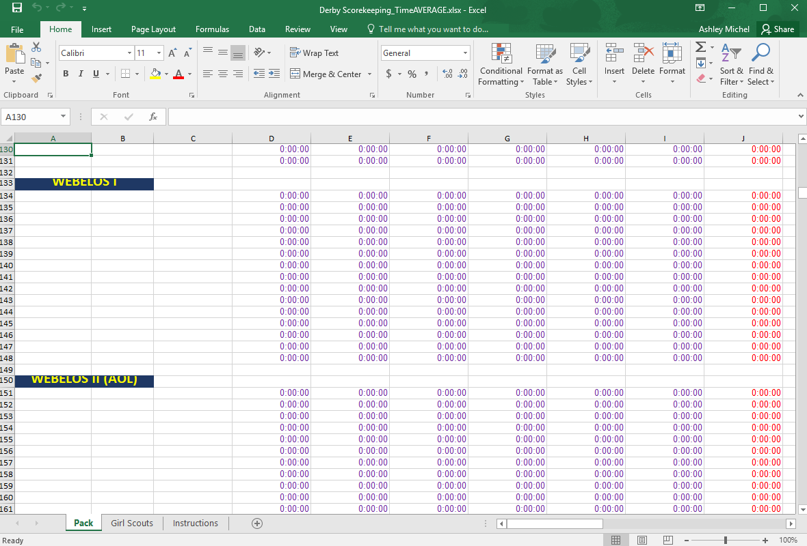

Likewise, it is also possible to make use of the “Pinewood Racing” app in the app stores of various smartphones, such as iOS and Android. This app allows racers to be entered in based on rank, assigns a number to each car, and automatically assigns scouts into various heats. It automatically calculates the fastest car, and can also expert a spreadsheet or PDF of the results. 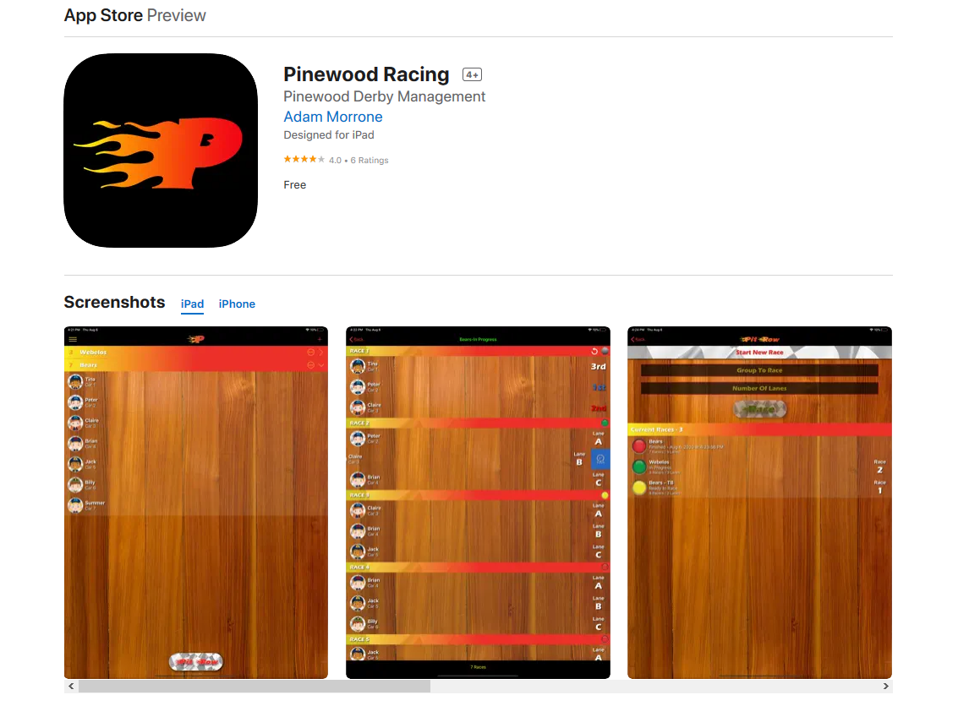
- Race Day
  - Arrive at the gym at least 90 minutes ahead of time to get everything open, assist with getting the concession stand set up and test the electronics for the track and audio / visual equipment.
  - The races are run by rank in the order of the den numbers starting with the Tigers, then the Wolves, Bears and Webelos.
  - Dens with more than six scouts will be divided into multiple groups since the track has only 6 lanes. The division will be done randomly by the leaders running the races. Each group will race their cars in three heats. Each car’s place of finish, 1 through 6, will be recorded in each heat. The place of finish will translate into a point total for each heat defined as 1 point for first place, 2 points for second place and so on up to 6 points for sixth place. The points for all three heats will be totaled up. If a den had more than one group, the lowest three point totals for each group will advance to the den finals. If a den has six or fewer scouts they will run in one group using the same scoring described above except that the first three heats are the den finals for those dens. The den finals will consist of three heats scored in the same way described above except that the two lowest point totals will be chosen to advance to the rank finals. In the event of tie scores for any place, a single heat run off between the cars involved in the tie will determine the car that wins / advances. First, second and third place ribbons will be awarded at the den level.
  - The rank level finals will be held immediately following completion of all of the den level finals at a particular rank. They will follow the same procedures as the den level contests. The two lowest point totals in the rank level finals will advance to the pack level finals. First, second and third place medals will be awarded at the rank level.
  - The pack level finals will be held at the completion of the last rank level final. They will follow the same procedures as the den level contests. The three lowest point totals qualify to represent the pack at the district Pinewood Derby. First, second and third place trophies will be awarded at the pack level.
  - Following completion of the last race everything needs to be carefully packed away for storage until next year’s race.
  - Make sure that the gym is thoroughly cleaned and that all of the lights are turned off prior to locking up for the day.
Combinations for the locks on the Track Case and Timer Case
Track Case: 18 – 8 – 30

Timer Case: 18 – 32 – 10

7) Extra Events for Siblings/Non-Racers

a) Face Painting booth

b) Hot Wheels track with Hot Wheels cars in a closed off area

c) Coloring station, printed out coloring sheets of race cars, word searches

d) Photo Booth

e) Carnival games

f) Pin the wheel on the car blindfold game

g) Tower building with red solo cups

h) Clips of Indy 500 races on a screen

i) have car themed playlist playing music. (Route 66, Shut up and Drive, Drive my car)

j) Lego building table

k) Have local troops set up a snack table to sell snacks and drinks as a fundraiser.

USS Kidd Overnight

- As Soon as Possible
  - This event is generally held on a Friday or Saturday in February or early March. Once a date is selected have the event chair contact the USS Kidd staff to book the event. https://www.usskidd.com/plan-your-visit/overnight-camping/
- Three to Four Weeks Prior to the Event
  - Contact the USS Kidd Staff to verify our reservation.
  - Once the date is confirmed add the event to the pack website calendar and set reminder e-mails.
- Two Weeks Prior to Event
  - E-Mail the release form to all of the den leaders for distribution to their scouts. These must be printed and signed for collection the night of the event.
- One Week Prior to Event
  - Send out pack newsletter from website reminding all registered users about the event.
- Day of the Event
  - Arrive at the USS Kidd about 1 hour prior to the event so that you can begin collecting release forms and payment.

POPCORN AND FUNDRAISING

Popcorn sales can generate enough income to financially support your Scouting program for the entire year! Money from popcorn can be used to cover the cost of camporees, pinewood derbies, field trips, equipment, badges and advancement, and summer camp. Every fall, the Istrouma Area Council conducts its annual popcorn fundraiser. Revenue from popcorn sales help the council maintain camp properties and service center, provide camperships for Scouts who need financial assistance to attend camp, conduct events such as Scouting For Food, Leader Trainings and our Centennial Service Project, and provide accident and sickness insurance for chartered organizations, members, and leaders. This annual event offers Scouting groups a simple, safe, effective way to raise money that, in turn, teaches kids speaking skills, confidence and salesmanship. Scouts have the opportunity to earn prizes, trips, and even a college scholarship account based on their total sales.

UNIT POPCORN KERNEL POSITION DESCRIPTION

The popcorn chairperson is responsible for the overall organization and implementation of the unit’s popcorn sale. This person ensures promotion, timely report of unit sales, popcorn pick up, and popcorn payment. Duties include:

District Kickoff
o Gather information, forms, materials, and ask questions

Develop a plan
o Establish Show & Sell Sites, such as businesses/functions, working in
cooperation with unit parents and leaders
o Set a site area for Take Orders that is both comprehensive & easy for Scout & parents to understand and canvas.

Unit Sales Goal
o Determine an overall sales goal for the unit and goal per Scout/family

Promote
o Market to the parents and Scouts of your unit through flyers, weekly e-mails, and notice of meetings throughout the sale Popcorn Kickoff Materials
o Schedule a kickoff day for your unit using the sales kickoff materials provided to get your Scouts excited for the sale! For additional supplies and support for your unit kickoff, please contact your District Executive.

Record Keeping
o Organize accurate records of unit sales, prizes earned, and payments due and made by the Scouts in your unit.

Product Organization
o Keep track of placing orders, picking up of popcorn, distribution of popcorn to Scouts, and returning of excess popcorn, if necessary, for your Unit.

Prizes/Incentives
o Work with Scouts to choose a prize level goal, order prizes and distribute upon delivery.

Have Fun!

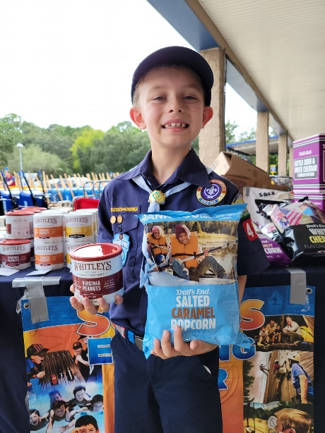

Popcorn can be sold individually or as a show n sell outside of businesses.

Other fundraising opportunities include:

- Country Meat Sticks
- World’s Finest Chocolate
- Christmas Wreaths
- Joint jambalaya dinner sale with the St. George Men’s Club
- Car wash
- Camp Cards
- Garage Sales
- Walk a Thons
- Used Book Sales

PACK CEREMONIES



This ceremony is used to symbolically pass the responsibility of leadership from one Cubmaster to another and involves the use to three candles and Cubmaster hat or hiking staff; one candle for the outgoing Cubmaster, one for the incoming Cubmaster, and one to represent the Spirit of Scouting, and the hat or staff as a ceremonial symbol of leadership. If the Pack owns one, the Pack flag should be set up right behind the table. If conducted as part of a Blue & Gold banquet, this ceremony should be the last one conducted just prior to the Retiring of the Colors.

Setting:
A small table or stand is placed in the front center of the audience, with a ceremonial candle holder on the table. A candle representing “The Spirit of Scouting” placed in the center/highest point and a candle representing the incoming Cubmaster is placed on the left side of the Scout Spirit candle, as viewed by the audience. Both candles are unlit. The lights of the hall should be dimmed, with the only lighting illuminating the candle table in preparation to conduct the ceremony. The ceremony begins with the current Cubmaster and the incoming Cubmaster entering from the rear center of the audience, approaching the center candle stand walking side by side, with the current Cubmaster on the right side and the incoming Cubmaster on the left side. They move to the front of the assembly with the current Cubmaster standing on the right side of the table, and the new incoming Cubmaster standing on the left of the table as viewed by the audience. Both turn and face the audience. If the environment and the situation permits, the current Cubmaster enters with their candle lit.

Current  Cubmaster: | I hold the candle which represents the light of Leadership that I have carried in serving our Pack. From this, I light the candle which represents the Spirit Of Scouting.
The candle of Scout Spirit represents the inner light that guides us in times of great difficulty and brings light into darkness.
It is only through inspiring each Cub Scout that a Leader truly serves the Pack, carries the light of leadership, and “Makes the Pack GO”.
Now the time has come to pass that light to another Leader who will now serve our Pack as Cubmaster
(the outgoing Cubmaster lights the candle of Scout Spirit, and places their candle in the stand to the right of the Scout Spirit candle when viewed by the audience)

The two Leaders now face each other across the table with the candle arrangement standing between them.

Current Cubmaster: | I now ask that as the incoming Cubmaster you light your candle from the candle of Scout Spirit, hold your candle in your left hand, and raise your right hand in the Cub Scout Sign as you prepare to take the Oath of Cubmaster.  Do you promise to carry the Spirit of Scouting within your heart, always Do Your Best to serve the members of our Pack?
Incoming Cubmaster: | “I promise I will”
Current Cubmaster: | Do you promise to carry on the highest traditions of our Pack?
Incoming Cubmaster: | “I promise I will”
Current Cubmaster: | Do you promise to embody the Spirit of Akela, serving as an example to all of the Cub Scouts and Cub Scout families that you encounter?
Incoming Cubmaster: | “I promise I will”
Current Cubmaster: | Do you promise to pass the fire of Scout Spirit to Cub Scouts everywhere?
Incoming Cubmaster: | “I promise I will”

Current I now ask that you face the members of our Pack family and Cubmaster: recite the Cubmaster’s Scout Promise.

The incoming Cubmaster turns to face the audience, holding their candle in their left hand with their right hand on the pole of the Pack flag, or raised in the Cub Scout sign if there is no flag. Each line should be stated with a brief pause after the completion of each line to emphasize the importance of each statement.

Incoming Cubmaster: | I Promise to Do My Best to Do My Duty to God.  I Promise to Do My Best to Do My Duty to my Country.
I Promise to Do My Best To Obey The Scout Law.
I Promise to Do My Best To Help Other People at all times,
I Promise to Do My Best To Keep Myself Physically,
I Promise to Do My Best To Keep Mentally Awake,
I Promise to Do My Best To Keep Morally Straight.

The incoming Cubmaster now turns facing the current outgoing Cubmaster, and places their candle in the candle holder.
Current : Throughout history, a hat (or staff) has been worn by those who serve Cubmaster: others in the role of leader, and now I pass to you the hat which represents the Leadership of our Pack, as it was passed to me by the Cubmaster who has served before me.

Both the outgoing Cubmaster and incoming Cubmaster step to the front of the candle table. The outgoing Cubmaster places the Cubmaster’s hat on the incoming Cubmaster, and the Leader’s Neckerchief.
Current On receiving this hat (or staff), I now pass the duties and responsibilities
Cubmaster: of the position of Cubmaster to you. May you be guided by the examples of those leaders who have gone before you.

At this time the outgoing Cubmaster can make any brief statements that they wish to the members of the Pack.
On completion of any statement, the outgoing Cubmaster extinguishes their candle, and may cross the bridge from right to the left as viewed by the audience in exiting the main ceremony area.

This marks the end of the ceremony, and should be followed by the new Cubmaster calling for the Retirement of the Colors, and the closing of the Blue and Gold banquet or proceedings.

Arrow of Light and Crossover Ceremony

Setup
Have small campfire in fire pit going, with table behind it with AOL candelabra with seven candles setup waiting to be lit.
Have an electric lighter to light candelabra.
Have bridge setup (someone needs to check on status of the bridge in closet).
Already have handed out candles to everyone ahead of time, as they entered meeting.
May utilize glow necklaces for younger scouts, we’ll see. Would also be handed out at beginning. Those can be lit whole time, not just briefly as with individual candles.
Sit the AOLs and their families toward the front.

AOL Ceremony
Cubmaster: Cub Scouts, leaders, parents and guests, greetings and salutations. Tonight, like people have done for thousands of years, we have gathered with Troop 136 around a fire in celebration, to share the light and to share important stories about our journey together in honor (# of Scouts receiving award) Webelos Scouts that have earned the highest award in Cub Scouting: The Arrow of Light. The Arrow of Light symbol is made up of an arrow which points the way to a good life and a rising sun which symbolizes the constant new challenges provided by Scouting and by life itself. It is the only Cub Scout award that can be worn on the BSA Scout uniform. It is an achievement all Cub Scouts should work towards. These Scouts have worked very hard over the last two years to earn this prestigious award, and demonstrate that they understand the purpose of Scouting.
Webelos Scouts, many years ago, you entered the Cub Scout Pack. During this journey, you learned the rules of the Pack, earned the rank of Bobcat, and then higher ranks beyond. As you met those challenges, you learned what it means to be a Cub, the Law of the Pack, and the three words that would inspire you to meet all other challenges: Do Your Best. Your first steps along the trail were spent with the Tiger clan. There, you experienced many challenges for a young scout. You became part of the clan, but continued to look for more. Having started on the trail, you next sought to join the Wolf clan. Here you were met with more challenges, harder than the Tiger tests, but with the cleverness of the wolf itself, you met them and continued on your journey. Now the trail becomes darker and fainter as you came to the Bear clan. Again harder challenges were presented before you.
As you met them, your knowledge grew and your spirit strengthened. It was this strength of spirit, like the bear, that prompted you to move onward. As you neared the summit, you joined the Webelos clan. The time of your testing had begun. In the Webelos clan you began to learn about Scouting. Just as you learned the ways of the Pack, as a member of the Webelos clan you would learn the ways of the Troop. In time, you earned the Webelos badge, blazing the rest of the trail on your own. Now at last you have reached the summit and the highpoint of this part of your journey. The Arrow of Light,
The seven candles before you represent the rays in the Arrow of Light. These seven rays stand for the seven great virtues of life...virtues that a Webelos Scout must have if they are to succeed and advance in Scouting and in life. For younger Scouts, living by and using these 7 great virtues will help you achieve much on your trail upward to the Arrow of Light.
The Arrow of Light symbol has seven rays, and our Arrow of Light candelabra has seven candles. They represent the journey to BSA Scouts, and the virtues of an Arrow of Light recipient.
As I call out the steps through the Cub Scout journey, I would ask a den leader or volunteer from each den to step forward to light one of our candles. (note on timing, as each candle is lit, the master of ceremonies explains the accompanying virtue so there is constant movement and talking to keep things moving).
Candle Lighting
(Representative from each den comes up)
The journey through Cub Scouts begins with the Lions, will our Lion den please light our first candle.
A Scout has WISDOM (light candle #1) Having wisdom doesn't mean that a Scout is smarter than others. It means that he uses what he knows to live a better life -- to be a good example for other people, young and old, Scouts and others, family and friends.
The next step in Cub Scouts is the Tiger badge, will our Tiger den please light our second candle. This second candle also represents Courage.
A Scout has COURAGE (light candle #2) Having courage doesn't mean that you're never afraid -- very courageous people are often afraid. However, facing danger despite your fear is the act of a brave, courageous Scout.
After Tigers comes the Wolf badge, will our Wolf den please light our third candle. This third candle also represents Self-Control.
A Scout has SELF-CONTROL (light candle #3) Scouts have to know when to stop. When you can stop yourself when you have had enough or done enough of something -- enough eating, enough playing, or even enough working -- then you have self-control. Know what behavior is correct in each situation, and do it. When you have self-control, you are growing up as a Scout.
After Wolves comes the Bears, will our Bear den please light our fourth candle. Our fourth candle also represents Justice
A Scout gives JUSTICE (light candle #4) Justice is being fair with others that we go to school with, work and play with. Justice means it doesn't matter who the person is, or what color they are, or what they do...Scouts are fair to everyone.
After Bears comes the Webelos, will our Webelos den please light our fifth candle.
A Scout has FAITH (light candle #5) Scouts believe in a higher power. Faith means that we believe in the Creator and other things we cannot see. When you know God exists in your heart, you have faith.
After first year Webelos is the year of the Arrow of Light, will one of our Arrow of Light recipients come light our sixth candle.
A Scout has HOPE (light candle #6) Hope means you look forward to good things that you believe will happen. You hope for better things tomorrow, but you work hard today to make those good things happen.
And the seventh candle represents the support of Akela, the one who loves and supports the Scout. Will our Arrow of Light recipients (names here) and their parents come to the front please, and will the parent or special adult of each of our Arrow of Light Scouts please light the seventh candle?
A Scout has LOVE (light candle #7) Scouts have many kinds of love. Love of family, home, your fellow Scouts, God and country are all a part of Scouting. Every kind of love is important for a full and happy life.
Once you have completed all the requirements for your Arrow of Light badge, then you have completed the Cub Scout trail.
You will find that if you live life by these seven virtues, you will be happy and will make the people around you happy as well. The Webelos Scouts before us this evening have proven that they understand their responsibilities as good sons and good Scouts. With the help of their willing parents, they will advance far in their future adventures. Congratulations, Scouts.
Cub Master to Den Leader: Den Leader, have your Webelos completed the Arrow of Light requirements?
Den Leader: Yes they have.
Entire Pack: Let the Arrow of Light be given to each of them.
Cubmaster: Will the following Webelos and their parents please stand before us as your name is called, and please retrieve the arrow as it is shot as your name is called. (Read out Names –Shoot arrow for scout to retrieve)
Cubmaster: Having met all of its challenges, it is our duty and privilege to award you with the highest Cub Scout honor: the Arrow of Light.
Parents, because of the support and guidance you have given this scout, I give the Arrow of Light to you to present to him. [Moves to the front and gives the Arrow of Light patch to the parents who then present it to their son. Den leader gives the certificate to the Scout.]
Cubmaster: And now the parents will present to their sons the career arrow. This career arrow represents the Arrow of Light and documents your journey through Cub Scouts, the awards you have earned, the ranks you have achieved. These arrows are very special, (Akela/parent gives career arrow Webelos) Each one is handmade, especially for each of you and your unique journey, by your parents. Each one is similar yet very different. Its shaft is straight and true; to remind a Scout to be straight and true in keeping his promises. The feathers on this arrow guide it on its course; just as the ideals of Scouting guide a scout on his course through life. Well done, Arrow of Light Scouts!
Cubmaster: Everyone, let’s give our arrow of light recipients a big round of applause. (After a speech, they’ll probably need a cue to clap).
(everyone claps for them)

Bridging
CUBMASTER: The main goal of Cub Scouting is to prepare Cubs to become BSA Scouts. Tonight, it is my privilege to present to you our Cub Scouts that have decided to continue their Scouting trail. (Call forward each candidate by name and their parents.)
This ceremony of crossing the bridge marks your completion in Cub Scouting, just as it marks the beginning of a whole new experience in Scouting. Congratulations and good luck! Let’s all gather around the bridge now and light our individual candles symbolically lighting the way for these cub scouts’ first steps into the Troop, and as an expression of our love and support in their first steps in this new adventure.
CUBMASTER: (to parents) During the years you and your children have been in Cub Scouting, we have had numerous opportunities to work together on your trail. Your Cub Scout have reached the age to enter Scouts BSA. I'm sure you and your child will find the same satisfaction there that you found in Cub Scouting. As a symbol of the growth of your child and their entrance into Scouts BSA, I will ask that you lead them before me and prepare to guide them across the bridge into Scouts BSA when the Scoutmaster grants permission for your children to enter their troop.
WEBELOS DEN LEADER: (Names each Webelos), you have contributed much to your den and pack, and we shall miss you and your parents. Now you are leaving us to enter the Scouts BSA troop of your choice. There you will continue to grow in Scouting skills and friendships. As you approach the bridge, and as a symbol of your growth, we will remove your neckerchief as you cross over into the Troop. As you depart our pack, we exchange the Cub Scout handshake, and as you are received on the other end of the bridge by the Troop, you will be greeted with the Scout handshake.
(As each candidate approaches the bridge, the Webelos Leader removes the Webelos neckerchief and hands it to the Scout's parents. Cubmaster gives each the Cub Scout handshake. Candidates cross over the bridge. Scoutmaster gives the candidate the Scout handshake and welcomes them and their parents to the troop.)
CUBMASTER: Troop 136 (Troop 1136), please receive (name each scout as s/he crosses).
Scoutmaster in response to each name: (we welcome _________).
(Then, after all cross bridge)
SCOUTMASTER: Scouts I want to welcome you to BSA Troop 136 (1136), members will now present you with a symbol of welcome, the shoulder shoulder loops for your new scout uniform, a symbol of the next step in your scouting journey. (After each has received his/her epilet, the Scoutmaster and new Scouts exchange the Scout salute. All new BSA scouts stand to one side)
SCOUTMASTER: Now to conclude our ceremony, will everyone, both parents, cub scouts, and BSA scouts repeat after me the scout oath:
[Raises hand in the sign of the BSA Scout and recites the Scout Oath and Law]

Scout Oath:
On my honor I will do my best
To do my duty to God and my country
and to obey the Scout Law;
To help other people at all times;
To keep myself physically strong,
mentally awake, and morally straight.

Scout Law:

A Scout is:
TRUSTWORTHY
LOYAL
HELPFUL
FRIENDLY
COURTEOUS
KIND
OBEDIENT
CHEERFUL
THRIFTY
BRAVE
CLEAN
REVERENT

SCOUTMASTER: Knowledge, once gained, must be shared. Each Scout must pass on to other Scouts what he or she has learned. As you grow more experienced in Scouting, we will ask you to begin to return to Scouting some of what you have received from it. Work diligently as you pass down your Trail to Eagle Scout, and you will learn much that you can share with the others who come after you. Remember, you will receive from Scouting only what you put into it. I challenge you to work hard so that you will have much to give back. Welcome to Troop 136.

CUBMASTER: Please blow out your candles. That concludes our ceremony, now in celebration we invite you to the parking lot area to light another type of candle, sparklers, in celebration of our AOL’s crossing over to the BSA Scout Troop. Thank you for coming.
(next year, get battery candles, wind kept blowing them out. Also we used tiki torches on either side of the bridge and did sparkers in the parking lot after for the younger scouts)

AOL Bridging for Two Troops

Bridging
CUBMASTER: The main goal of Cub Scouting is to prepare Cubs to become BSA Scouts. Tonight, it is my privilege to present to you our Cub Scouts that have decided to continue their Scouting trail. (Call forward each candidate by name and their parents.)
This ceremony of crossing the bridge marks your completion in Cub Scouting, just as it marks the beginning of a whole new experience in Scouting. Congratulations and good luck! Let’s all gather around the bridge now and light our individual candles symbolically lighting the way for these cub scouts’ first steps into the Troop, and as an expression of our love and support in their first steps in this new adventure.
CUBMASTER: (to parents) During the years you and your children have been in Cub Scouting, we have had numerous opportunities to work together on your trail. Your Cub Scout have reached the age to enter Scouts BSA. I'm sure you and your child will find the same satisfaction there that you found in Cub Scouting. As a symbol of the growth of your child and their entrance into Scouts BSA, I will ask that you lead them before me and prepare to guide them across the bridge into Scouts BSA when the Scoutmaster grants permission for your children to enter their troop.
WEBELOS DEN LEADER: (Names each Webelos), you have contributed much to your den and pack, and we shall miss you and your parents. Now you are leaving us to enter the Scouts BSA troop of your choice. There you will continue to grow in Scouting skills and friendships. As you approach the bridge, and as a symbol of your growth, we will remove your neckerchief as you cross over into the Troop. As you depart our pack, we exchange the Cub Scout handshake, and as you are received on the other end of the bridge by the Troop, you will be greeted with the Scout handshake.
(As each candidate approaches the bridge, the Webelos Leader removes the Webelos neckerchief and hands it to the Scout's parents. Cubmaster gives each the Cub Scout handshake. Candidates cross over the bridge. Scoutmaster gives the candidate the Scout handshake and welcomes them and their parents to the troop.)
CUBMASTER: Troop 1136, please receive (name each scout as she crosses).
Scoutmaster (in response to each name:) “We welcome _________.”
(Then, after all cross bridge)
SCOUTMASTER: Scouts I want to welcome you to BSA Troop 1136, members will now present you with a symbol of welcome, the shoulder shoulder loops for your new scout uniform, a symbol of the next step in your scouting journey. (After each has received his/her shoulder loop, the Scoutmaster and new Scouts exchange the Scout salute. All new BSA scouts stand to one side)

CUBMASTER: Troop 136, please receive (name each scout as he crosses).
Scoutmaster (in response to each name:) “We welcome _________.”
(Then, after all cross bridge)
SCOUTMASTER : Scouts I want to welcome you to BSA Troop 136, members will now present you with a symbol of welcome, the shoulder shoulder loops for your new scout uniform, a symbol of the next step in your scouting journey. (After each has received his/her epilet, the Scoutmaster and new Scouts exchange the Scout salute. All new BSA scouts stand to one side)

Conclusion

SCOUTMASTER 1136: Now to conclude our ceremony, will everyone, both parents, Cub Scouts, and BSA Scouts repeat after me the scout oath:

[Raises hand in the sign of the BSA Scout and recites the Scout Oath and Law]

Scout Oath:
On my honor I will do my best
To do my duty to God and my country
and to obey the Scout Law;
To help other people at all times;
To keep myself physically strong,
mentally awake, and morally straight.

Scout Law:

A Scout is:
TRUSTWORTHY
LOYAL
HELPFUL
FRIENDLY
COURTEOUS
KIND
OBEDIENT
CHEERFUL
THRIFTY
BRAVE
CLEAN
REVERENT

SCOUTMASTER 136: Knowledge, once gained, must be shared. Each Scout must pass on to other Scouts what he or she has learned. As you grow more experienced in Scouting, we will ask you to begin to return to Scouting some of what you have received from it. Work diligently as you pass down your Trail to Eagle Scout, and you will learn much that you can share with the others who come after you. Remember, you will receive from Scouting only what you put into it. I challenge you to work hard so that you will have much to give back. Welcome to our Troops.

CUBMASTER: Please blow out your candles. That concludes our ceremony, now in celebration we invite you to the parking lot area to light another type of candle, sparklers, in celebration of our AOL’s crossing over to the BSA Scout Troop. Thank you for coming.

Flag Retirement Ceremony

PARTICIPANTS:
Unit Leader: The acting Cubmaster for a Cub Scout Pack, the acting Senior Patrol Leader for a Boy Scout Troop, or the Crew President for a Venturing Crew.
Retirement MC: The Den Leader of the participating den for a Cub Scout Pack or a senior Den Leader if more than one den is participating. The acting Patrol Leader of the participating patrol for a Boy Scout Troop or a member of the Troop leadership chosen by the Senior Patrol Leader if more than one patrol is participating. A member of the Crew leadership chosen by the Crew President for a Venturing Crew.
Color Guard Members: An even numbered group of four to eight Scouts, depending on the size of the flag, chosen by the person acting as the Retirement MC from the eligible participants identified by the Unit Leader. The group could be a Cub Scout Den, a Webelos Den, an entire Pack, a Boy Scout patrol, a Boy Scout Troop, or a Venturing Crew.
MATERIALS and GUIDELINES:
All participants should be in full Class A uniform. For Webelos Scouts this should include the Webelos activity colors if used by the Den. For Boy Scouts this should include either the Merit Badge Sash or the OA Sash (not both). Avoid any dangling items that could be easily ignited.
The flags to be retired. Large flags may need to be cut into pieces before being placed into the fire. If this is necessary the blue field should be separated from the stripes and then each of the stripe separated from each other. Scissors should be used to cut the flag. It should never be cut with a knife or torn in any way.
Materials to build a modest fire that is large enough to consume the largest flag or flag remnant that will be placed into the fire. This fire should have been allowed to burn for some time so that a bed of coals has been produced that will fully consume the flag. The fire should be blazing. Adding some small pieces of cedar or another fast burning wood that produces a cheerful flame is advised just prior to beginning the ceremony. The Retirement MC should be responsible for the tending of the fire just prior to the start of the ceremony. Depending on the setting, it may also be necessary to have a burn barrel to keep the fire above the ground. Check the regulations in force at the site where you are conducting the ceremony.
Speakers or Audio Equipment to Play Patriotic Songs. Not necessary but a nice extra.
Follow Leave No Trace fire impact guidelines, all fire safety guidelines, and obey all applicable laws. Take note that flags made from nylon ignite very quickly, burn very hot, and release innocuous gases as they burn. Subsequently the fire should be placed far enough away to keep the audience out of the primary smoke path of the fire and the color guard should plan to stand out of the smoke path after placing these flags into the fire. Also be aware that it is illegal to burn nylon in some states and municipalities so check local regulations for burning flags made of this material. It may also be necessary to obtain a burn permit or other permits from local municipalities before igniting the crematory fire.
BEGINNING OF THE CEREMONY
(The Unit Leader takes his place five paces to the right of the burning fire and two paces in front of the burning fire facing the audience. The Retirement MC and the Color Guard are stationed with the flag in a position facing the fire with their backs to the audience at least ten paces away from the fire. The Retirement MC is on the right side of the Color Guard members. The flag to be retired is carried by the Color Guard member in the middle of the assembly.)
(Play “You’re a Grand Old Flag”)
RETIREMENT MC: Color guard, attention.
Color guard, forward march.
(The Color Guard advances to within two paces of the fire.)
Color guard, halt.
Color guard, about face.
RETIREMENT MC: Title 36, Section 176, of the United States Code states, “No disrespect should be shown to the flag of the United States of America.”
Furthermore, Paragraph (K) of this same Title 36, Section 176 states, “The flag, when it is in such condition that it is no longer a fitting emblem for display, should be destroyed in a dignified way, preferably by burning.”
The BSA publication “Our Flag” states, “When the national flag is worn beyond repair, burn it thoroughly and completely on a modest, but blazing fire. This should be done in a simple manner with dignity and respect. Be sure the flag is reduced to ashes, unrecognizable as a former flag.”
The flag we present tonight was inspected earlier this day. During that inspection it was found to be no longer suitable for display. A fresh new flag now flies in its place. A flag should never be thrown away or used in any method other than its intended purpose. It should never be turned into clothing or used as a common piece of scrap cloth. It should never be altered in any way, in either design or color. It should represent the dignity of the country, until it is gone from this earth.
UNIT LEADER: Tonight we will retire this great symbol of freedom throughout the world. Please remain silent until directed otherwise. ABSOLUTE DIGNITY MUST BE
MAINTAINED THROUGHOUT THE ENTIRE CEREMONY!
Please stand out of respect for the flag of our great nation. Scouts, attention.
Just a simple piece of colored cloth; sewn together in a red, white, and blue design. A piece of cloth that of itself does nothing more than hang or blow in the wind. Each flag does not only represent its own history, but that of every flag that has flow before it. To many millions of people throughout our nation’s glorious history, it has stood tall, standing as a monument of Freedom, for all Americans.
Men and women have given their lives for it, fought for it, cried for it, and revered it as a symbol of the greatest country on earth. Books, songs, and poems have been written for it, and our National Anthem was inspired by it. Each day our children are encouraged to pledge their allegiance to it, and whenever it is raised or passes by, we all place our hands over our hearts or salute it. It stands for the freedom we all share and the pride and patriotism we feel for our country.
RETIREMENT MC: Color guard, present the colors. Please place your hand over your heart or salute if you are in uniform.
(The Retirement MC steps to the position opposite that of the Unit Leader. The color guard unfolds the flag for the last time, and presents the flag tilted so that it can be seen by the audience. The Retirement MC waits for at least 15 seconds after the flag is in full view before continuing the ceremony.) RETIREMENT MC: Two.
UNIT LEADER: This is your flag. It was born on June 14, 1777. It is more than just a piece of cloth shaped into a colorful design. It is the refuge of the world's oppressed people. It is the silent sentinel of freedom. It is the emblem of a great sovereign nation. It is the inspiration for which American Patriots gave their lives and fortunes. It has led brave warriors into battle from Valley Forge to the dry deserts of Iraq. It walked in silence with each of our honored dead to their final resting place, beneath the silent white crosses row upon row. It has flown through peace and war, strife and prosperity, and amidst it all it is respected.
“Old Glory” is its nickname; proudly it waves on high. Honor it, respect it, and defend it. Never let its enemies tear it down from my lofty position lest it never return. Keep alight the fires of patriotism, strive earnestly for the spirit of democracy, and keep it always as a symbol of freedom and liberty in our country.
These flags are now old and faded, do not let them fly in disrepair, rather retire them from their duties only to replace them each with a new flag so that they may continue to symbolize our country. With this, renew your commitment to what the flag stand for and pledge your allegiance one final time.
RETIREMENT MC: Please place your hand over your heart or salute if you are in uniform. Join me now in one final Pledge of Allegiance:
“I pledge allegiance to the flag of the United States of America, and to the Republic, for which it stands, one Nation under God, indivisible, with liberty and justice for all.”
(Play the National Anthem)
Color guard, retire the colors.
(The Unit Leader now faces the fire. The color guard now lays the flag flat and places it into the flame, folding the corners into the flame so that all the flag is consumed by the fire. The members of the Color Guard then step to the sides of the fire facing the flame, come to attention and salute. The Retirement MC will inspect the fire and stir the ashes of the fire to ensure that the flag is completely consumed by the flame. When the flag is consumed, the MC retreats to the position opposite from the Unit Leader, comes to attention, and salutes. There is now at least a 15 second pause before continuing.)
RETIREMENT MC: She is gone! (They are gone)
Two.
Color guard retreat.
(The Color Guard members now turn and face the audience. The retirement MC now goes to the center of the fire faces the audience. They remain after the audience leaves, prepared to stand vigil until the fire burns to ambers.)
UNIT LEADER: Please honor our nation and join in singing “God Bless America”.
When the song is completed, please depart from the fire in silent dignity.
God bless America, land that I love.
Stand beside Her, and guide Her,
Through the night, with the light from above. From the mountains, to the prairies, To the oceans white with foam.
God bless America, my home sweet home.
God bless America, my home sweet home.
(The Unit Leader now departs with the audience. The Retirement MC and the Color Guard complete whatever tasks necessary to put out the fire. The grommets from the flag should be separated from the ashes. These may be kept by Color Guard members or distributed.)

Rank Awards Ceremony

Materials needed
The Wolf Head
Solar powered tiki torches
Neckerchiefs for next ranks
Rank patches
Certificates
Face Paint crayons

Setup
Place the Wolf’s Head in an area where children can easily line up behind it and crawl through it unimpeded. Have a table with the rank certificates and patches attached to them lined up in alphabetical order by den. Situate the tiki torches on either side of the Wolf Head and have two adults stand on either side of it to hold it steady. Have a stack of neckerchiefs sorted by rank, ready to easily grab and hand out.

Baden-Powell Promotion Ceremony
Tonight we are celebrating the conclusion of our Scouting year. As many of you know, Scouting started in England in 1907 when Lord Robert Baden-Powell took 7 boys to Brownsea Island for a camping experiment. But the roots of Scouting go even farther back. In 1899, Baden-Powell was a Colonel in the British Army fighting the Dutch Boers in South Africa. Colonel Baden-Powell was in charge of a town called Mafeking. It was under siege by the Boers. The Boers shelled the town every day except Sundays. When that happened, everyone had to hide in trenches until the shelling stopped. Baden-Powell noticed that the last ones into the trenches and the first ones out were the young boys. He needed to keep these young lads from doing risky things and getting wounded. So he organized them into a Boys Corps. They ran messages from Headquarters to the troops and citizens, and they practiced Army Scouting skills. This helped him enforce discipline on them in a way that they could accept.
The food was running out, the Boer force was 10 times the size of the British force, but Baden-Powell used his cunning to hold the town for 217 days, until British reinforcements could arrive and rescue the town from the Boers. When he got back to England, he found himself a National hero and a small book he had written for the Army, "Aids to Scouting", was being used by British boys to play games of scouting. He remembered those boys in Mafeking and what his Boys Corps did for them. He rewrote his book into "Scouting for Boys" in 1908 and Boy Scouting was born.
The tradition Baden-Powell started in Mafeking, we are continuing tonight. When the kids in Mafeking learned their scouting skills, they were rewarded with a promotion in rank. So too, do Cub Scouts, after showing their abilities in certain skills, earn their ranks of Lion, Tiger, Wolf, Bear and Webelos. Our Scouts have learned many new skills this year. We will now reward their efforts by promoting them to their new ranks for this next Scouting year.
A long time ago, Akela, the leader of the Pack, knew the day would come when the Cubs would grow and learn, and some day go out into the world as Scouts. While the Cubs were with the Pack, however, they must develop the necessary skills of the Scout, learn the Law of the Pack, earning each rank to show the world that they truly did their best. Each Cub would proudly wear their rank to show everyone how far they have come down the Cub Scout Trail.
Tonight, we gather here, at our meeting place, as Cub Scouts have done for decades, to present to our hard working Cubs the new symbols of their rank, and advancement within the Pack and in Scouting. You have worked hard all year. You have finished the required activities designed to give you the skills every scout needs. And now, we your leaders will honor your hard work and dedication by awarding you your new rank patch. Wear it proudly, and know that you truly did your best.

Lion Promotion:
We begin with our youngest scouts, the Lion Den. The Lions may be our youngest, but they are some of our most energetic and enthusiastic scouts. Will the Lions please come forward and assemble behind the Wolf’s Head? Scouts, you have completed Kindergarten and have shown yourselves ready to become Tiger Scouts. Wear your new uniform and neckerchief proudly like all Scouts have for the last century. Crawl through when your name is called and approach your leaders to receive your Lion Patch and Tiger neckerchief. Then, approach your parents.
Cubmaster: Do you want to wear the sign of the Lion? If you do, please say "yes".
Tigers: Yes
Cubmaster: We will give you the sign of the Lion which will start you on your journey along the Scouting Trail. You will need lots of support from your family as you try to attain Cub Scoutings' highest honor, the Arrow of Light.
The black on your cheeks is for happiness along the Lion Trail.
(Paint two horizontal stripes on each cheek)
The red on your chin is for determination along the Tiger Trail.
(Paint two vertical stripes on chin)
The yellow on your forehead is your Lion mane which symbolizes bravery.
(Paint a triangle on forehead)
Lion Cubs, remember the meaning of your Lion paint. It shows that you are ready to move along the upward trail of Scouting.

Tiger Promotion:
Now we move on to the Tigers. Our Tigers are strong and quick and ready to learn. We are proud of how much they have learned this year. Please line up behind the Wolf’s Head and come through when your name is called to receive your rank patch. Scouts, you have completed the First Grade and have shown yourselves ready to become Wolf Scouts. Wear your new neckerchief proudly like all Scouts have for the last century. Crawl through when your name is called and approach your leaders to receive your Tiger Patch and Wolf neckerchief. Then, approach your parents.
Cubmaster: Do you want to wear the sign of the Tiger? If you do, please say "yes".
Tigers: Yes
Cubmaster: We will give you the sign of the Tiger which will start you on your journey along the Scouting Trail. You will need lots of support from your family as you try to attain Cub Scoutings' highest honor, the Arrow of Light.
The black on your cheeks is for happiness along the Tiger Trail.
(Paint two horizontal stripes on each cheek)
The yellow on your chin is for sunlight along the Wolf Trail.
(Paint two vertical stripes on chin)
The red on your forehead is for bravery when you attempt the Bear Trail.
(Paint two vertical stripes on forehead)
Tiger Cubs, remember the meaning of your Tiger paint. It shows that you are ready to move along the upward trail of Scouting.

Wolf Promotion:
Now we move on to the Wolves. These Scouts are not our youngest, not our oldest, but are some of our most dedicated. They are starting to learn Scouting skills they will use for the rest of their lives. Please line up behind the Wolf Head and come through when your name is called to receive your patch. Scouts, you have learned new skills and have shown yourselves ready to become Bear Scouts. Wear your new rank and neckerchief proudly like all Scouts have for the last century. Crawl through when your name is called and approach your leaders to receive your Wolf Patch and Bear neckerchief. Then, approach your parents.
Cubmaster: Do you want to wear the sign of the Wolf? If you do, please say "yes".
Cubs: Yes
Cubmaster: You have worked hard with your Den and your parents to fulfill the Wolf requirements. You are now ready to wear the sign of the Wolf.
The black on your chin stands for happiness from your days as a Tiger Cub.
(Paint two vertical black stripes on chin)
The red on your forehead is for bravery when you become a Bear.
(Paint two vertical stripes on forehead)
The yellow across your nose is for sunlight along the Wolf trail.
(Paint a yellow ramp across the nose from ear to ear with a stripe under the ramp on each cheek)
Wolf Cubs, remember the meaning of your Wolf paint. It shows that you are ready to move along the upward trail of Scouting.

Bear Promotion:
The Bear rank is the last rank where you will wear the blue uniform of the Cub Scout. This year, you’ve begun to learn skills that you will use at the Troop, such as first aid and pocket knife safety. You have learned responsibility, and next year, you will be some of our oldest scouts, and our leaders for the younger Cubs. Please line up behind the Wolf head and come through when your name is called to receive your rank patch. Scouts, you have learned new skills and have shown yourselves ready to become First Year Webelos Scouts. Wear your new rank and neckerchief proudly like all Scouts. Crawl through when your name is called and approach your leaders to receive your Bear Patch and Webelos neckerchief. Then, approach your parents.
Cubmaster: Do you want to wear the sign of the Bear? If you do, please say "yes".
Cubs: Yes
Cubmaster: You are well on your way along the Cub Scout Trail to reach the honor of the Arrow of Light, and eventually start the Boy Scout trail to seek the sign of the Eagle.
To help you along your journey, we will give you the sign of the Bear.
The yellow on your chin stands for Sunlight from the Wolf Trail.
(Draw two vertical yellow stripes on chin)
The blue on your forehead is for loyalty when you become a Webelo.
(Draw two vertical blue stripes on forehead)
The red on your cheeks is for courage and the hard work you and your parent did to achieve the Bear Rank.
(Draw two upward slanting lines on each cheek)
Bear Cubs, remember the meaning of your Bear paint. It shows that you are ready to move along the upward trail of Scouting.

Webelos Promotion:
The Webelos rank is an 18-month journey, a different one from the journeys taken before. The Webelos Scout is not quite a Troop scout yet, but nor is he or she just a Cub Scout. This in-between period is a time of great growth, as scouts learn to survive in the wild, to cook over a campfire, to set up a campsite properly and how to begin planning his journey for himself. For our Webelos scouts who have been tested and made it through the trials, come through the Wolf’s head and receive your new rank, and permission to wear the tan uniform of Scouting!
Would the following Scouts and their Webelos Den Leader please step forward, and line up behind the Wolf Head. Scouts, you have learned new skills and have shown yourselves ready to become Second Year Webelos Scouts. Wear your Webelos Colors proudly like all Scouts have for the last century. Crawl through when your name is called and approach your leaders to receive your Webelos Patch. Then, approach your parents.
Cubmaster: The sign of the Webelos Scout signifies a major step on the Cub Scout Trail. Just as Indian boys became warriors and were painted in the colors of their tribe, we will paint you with the colors of Scouting.
Do you want to wear the sign of the Webelos, please say "yes".
Cubs: Yes
Cubmaster: You are well on your way along the Cub Scout Trail to reach the honor of the Arrow of Light, and eventually start the Boy Scout trail to seek the sign of the Eagle.
To help you along your journey, we will give you the sign of the Webelos.
The blue W across your nose is for strength as you work on the Arrow of Light.
(Paint a large W From ear to ear across the bridge of nose)
The yellow on your chin and forehead is the color of sunlight and will light your way along the Scouting Trail.
(Paint a yellow triangle on chin pointing down and on forehead pointing up)
The red stands for fire so that you have a burning desire to explore new areas.
(Paint red stripes on each side of the chin and forehead triangles and under the W on each cheek)
All of these colors together form the Webelos symbol. You should be very proud to wear it.

To all of our scouts, congratulations on your new rank! And to all of our leaders, parents, den chiefs and volunteers, thank you as well! This program could not function without the dedication and sense of humor of all of our devoted leaders and parents. Let’s take some time to revel in our new ranks, and then dive right in to earning the next one! Those of you going to Cub Scout day camp can start working on requirement for your new ranks right away! Wear those badges with pride, you’ve earned them!

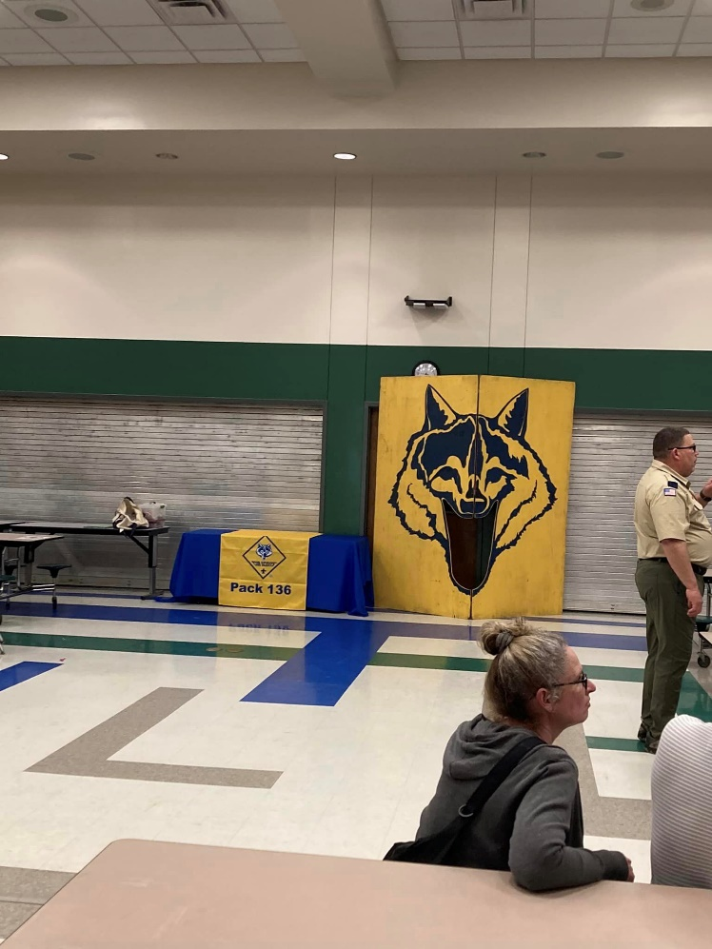
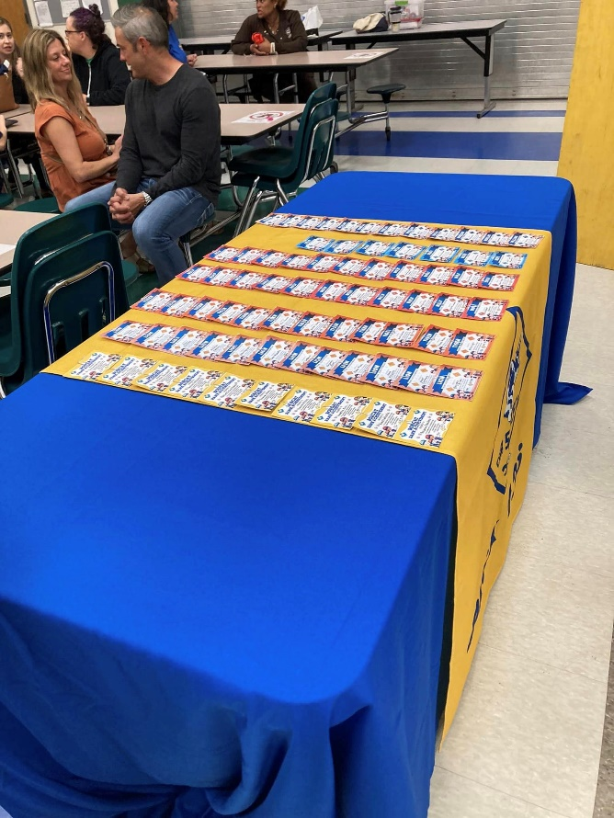

Scout Songs

Little Green Frog Song

Lyrics:
Eee Ah went the little green frog one day
Eee Ah went the little green frog.
Eee Ah went the little green frog one day
His eyes went Eee and Ah.
Honk, Honk, went the big blue bus one day
Squish, Squash, went the little green frog.
His eyes don't go Eee Ah any more
'Cause he got eaten up by a dog. Woof! Woof!

Boom Chicka Boom Song

The Tune: view video
There are always new verses being thought up - please email me with yours Here
Lyrics:
(repeat each line after song leader)
I said a Boom Chicka Boom
I said a Boom Chicka Boom
I said a Boom Chicka Rocka Chicka Rocka Chicka Boom
Uh huh
Oh yeah
One more time ______ style.
Janitor Style:
I said a Broom Sweep-a Broom
I said a Broom Sweep-a Broom
I said a Broom Sweep-a Mop-a Sweep-a Mop-a Sweep-a Broom
Valley Girl Style:
I said like boom chicka boom
I said a totally boom chicka boom
I said like boom chicka like rocka chicka like gag me with a spoon
Baseball Style:
I said a boom chicka boom
I said a boom chicka boom
I said a boom chicka rocka hit that softball to the moon.
Barn-yard Style:
I said a moo chicka moo
I said a moo chicka moo
I said a moo chicka watch your step, don't track it in the room.
Race Car Style:
I said a vroom shifta vroom
I said a vroom shifta vroom
I said a vroom shifta grind-a shifta grind-a shifta vroom
Astronaut Style:
I said a moon shoot the moon
I said a moon shoot the moon
I said a moon blast-me shoot-me blast-me shoot-me-to-the-moon
Flower Style:
I said a bloom chicka bloom
I said a bloom chicka bloom
I said a bloom chicka blossom smell those flowers chicka bloom
Parent Style:
I said a boom GO TO YOUR ROOM
I said a boom GO TO YOUR ROOM
I said a boom GO TO YOUR ROOM and don't come out 'til next June.
Cheerleader Style:
I said a Boom-Go-Fight-Boom
I said a Boom-Go-Fight-Boom
I said a Boom Go-Fight-Win Go-Fight-Win Go-Fight-Boom
Taco Bell Style:
I said a bean chicka bean
I said a bean chicka bean
I said a bean and cheese burrito and a nacho supreme.

Don't Wear No Socks Song

The Tune: view video
Lyrics:
(Instead of "Your Momma", you could use "Camp Staff", "Boy Scouts", "Our Gang", ... whatever you want)
Your Mama don't wear no socks
A ding dong
I saw 'em when she took 'em off
A ding dong
She threw them in the tree
A ding dong
Now the dogs refuse to pee
A ding dong dong dong dong
A ding dong dong dong dong
A ding dong
She threw them in the lake - the fish began to regurgitate.
She threw them on my bed - now my poor Teddy's dead
She threw them in her bed - now dad sleeps in the shed
She threw them under the bed - left all the cockroaches dead
She served them up for lunch - but no one wanted much
She put them in the fridge - now we all live under a bridge
She threw them in the sky - now Superman refuses to fly
She threw them in the air - now Superman's on medicare
She threw them over the fence - haven't seen the neighbor since
She threw them on the wall - now Spiderman won't crawl
She threw them on the ceiling - now the paint's all peeling
She threw them in a boat - now that boat can't float
She threw them at the cat - now the cat's a welcome mat
She threw them on the clock - now the clock don't tick or tock
She threw them up towards heaven - brought down a 7-4-7
She threw them in the garbage can - killed 3 rats and the garbage man
She threw them in the washing machine - now all the clothes are green
She threw them at a squirrel - made that poor squirrel hurl
She threw them at a rock - that rock got up and walked
She threw them at a bus - you should have heard it cuss
She threw them at a flower - now it's praying for an April shower
She threw them in the fire - that made the fire expire
She threw them in my Coke - I took a sip and nearly croaked.
She threw them at the sun - Made the sun dial 911
She threw them on a telephone wire - Started the Chicago fire
She threw them in a hole - Wouldn't touch 'em with a 10 foot pole
She thew them in outer space - That's the end of the human race
She threw them at King Kong - That's the end of this silly song

I Met a Bear Song

This Song is meant for Scouts BSA.
Decide for yourself if it is appropriate for your younger scouts or not.
Audience repeats each short line after the leader, then everyone sings the whole verse together.
Lyrics:
The other day,
I met a bear,
Out in the woods,
away out there. [Point]
everyone: The other day, I met a bear. Out in the woods, away out there.
He looked at me,
I looked at him,
He sized up me,
I sized up him.
everyone: He looked at me, I looked at him. He sized up me, I sized up him.
He says to me,
'Why don't you run?'
'Cause I can see,
you got no gun.'
everyone: He says to me, 'Why don't you run?' 'Cause I can see you got no gun.'
I says to him,
'That's a good idea.'
'Now legs get going,
get me out of here!'
I began to run,
away from there,
But right behind
me was that bear.
And on the path
ahead of me,
I saw a tree,
Oh glory be.
The lowest branch
was ten feet up,
I'd have to jump
and trust my luck.
And so I jumped
into the air,
But I missed that branch
away up there.
Now don't you fret,
and don't you frown,
I caught that branch
on the way back down.
That's all there is,
there ain't no more,
Unless I meet
that bear once more.

Ain't No Bugs on Me Song
Lyrics:
Oh, there ain't no bugs on me, on me.
There ain't no bugs on me
There may be bugs on some of you mugs
But there ain't no bugs on me.
Oh there ain't no flies on me, on me.
There ain't no flies on me.
There may be flies on some of you guys
But there ain't no flies on me.
Well, the Juney bug comes in the month of June
The lightning bug comes in May
Bed bug comes just any old time
But, they're not going to stay
Well, a bull frog sittin' on a lily pad
Looking up at the sky
The lily pad broke and the frog fell in
He got water all in his eye.
There ain't no frogs on us.
There ain't no frogs on us.
There might be frogs on some of you dogs,
But there ain't no frogs on us.
Mosquito he fly high
Mosquito he fly low
If old mosquito lands on me
He ain't a gonna fly no mo'
A peanut sittin' on a railroad track
His heart was all a flutter
Along come a choo-choo on the track
Toot! Toot! Peanut butter!
A cow walked on the railroad track,
the train was coming fast.
The train got off the railroad track
to let the cow go past!
As I went walking through the woods
Humming a tune so gaily
The wind come whistling through the trees
And froze my ukelele
Oh there ain't no lobsters on me
There, ain't no lobsters on me
There may be lobsters On some of you mobsters
But there ain't no lobsters on me.
Oh it ain't gonna rain no more no more
It ain't gonna rain no more
How in the heck can I wash my neck
When it ain't gonna rain no more?
Well little bugs have littler bugs.
Up on their backs to bite'em
And the littler bugs have still littler bugs
And so ad infinitum.
We had a cat down on our farm
It had a ball of yarn
When those little cats were born
They all had sweaters on
She lay down by the sewer
And by the sewer she died
And at the coroner's inquest
They called it sewer side
We had a goat down on our farm
It ate up old tin cans
When those little goats were born
They came in Ford sedans
Some people say that fleas are black
But I know that ain't so
'Cause Marry had a little lamb
Whose fleece was white as snow
Mary had a little lamb,
so goes the tale of yore.
She loved that little lamb so much,
she passed the plate for more.
I woke up in the morning,
I glanced upon the wall.
The roaches and the bedbugs
were having a game of ball.
The score was six to nothing,
the roaches were ahead.
A bedbug hit a home run
and knocked me out of bed!
The chamber maid came to my bed
Get up you lazy sinner
We need the sheets for table cloths
And it's almost time for dinner
Jack and Jill went up the hill
To try out Jack's new flivver
The car broke down a mile from town
And dumped them in the river.
A doctor fell into a well
and broke his collar bone.
We think that he should tend the sick
and leave the well alone.
A farmer slipped on the old barn roof
when rotten boards gave way,
And as as he fell, he shrugged and said,
'It's time to hit the hay.'
Humpty Dumpty fell right down
and landed on his head,
So, all the horses and the men
had scrambled eggs and bread.

My Country Tis of Thee
Lyrics:
My country, 'tis of thee,
Sweet land of liberty,
Of thee I sing;
Land where my fathers died,
Land of the pilgrims' pride,
From ev'ry mountainside
Let freedom ring.
My native country, thee,
Land of the noble free,
Thy name I love;
I love thy rocks and rills,
Thy woods and templed hills,
My heart with rapture thrills
Like that above.
Let music swell the breeze,
And ring from all the trees,
Sweet freedom's song;
Let mortal tongues awake,
Let all that breathes partake,
Let rocks for silence break,
The sound prolong.
Our fathers' God to Thee,
Author of liberty
To thee we sing;
Long may our land be bright,
With freedom's holy light,
Protect us by thy might,
Great God, our King.

America, the Beautiful Song

Lyrics:
O beautiful for spacious skies,
For amber waves of grain,
For purple mountain majesties
Above the fruited plain!
America! America!
God shed his grace on thee
And crown thy good with brotherhood
From sea to shining sea!
O beautiful for pilgrim feet
Whose stern impassioned stress
A thoroughfare for freedom beat
Across the wilderness!
America! America!
God mend thine every flaw,
Confirm thy soul in self-control,
Thy liberty in law!
O beautiful for heroes proved
In liberating strife.
Who more than self the country loved
And mercy more than life!
America! America!
May God thy gold refine
Till all success be nobleness
And every gain divine!
O beautiful for patriot dream
That sees beyond the years
Thine alabaster cities gleam
Undimmed by human tears!
America! America!
God shed his grace on thee
And crown thy good with brotherhood
From sea to shining sea!
O beautiful for halcyon skies,
For amber waves of grain,
For purple mountain majesties
Above the enameled plain!
America! America!
God shed his grace on thee
Till souls wax fair as earth and air
And music-hearted sea!
O beautiful for pilgrims feet,
Whose stem impassioned stress
A thoroughfare for freedom beat
Across the wilderness!
America! America!
God shed his grace on thee
Till paths be wrought through
wilds of thought
By pilgrim foot and knee!
O beautiful for glory-tale
Of liberating strife
When once and twice,
for man's avail
Men lavished precious life!
America! America!
God shed his grace on thee
Till selfish gain no longer stain
The banner of the free!
O beautiful for patriot dream
That sees beyond the years
Thine alabaster cities gleam
Undimmed by human tears!
America! America!
God shed his grace on thee
Till nobler men keep once again
Thy whiter jubilee!

Announcements Song

Lyrics:
Announcements, announcements, announcements!
What a terrible way to die,
A terrible way to die,
A terrible way to be talked to death.
A terrible way to die.
Announcements, announcements, announcements!
(London Bridge)
Make the announcements short and sweet,
Short and sweet,
Short and sweet.
Make the announcements short and sweet,
They're so BORING!
Announcements, announcements, announcements!
(Ever Seen a Windmill)
Have you ever seen a windbag,
A windbag, a windbag?
Have you ever seen a windbag?
Well, there's one right now.
Swings this way and that way,
And this way and that way,
Have you ever seen a windbag?
Well there's one RIGHT NOW!
Announcements, announcements, announcements!
(Freres Jaques)
Words of wisdom,
Words of wisdom.
Here they come,
Here they come.
Boring words of wisdom,
Boring words of wisdom.
Dum, dum, dum,
Dum, dum, dum.
Announcements, announcements, announcements!
(What Do You Do With A Drunken Sailor)
What do you do with a loud Cubmaster?
What do you do with a loud Cubmaster?
What do you do with a loud Cubmaster,
Early in the evening?
Hit him in the face with a chocolate cream pie!
Hit him in the face with a chocolate cream pie!
Hit him in the face with a chocolate cream pie,
Early in the evening!
Announcements, announcements, announcements!
Row, row, row your boat
Gently down the stream
Throw the announcements overboard and listen to them scream.
Row, row, row your boat
Gently down the stream.
Ha Ha! Fooled you,
I'm a submarine.
Announcements, announcements, announcements!
(Grand Old Duke of York)
The man stood up to talk.
He talked real long and hard.
He talked so long I wrote this song,
On the lid of a can of lard!
He's got something to say.
I'm sure it must be good.
But if he talks too long today,
we'll leave its understood.
Announcements, announcements, announcements!
We've got a silly cheer,
That you've just got to hear!
It makes no sense we're sure you know,
The announcements have to GO!

Back to Gilwell Song

This Song is meant for Scouts BSA.
Decide for yourself if it is appropriate for your younger scouts or not.
The Wood Badge song.
The Tune: Your browser does not support the audio element.
Lyrics:
I used to be a Beaver, and a good ol' Beaver too,
But now I've finished Beaver-ing,
I don't know what to do,
I'm growing old and feeble,
And I can Beaver no more,
So I'm going to work my ticket if I can.
Chorus:
Back to Gilwell, happy land;
I'm going to work my ticket if I can.
Verses:
I used to be a Bobwhite
I used to be an Eagle
I used to be a Fox
I used to be an Owl
I used to be a Bear
I used to be a Buffalo
I used to be an Antelope
I used to be a Staffer

Be a Good Scout Song

Deanna Durbin sang this in the 1938 movie "That Certain Age".
Lyrics:
Be a good Scout, and always wear a smile,
Be a good Scout, be cheerful all the while,
It's the creed, yes indeed, that a Scout must practice gaily.
Help those in need - do a Good Turn daily,
Be a good Scout - be Loyal, Clean and Brave,
Never say die, just let your banner wave,
On your honor, do your best
When they put you to the test.
And always be a good scout.

God Bless America

Lyrics:
God bless America, land that I love.
Stand beside her, and guide her,
Through the night, with a light from above.
From the mountains, to the prairies,
To the oceans, white with foam.
God bless America, my home sweet home.
God bless America, my home sweet hom

God Bless My Underwear

Lyrics:
God bless my underwear, my only pair.
Stand beside them, and guide them,
Through the rips, through the holes, through the tears.
From the washer, to the dryer, to my backpack, to my rear.
God bless my underwear, my only pair.
God bless my underwear, or I'll be bare.
God bless my underwear
That I wear down there.
I outgrow them, then throw them,
Those who wear them will never be square
When the bully, gives a wedgie
Pray that they won't ever tear
God bless my underwear, my only pair.
God bless my underwear, or I'll need to share.

How I Hate to Get Up in the Morning Song

This Song is meant for Scouts BSA.
Decide for yourself if it is appropriate for your younger scouts or not.
Lyrics:
The other day I chanced to meet a camping friend of mine.
He'd been in camp for several weeks and he was looking fine.
His muscles had developed and his cheeks were rosy red.
I asked him how he liked the camp, and this is what he said:
Oh, how I hate to get up in the morning.
Oh, how I'd love to remain in bed.
For the hardest blow of all,
Is to hear the bugler call;
You've got to get up,
You've got to get up,
You've got to get up this morning.
Someday I'm going to murder the bugler.
Someday they're going to find him dead.
I'll amputate his reveille
and stomp upon it heavily,
And spend the rest of my life in bed!
A bugler at camp is the luckiest of men.
He wakes the boys at five and then goes back to bed again.
He doesn't have to blow again until the afternoon.
If everything goes well with me, I'll be a bugler soon!
Oh, how I hate to get up in the morning.
Oh, how I'd love to remain in bed.
For the hardest blow of all,
Is to hear the bugler call;
You've got to get up,
You've got to get up,
You've got to get up this morning.
Someday I'm going to murder the bugler.
Someday they're going to find him dead.
I'll amputate his reveille
and stomp upon it heavily,
And spend the rest of my life in bed!

Scout Vespers Song

Lyrics:
Softly falls the light of day,
As our campfire fades away.
Silently, each Scout should ask
Have I done my daily task?
Have I kept my honor bright?
Can I guiltless sleep tonight?
Oh, have I done and have I dared
Everything to be prepared?
Listen Lord, O Listen Lord,
as I whisper soft and low.
Bless my Mom and bless my Dad,
there is something they ought to know.
I will keep my honor bright,
the Oath and Law will be my guide.
And Mom and Dad this you should know,
deep in my heart I love you so.
Quietly we join as one,
Thanking God for Scouting fun,
May we now go on our way.
Thankful for another day.
May we always love and share,
Living in peace beyond compare,
As Scouts may we find,
Friendships true with all mankind.
Quietly we now will part,
Pledging ever in our heart,
To strive to do our best each day,
As we travel down life's way.
Happiness we'll try to give,
Trying a better life to live,
Till all the world
Be joined in love,
Living in peace under skies above.
As the night comes to this land,
On my promise I will stand,
I will help the pack to go,
As our pack helps me to grow.
Yes, I'll always give good will,
I'll follow my Akela still.
And before I stop to rest,
I will do my very best.

Scout WETspers Song
Lyrics:
Softly falls the rain today
As our campsite floats away.
Silently, each Scout should ask
Did I bring my SCUBA mask?
Have I tied my tent flaps down,
Learned to swim so I won't drown,
Oh, have I done, and will I try
Everything to keep me dry?

Grand Old Duke of York

Lyrics
Oh, the grand old Duke of York
He had ten thousand men
He marched them up to the top of the hill
And he marched them down again
And when they were up, they were up
And when they were down, they were down
And when they were only half-way up
They were neither up nor down
Oh, the grand old Duke of York
He had ten thousand men
He marched them up to the top of the hill
And he marched them down again
And when they were up, they were up
And when they were down, they were down
And when they were only half-way up
They were neither up nor down
Oh, the grand old Duke of York
He had ten thousand men
He marched them up to the top of the hill
And he marched them down again
And when they were up, they were up
And when they were down, they were down
And when they were only half-way up
They were neither up nor down

Pack Resources List

- St. George School Office - 225-293-1298
  - Dragon Tales Contact - Charlene Lauman Charlene.Lauman@sgschoolbr.org
  - To request permission for events at the school - Angele Fontenot Angele.Fontenot@sgschoolbr.org
  - Principal - Jack Nelson Jack.Nelson@sgschoolbr.org
- St. George Church Office - 225-293-2212
  - Booking Rooms for Events - Missy Gregoire missyg@st-george.org
  - Pastor - Father Paul Yi paulyi@st-george.org
- Istrouma Area Council of the Boy Scout of America Office - 225-926-2697
http://www.iac-bsa.org/
  - 9644 Brookline Ave., Baton Rouge, LA 70809
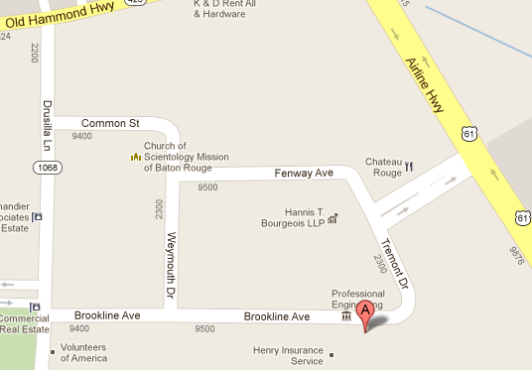
  - Sewell Eagle District Representative – David “Jason” Morrill
  - Scout Shop - 225-925-8465 - Hours: Monday – Friday: 9:00 AM to 6:00 PM and Saturday: 10:00 AM to 4:00 PM
St. George Fire Protection District - 225-454-6550
  - Eldon Ledoux - 225-454-6573
- East Baton Rouge Sheriff’s Office
  - Randy Aguillard - 225-907-0353 raguillard@ebrso.org
- Crown Trophy - 225-293-6520
  - 5140 South Sherwood Forest Blvd., Baton Rouge, LA 70816
- Skate Galaxy - 225-756-2424
  - 12828 Jefferson Hwy., Baton Rouge, LA 70816
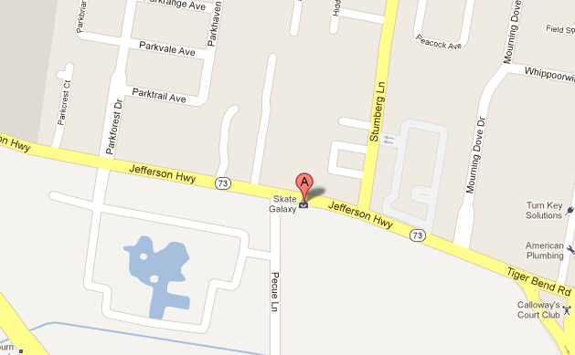
- USS Kidd - (225) 342-1942
  - 305 South River Road Baton Rouge, LA 70802
  - https://www.usskidd.com/plan-your-visit/overnight-camping/

Appendix 1: Pack Handbook

Basic Scout Definitions


Cub Scout
A boy or girl who is in grades 1 – 5 or who is 6 – 11 years of age and is registered with the Boy Scouts of America. He is part of a Den within a Pack.

Scout BSA
A boy or girl who is in grades 6 – 12 or who is 11 – 18 years of age and is registered with the Boy Scouts of America. He is part of a Patrol within a Troop.

Pack
The pack is the main unit in Cub Scouting. Our pack is chartered by St. George Catholic Church in Baton Rouge. We mainly serve boys and girls attending St. George School, however, we also have some scouts from the surrounding communities.

Den
The den is a group of scouts in the same level of Scouting. They are usually in the same grade. We may have more than one den of scouts in a grade level or rank. Dens may be all-girl or all-boy dens.
At this time, there are not enough girls involved in our Cub Scout Pack to have all-girl dens for each rank. Girls may either work independently with their parents on their rank level and attend all Pack events and meetings, or work with an existing den with boys. Parents should attend all Den and Pack functions with their scout.

Cub Scout Organization

Cubmaster
The Cubmaster is responsible for the program that is delivered to the scouts either through the Dens or the Pack Meeting. The Cubmaster is the MC of the Pack meetings and at other Pack activities and outings.

Assistant Cubmaster
The Assistant Cubmaster helps the Cubmaster plan and implement the program for the scouts. The Assistant Cubmaster fills in for the Cubmaster if he is not available.

Treasurer
The Treasurer is responsible for the finances of the Pack including tracking the Dues and Fees received and money distributed to the Den Leaders. The Treasurer also supplies a monthly financial status at the committee meetings.

Advancement Chairperson
The Advancement Coordinator is in charge of tracking and purchasing awards and advancement insignia for the entire pack. The Advancement Coordinator also assists in presenting the awards at the Pack Meeting

Event Chairpersons
The Chairperson of an event is in charge of the planning and execution of a pack activity. They usually have a number of parent volunteers on their event committee. They report to the Committee on the plans prior to the event and with a summary after the event. Some events that have chairpersons are the Skate Night, Fall and Spring Campouts, Blue & Gold, and Pinewood Derby.

Den
This is a smaller group of scouts within the Pack. They generally meet twice a month in weeks other than the week of a pack meeting or special activity. The Den is lead by an adult Den Leader and one or more Assistant Den Leaders. Some dens also have a Den Chief and/or Denner.

Den Leader/Assistant Den Leader
Adult responsible for the planning and implementing of den meetings and outings, tracking advancements of the scouts within the den, and assisting the scout/parent team in achieving Scout rank requirements.

Den Chief
A registered Scout who is at least 11 years old. The Den Chief assists the Den Leader(s) at the weekly den meetings.

Denner
A Cub Scout member of the Den who helps the Den Leader(s) by taking attendance or other assigned duties during a den meeting. The job of denner should rotate at regular intervals to allow different scouts the leadership opportunity.

Responsibilities

Pack
The pack will:
- Provide regular meetings, activities, and outings for scouts and their families.
- Communicate regularly with families regarding upcoming pack events.
- Recruit parents and other adults to help with the dens.
- Provide training and support for committee members and event chairpersons.
- Purchase rank advancements and awards.
- Maintain a working relationship with our Chartered organization, St. George Church.
- Coordinate with Scout troops for Den Chiefs and crossover ceremonies.

Den
The den will:
- Provide a fun, safe environment for the scouts.
- Schedule regular meetings and secure the meeting location.
- Participate in Pack functions.
- Communicate regularly with families regarding upcoming pack events and den activities.
- Track each scout’s rank advancement and attendance in ScoutBook to ensure that the scout is properly recognized.

Parent
The parent(s) will:
- Provide transportation to/from den meetings for their scout.
- Ensure that their scout is on time for Scout meetings or activities.
- Attend pack meetings/functions with their scout.
- Review the Child Protection Guide found in each scout’s handbook. This should be completed each year, as there are different activities for each level.
- Provide encouragement and help for the scout to complete rank requirements.
- Verify in writing that rank requirements have been completed. This can be done by signing and dating the scout’s handbook when a requirement is complete.
- Pay the scout’s Fees and Dues on time.
- Support the pack by volunteering to help with at least one pack meeting or function, or by becoming a member of the committee.
- Support the den leader(s) by helping with the den as needed.

Cub Scout
The Cub Scout will:
- Follow the Scout Law.
- Respect other Scouts and their property.
- Respect the den leader(s) and others who are helping with the den.
- Work toward their rank requirements.
- Attend all den and pack meetings and activities.
- Bring his handbook to every den meeting.

Meetings & Activities

Registration
At the beginning of each school year, the pack collects registration fee of $50 from each scout participating in the pack. This fee covers registering your scout with the Istrouma Council and pack expenses. We have a pack t-shirt which costs $10. You also have the option to purchase a subscription to Boy’s Life Magazine for $12.

Pack Fees
The pack fees are used to purchase awards, advancements, and recognitions for the scouts in the pack, as well as pay for pack camping equipment, food, and materials, etc. supplied by the pack for events during the year. This does not include belt loops not earned at Pack sponsored events.

Den Dues
Dens may elect to collect dues each week to use for purchasing snacks, supplies, and paying for any outings, etc. The den may decide to operate on a pay-as-you-go plan instead of collecting dues.

Fund Raising
To fund the programs of the pack without charging more fees to parents, the pack participates in one key fund raising activity.

Popcorn
Each fall the Council sponsors a popcorn sale. Over 30% of the total sales price is kept as profit for the pack.
The Scouts will take orders for popcorn beginning in September and the popcorn will be delivered in October or November.
Each den will have a popcorn coordinator who will schedule and coordinate store sales and popcorn for their den. This person will also be a member of the pack popcorn committee.
The pack sets a goal of $200 in popcorn sales per scout

Crossing over to Scouts

Children nearing the end of 5th grade who wish to continue in Scouts will cross over to a Scout troop at the January or February pack meeting. Our Pack generally feeds into our Troop 136 and Troop 1136, but there are several area Scout troops to choose from. They have different leadership styles, types of activities, and time commitments. The scout and his parents should visit several different troops to find the troop that best matches their personal preferences.

Uniform

Only official insignia can be put on the Scout uniforms. Please refer to the insignia placement guide for the correct placement of official insignia.
Patches from events may be worn on the right shirt pocket below the button on a temporary basis. Special patch vests can be worn to display special patches from past events or places visited.
*Uniforms may be worn to school at St. George on days of Pack meetings.

Unit Numerals
Our unit numerals are 136. See the Cub Scout and Webelos Scout Insignia portion of this document to determine where the various numerals and patches are to be sewn onto the uniform. This information is also available on our website.

Required Elements

Lion
Official Blue Lion Scout T-shirt
Official Yellow neckerchief with slide (optional)
Lion Scout Hat (optional, pawprints front panel)
Cub Scout Belt (optional, but recommended to hold sports & academics belt loops)
Khaki school pants or shorts (do not have to be Scout issued)

Tiger
Official Blue Cub Scout shirt with proper insignia
Official orange neckerchief with slide
Cub Scout Hat (optional, orange front panel)
Cub Scout Belt (optional, but recommended to hold sports & academics belt loops)
Khaki school pants or shorts (do not have to be Scout issued)

Wolf
Official Blue Cub Scout shirt with proper insignia
Official Red neckerchief with slide
Cub Scout Hat (optional, red front panel)
Cub Scout Belt (optional, but recommended to hold sports & academics belt loops)
Khaki school pants or shorts (do not have to be Scout issued)

Bear
Official Blue Cub Scout shirt with proper insignia
Official neckerchief (Yellow-Wolf; Blue-Bear) with slide
Cub Scout Hat (optional, blue front panel)
Cub Scout Belt (optional, but recommended to hold sports & academics belt loops)
Khaki school pants or shorts (do not have to be Scout issued)

Webelos
Official Blue Cub Scout shirt with proper insignia
Official plaid neckerchief with slide
Webelos Hat (optional, plaid front panel)
Scout Belt in color to match shirt (optional, but recommended to hold sports & academics belt loops)
Blue pants (do not have to be Scout issued)

Arrow of Light
Official Tan Scout shirt with proper Cub Scout insignia
Official plaid neckerchief with slide
Webelos Hat (optional, plaid front panel)
Scout Belt in color to match shirt (optional, but recommended to hold sports & academics belt loops)
Olive pants (do not have to be Scout issued)

Pack Code of Conduct
- Don't interrupt
- No nasty jokes
- No punching or kicking
- Listen to Akela and don't talk back
- No cussing
- Don't stick your tongue out or spit
- No talking ugly about other people

Consequences

“Three Strikes and You’re Out”
- The first time a scout breaks a rule, they get a warning.
- The second time, the scout spends 5 minutes in Time Out. (Time Out is an interruption of a child's unacceptable behavior, by removing them from the scene of the action.) A chair off to the side, out of the activity of the den meeting, can serve as the Time Out area. After 5 minutes the scout is asked if they are ready to return to the group. If a scout doesn't control himself in Time Out, he moves on to his third strike.
- When a Cub commits his third infraction of the Code of Conduct, he is excused from the meeting and must call a parent to come and get him. Have a conference with the scout and at least one parent before he can return to the next den meeting. Be sure to explain the Den's Code of Conduct and the consequences of breaking the rules to the parents of scouts in your den at each of our den parents meetings.
With enforcing each scout will have a parent present at all meetings and events the parent should step in and correct their own child when they become disruptive. BSA does not stand for Baby Sitters of America.

Appendix 3: Informational Links

- BSA Website - http://www.scouting.org/
- My.Scouting - https://my.scouting.org/
- Istrouma Area Council Website - http://www.iac-bsa.org/
- Scouting Resources - http://www.macscouter.com/
- US Scouting Service Project - http://usscouts.org/
- Boy Scout Trail - http://www.boyscouttrail.com/
- Scouter Forums - http://www.scouter.com/
- Merit Badge Info - http://meritbadge.org/wiki/index.php/Main_Page
- Boy’s Life Magazine - http://boyslife.org/
- Scouting Magazine - http://scoutingmagazine.org/
- Den and Pack Meeting Resource Guide - http://www.scouting.org/scoutsource/CubScouts/Leaders/DenLeaderResources/DenandPackMeetingResourceGuide.aspx
- Den Leader Resources - http://www.scouting.org/scoutsource/CubScouts/resources/TheNewCubScoutDenLeaderKit.aspx
- The Insane Scouter - http://insanescouter.org/
- Bryan on Scouting - https://blog.scoutingmagazine.org/
- Scouter Mom - https://scoutermom.com/
- Pinterest - https://www.pinterest.com/
- Pack Website https://scoutpack136.com/
- Troops Website https://scoutsbsastgeorge.wordpress.com/

Appendix 4: Pack Meeting Agenda
Pack Meeting Agenda

GATHERING: (activity for children, game, craft)
OPENING:
Pledge
Oath
Law
Invocation: (nondenominational)

WELCOME:

Welcome families, guests, scouts, leaders and special guest.

ENTERTAINMENT: Run on skit or song or game

ANNOUNCEMENTS: (have a print handout)
            - Most immediate upcoming event
            - Dues or payments due
            - Actions that still need to be taken
RECOGNITION:
Read out names of scouts who earned an achievement or award in past month, or hand our ranks at end of year.

SPECIAL GUEST :

CUBMASTER’S MINUTE:

- Speak briefly on a point of the Scout Law, Oath, or what it means to be a scout and how other scouts are living this somewhere in the world.

CLOSING – Vespers or some other song

Appendix 5: Campfire Program

Scouts and campfire programs are a timeless combination. While they are historically linked to Cub and Boy Scouts of America troops, Girl Scout troops have become more involved in planning campfire programs and enjoying the benefits. Whether performing, helping in the background, or just watching, campfire programs offer Scouts of all ages the opportunity to get involved, express themselves, and learn a bit more about their peers and themselves.

Elements of a Campfire Program
A campfire program is a gathering of Scouts, troop leaders, and family members for fun and fellowship. Despite its name, it doesn't have to take place at night, nor does it have to include an actual fire.
A successful campfire program includes four key elements:
- Showmanship: Great opening and closing ceremonies add some flair to your event and can include a creative way to light the campfire (if you're using one).
- Songs: Sing all kinds of songs, from silly Scouting songs to the National Anthem.
- Stories: Whether they're funny or scary, stories are a vital part of campfires.
- Stunts: Both pre-planned and improvised skits work great as stunts; invite some audience participation to make things really interesting.

Benefits
There are numerous benefits to holding a campfire program. It gives every Scout the opportunity to participate in a group activity and potentially discovers a new interest or talent. Even if they don't want to perform, they can be given a behind-the-scenes role, such as managing the props or holding the microphone for the Scouts with speaking parts.
Campfire programs give Scouts a forum to practice their public speaking skills. Whether they are memorizing lines or ad-libbing, they will be learning how to speak in front of a group, which is a skill that will serve them well in adulthood.
Scouts also have the chance to tap into their creativity as they plan their contribution to the campfire program. Some may want to strictly follow a pre-existing script for a skit or read a favorite story, but others will want to add their own personal touches in creating original writings and/or performing something they make up themselves.

Whether outgoing or shy, there's a role for every Scout in a campfire program, so encourage everyone to get involved.

"Follow the Flames"
A good campfire program lasts about 45 to 60 minutes. This is long enough to keep everyone's attention, but not so long that the Scouts become restless. As the campfire starts to die down, so should the action. When the fire is first blazing, have high energy activities. As it starts to wind down, do slower songs and stories.
Though a fire isn't necessary, having one is helpful as "following the flames" can help you pace things. When the campfire flame is high, there should be lots of energy in your campfire; this is the best time for your audience participation songs and skits. As the fire burns down, the mood should come down, too. Slower songs, calmer stories, and a short inspirational leader "minute" talk will wind down the campfire and naturally bring the event to a close.

Planning
To have a memorable and enjoyable campfire program, it is imperative that you plan it in advance. Prior planning will help ensure that your program runs smoothly and that everyone can be ready for their turn on the campfire stage. The Boy Scouts of America's website says, “Be sure that every feature of this campfire program upholds Scouting’s highest traditions.”
There are some skit topics that fall into a "gray area" where leaders should use their judgment about the appropriateness of the skit, like avoiding "potty humor" that many young children are fond of. Scout leaders should think about whether the skit will uphold the Boy Scouts of America's Scout Oath and Law or the Girl Scout Promise and Law.

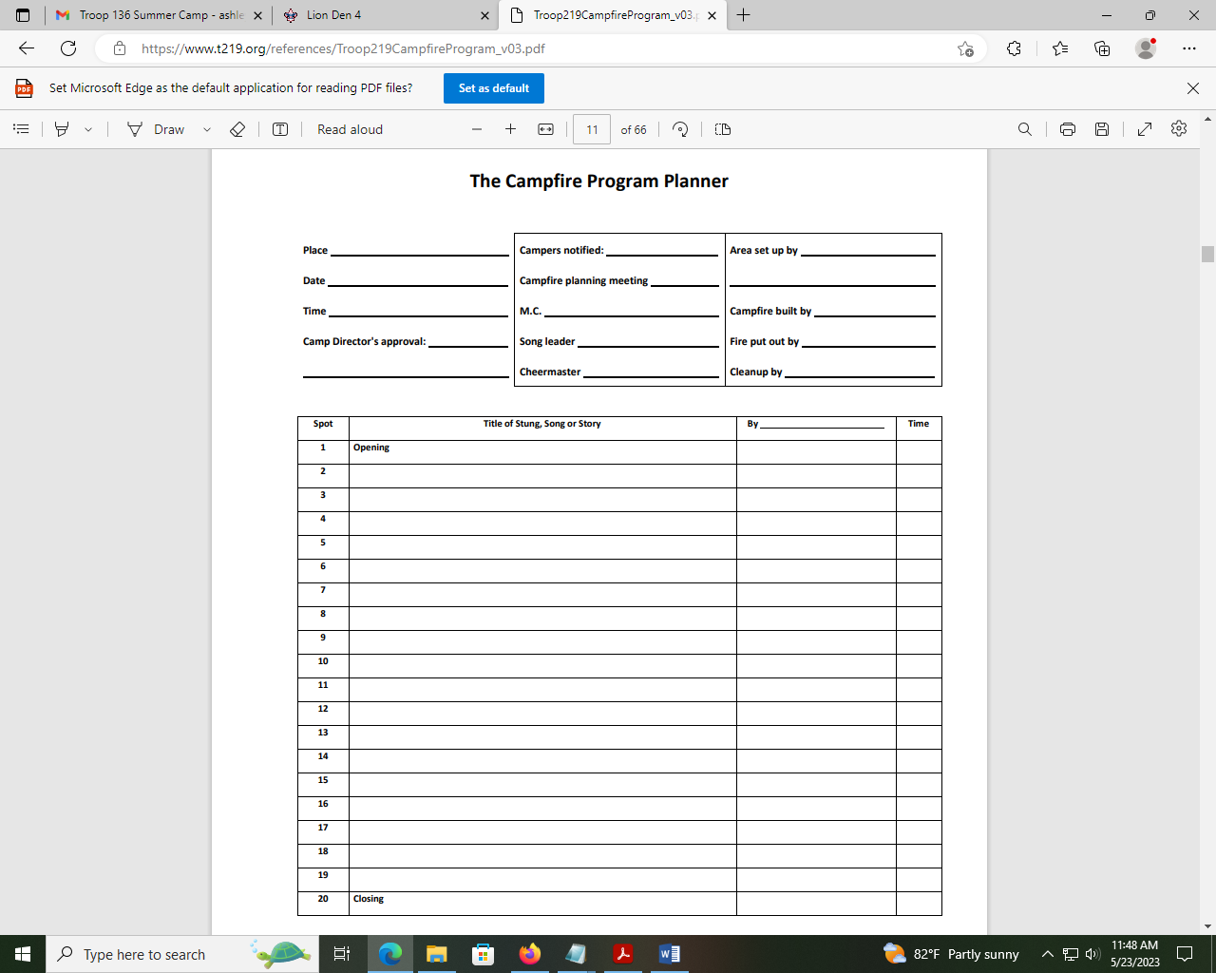

Stories

Gloop Maker
https://www.campingdude.com/content/story/gloop_maker-1096.asp

The Vinder Viper
https://www.boyscouttrail.com/content/story/vinder_viper-128.asp

The Ghost of the Bloody Finger
https://www.thecampingfamily.com/short-campfire-ghost-stories.html

The Ghost of Able Fable
https://www.boyscouttrail.com/content/story/ghost_of_able_fable-1068.asp

The Purple Gorilla
https://www.campingdude.com/content/story/purple_gorilla-1454.asp

The Chicken in the Library
A librarian is working away at her desk when she notices that a chicken has come into the library and is patiently waiting in front of the desk. When the chicken sees that it has the librarian's attention, it squawks, "Book, book, book, BOOK!"The librarian complies, putting a couple of books down in front of the chicken. The chicken quickly grabs them and disappears.
The next day, the librarian is again disturbed by the same chicken, who puts the previous day's pile of books down on the desk and again squawks, "Book, book, book, BOOK!"
The librarian shakes her head, wondering what the chicken is doing with these books, but eventually finds some more books for the chicken. The chicken disappears.
The next day, the librarian is once again disturbed by the chicken, who squawks (in a rather irritated fashion, it seems), "Book, book, book, BOOK!" By now, the librarian's curiosity has
gotten the better of her, so she gets a pile of books for the chicken, and follows the bird when it leaves the library. She follows it through the parking lot, down the street for several blocks, and finally into a large park. The chicken disappears into a small grove of trees, and the librarian follows. On the other side of the trees is a small marsh. The chicken has stopped on the side of the marsh. The librarian, now really curious, hurries over and sees that there is a small frog next to the chicken, examining each book, one at a time. The librarian comes within earshot just in time to hear the frog saying, "Read it, read it, read it..."

Songs (for harmonica)

THIS OLD MAN

Song: | 6 5 6 6 5 6  This old man, he played ONE  -6 6 -5 5 -4 5 -5  He played nick nack on my THUMB  5 -5 6 4 4 4 4  With a nick nack, paddy wack  4 -4 5 -5 6  Give your dog a bone,  6 -4 -4 -5 5 -4 4  This old man came rolling home.  Other stanzas: TWO - SHOE  THREE - KNEE  FOUR - DOOR  FIVE - HIVE  SIX - STICKS  SEVEN - HEAVEN  EIGHT - GATE  NINE - SPINE  TEN - ONCE AGAIN

SHE’LL BE COMING AROUND THE MOUNTAIN
6 -6 7 7 7 7 -6 6
She'll be com-in' round the moun-tain
5 6 7
when she comes.
7 -8 8 8 8 8 9 8
She'll be com-in' round the moun-tain
-8 7 -8
when she comes.
9 -9 8 8 8 8 -8 7
She'll be com-in' round the moun-tain
7 7 -6 -6 -6 -6 -8 7
She'll be com-in' round the moun-tain
-7 -6 6 6 6 6 8 -8
She'll be com-in' round the moun-tain
-6 -7 7
when she comes.
She’ll be huffin’ and a-puffin’…
Oh, we’ll all come out to meet her …
She’ll be wearing pink pajamas…

TAPS
ong: | 3 3 4 3 4 5 3 4 5 3 4 5  Fad-ing light dims the sight, and a star gems the sky  3 4 5 4 5 6 5 4 3 3 3 4  gleaming bright, From a - far drawing nigh falls the night.

YOU ARE MY SUNSHINE
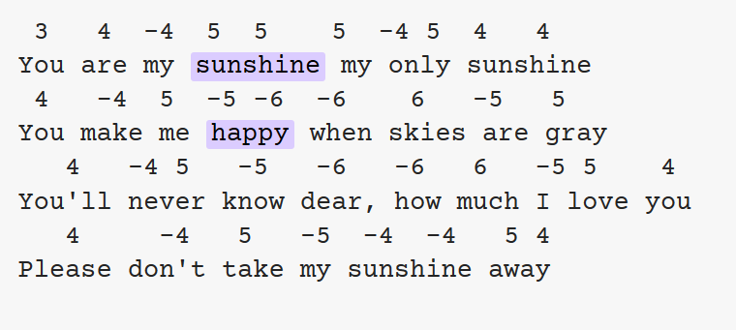

SCOUT VESPERS
Softly falls the light of day
As our campfire fades away
Silently each scout should ask
Have I done my daily task?
Have I kept my honor bright?
Can I guiltless sleep tonight?
Have I done and have I dared
Everything to Be Prepared?
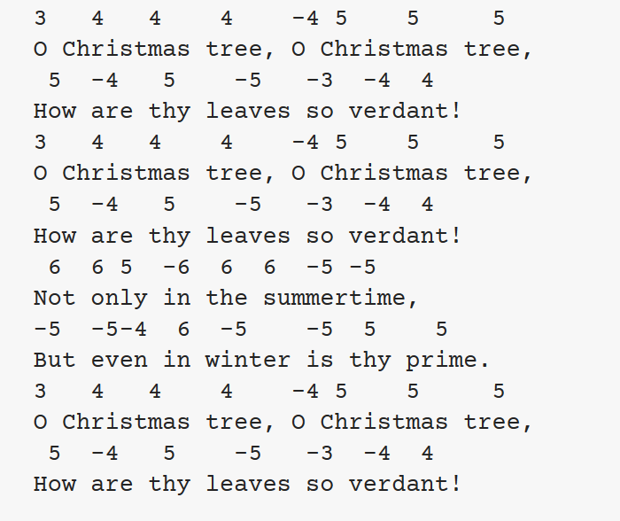

Appendix 6: Advancement Chair How-To
If you’ve recently taken on advancement for your pack, you’re finding out that it’s an important job, but be assured that it’s not overwhelming once you learn what’s involved. Advancement is one of the eight methods of Cub Scouting, and it is one of the most visible. Cub Scouts is all about fun, and while they’re having fun the boys are also doing things that lead to advancing in rank. It’s through advancement that the familiar symbols appear: rank badges, Progress through Ranks beads, arrow points and activity badges, as well as the supplemental awards such as Academics & Sports belt loops and pins.
Since kids like to receive recognition for the things they’ve earned, and since families like seeing their kids receive them, it’s important for the pack to make sure that they’re promptly awarded. This is where the pack advancement chair comes in.
If you’re new to Cub Scouting, here are the basics:
- All Cub Scouts must first earn the Bobcat badge indicating that they have completed the joining requirements. Diamond-shaped badges of rank are worn on the left pocket.
- First-graders work toward the Tiger Cub rank, earning Tiger Track beads (which attach to a tiger paw totem) along the way, and receive other beads for additional electives.
- Second and third-graders work toward Wolf and Bear ranks respectively. Every three requirements completed are marked by a Progress Toward Ranks bead (yellow for Wolf, red for Bear) worn on a totem from the right pocket. Electives completed past earning of the rank are marked by arrow points ironed on below the left pocket.
- Fourth-graders work toward the Webelos rank by earning Activity Badges (actually pins) worn on the Webelos Colors (a three-colored ribbon set that attaches to the sleeve). The oval Webelos badge replaces the diamond array of lower rank badges on the left pocket.
- Fifth-graders earn Arrow of Light, a badge worn on the left pocket flap as a Cub Scout which moves to below the pocket of the Boy Scout uniform – the only Cub Scout insignia worn in Boy Scouts.
- Cub Scouts of all ranks may earn “belt loops” (metal clips worn on the Cub Scout belt) and activity pins in the Academics and Sports program.
What do you do as a pack advancement chair? The official job description reads like this:
- Have a working knowledge of the Cub Scout advancement plan.
- Help plan and conduct induction and advancement recognition ceremonies, coordinating as needed with the Webelos den leader or Scoutmaster.
- Educate parents, guardians, and pack committee members in ways to stimulate Cub Scout advancement.
- Promote the use of Cub Scout den advancement charts and other tools to recognize and record advancement in the den.
- Collect den advancement reports at pack leaders meetings for use when ordering badges and insignia from the local council service center.
- Promote Scout Life magazine as an aid to advancement.
- Help build or obtain advancement equipment for use in making advancement ceremonies more effective.
- Promote the wearing and proper use of uniform and insignia.

MUST DO
- Be registered with the Council for the position which will give you authority to manage records in Scoutbook and the online databases.
- Read the Guide to Advancement specifically chapter 4, which deals with Cub Scout advancement.
- Watch the online training videos on my.scouting.org
- Keep track of Den advancements on paper and Scoutbook
- Compile an Advancement Report in Scoutbook in order to purchase rank patches.
- Advance everyone in Scoutbook in May
- Stay in touch with leaders weekly to keep up with what the dens are working on.
- Plan awards ceremony
- Get awards to scouts who miss ceremony
- Send individual emails to parents in April if kids still have requirements to finish. Provide links and resources for doing them at home.

Scoutbook Link: https://scoutbook.scouting.org/

- My Dashboard is where Pack management happens


- Know how to Advance dens (Click on the Den, Click on “Edit Den,” Click on “Advance Den”
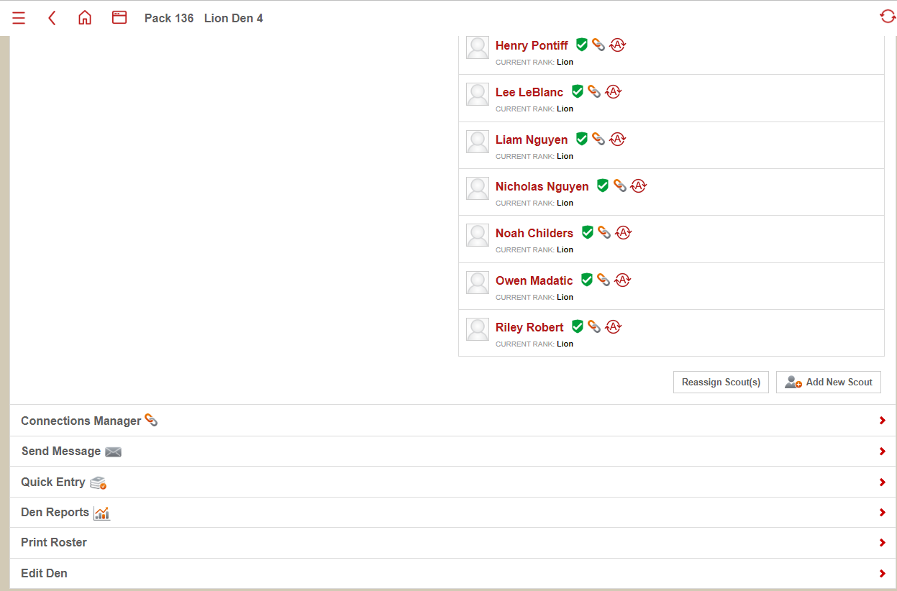



- Know how to add dens (Click on “add den” from Pack dashboard, choose the den type, and assign a den number, add den leader and assign scouts from roster)



- How to add leaders to dens (Click on “Add leader,” search by BSA member #, assign position, click checkbox next to “administration,” add)
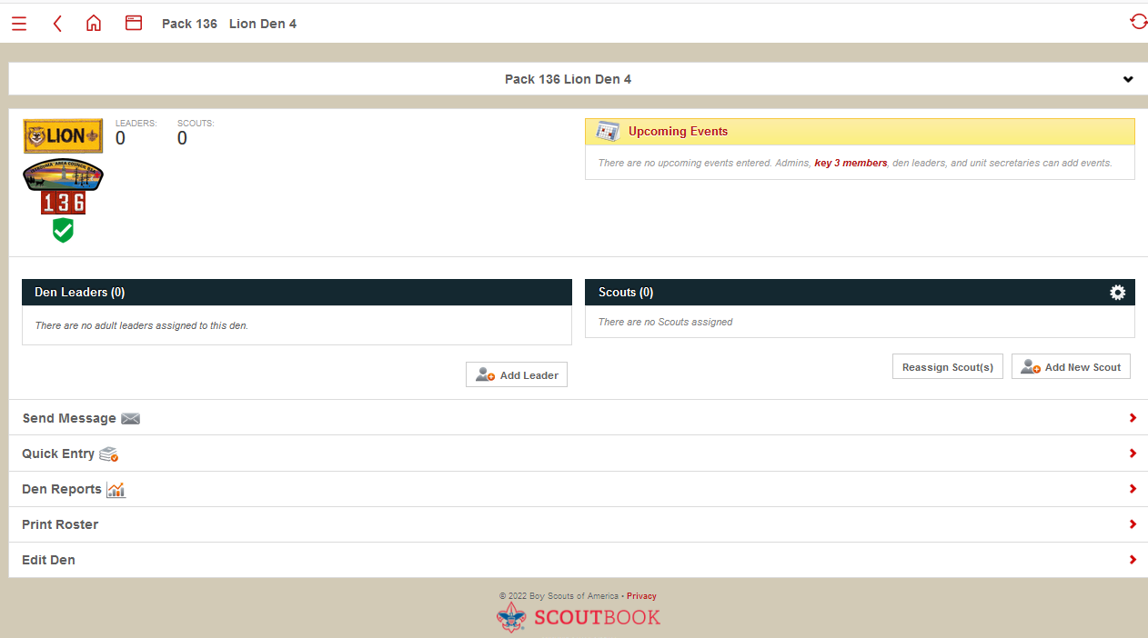
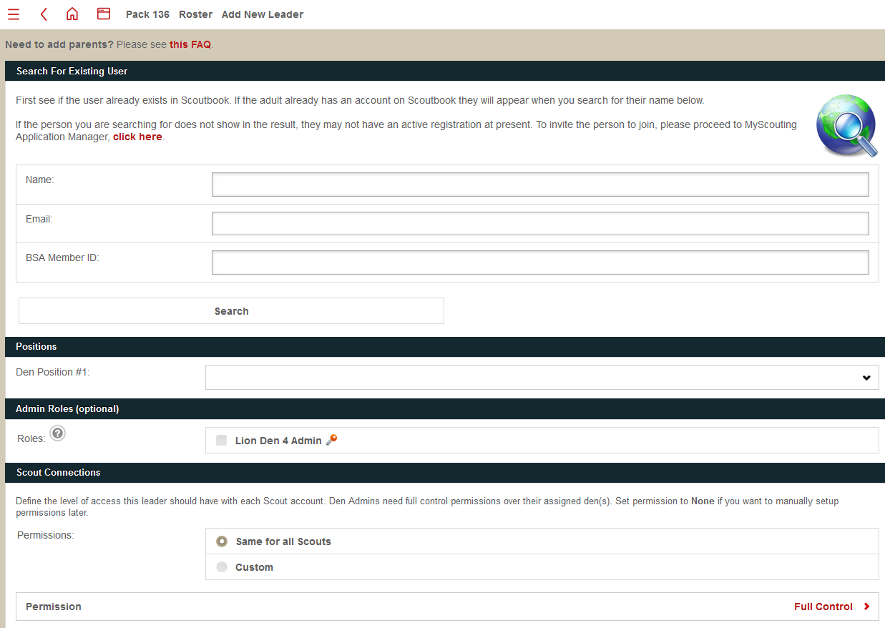
- How to add scouts to dens (scouts must be in dens and have Bobcat to record advancements or be advanced to next rank) Scouts not assigned to a den or patrol will show up on the unit dashboard under “Scouts not in den or patrol.” Click on the den the scout will be assigned to, Click “Add new scout,” then click “Invite existing scouts already in the pack to join this den.” If the scout is transferring from elsewhere, click “transfer to this den.” If coming from another unit, you must have the scout’s BSA member #. From the existing roster, click the checkbox next to the scout’s name, and then click the red “Invite” button at the bottom. This will add the scout to the den.
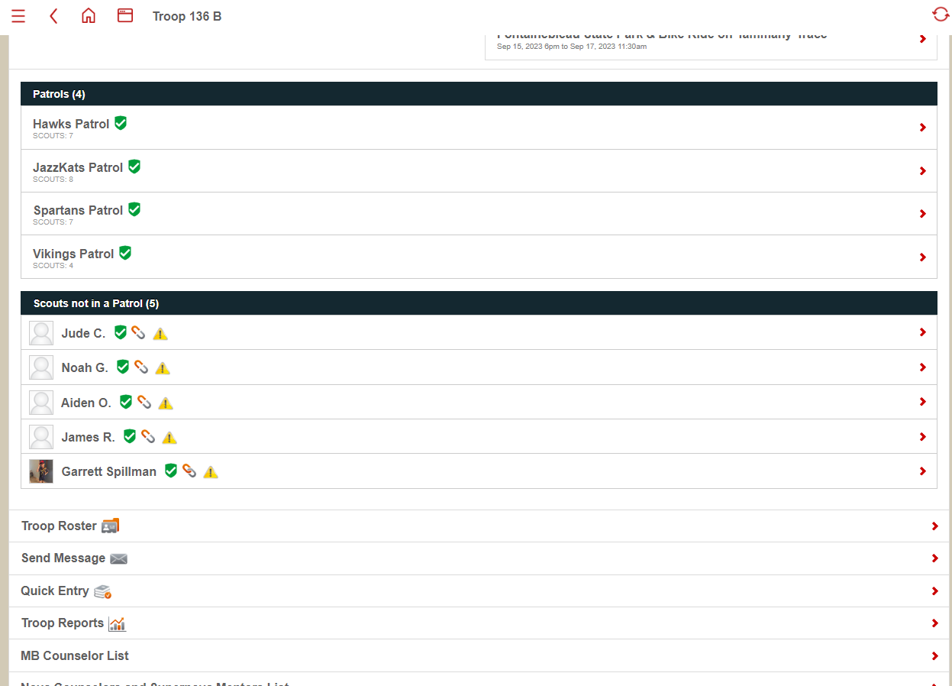
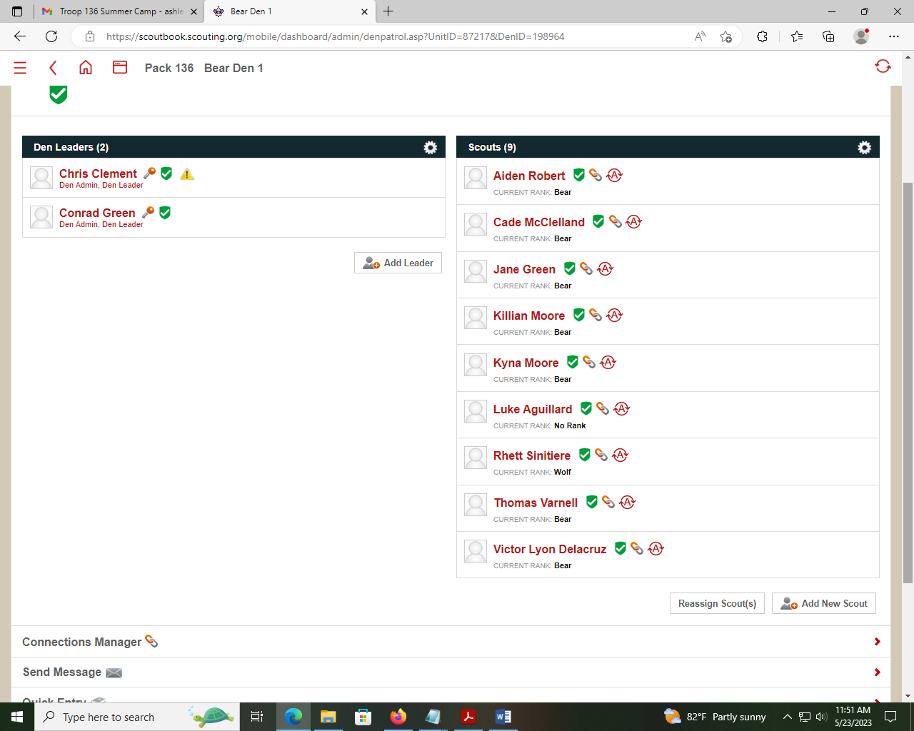
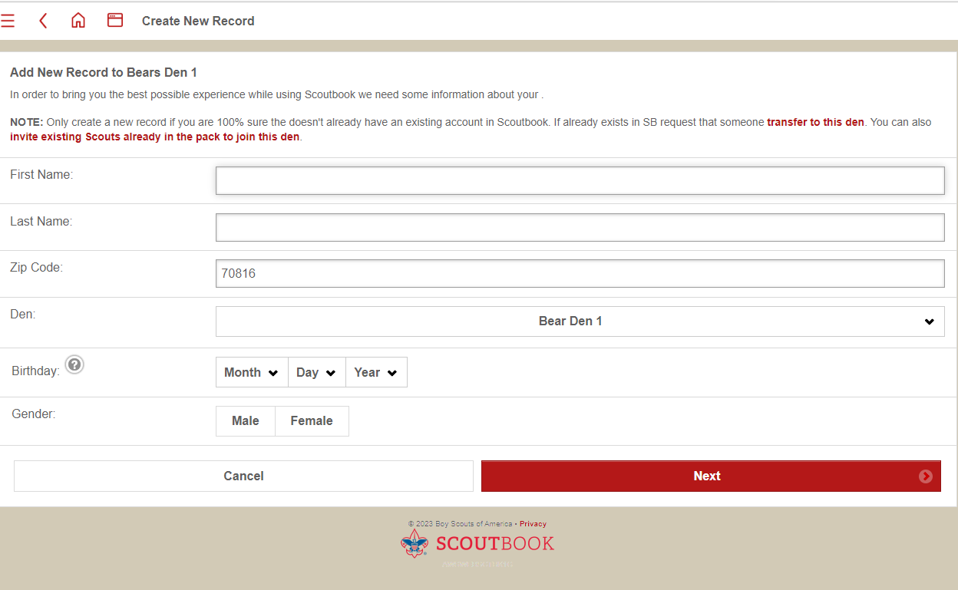
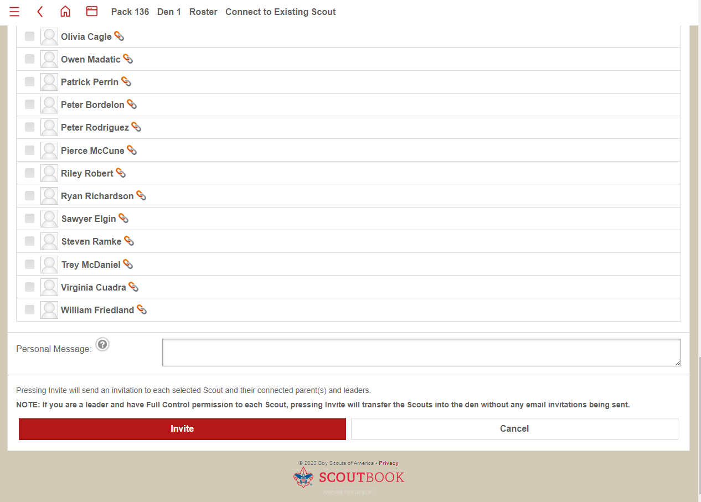
- What to do if a scout isn’t showing up in Scoutbook
Scouts must be on the official roster for the unit to show up in Scoutbook. If a scout is not showing up in the roster, contact the Council office to have an administrator add them. The scout may need to fill out a new Youth Application. Scouts transferring from a previous unit should have their BSA Member # to help facilitate this process.
- How to remove scouts and leaders from dens (Click on the person’s name, if it is a scout, click on “{name’s} membership,” and then click on their current position. Enter in today’s date on the “date ended” line, and click “update”)
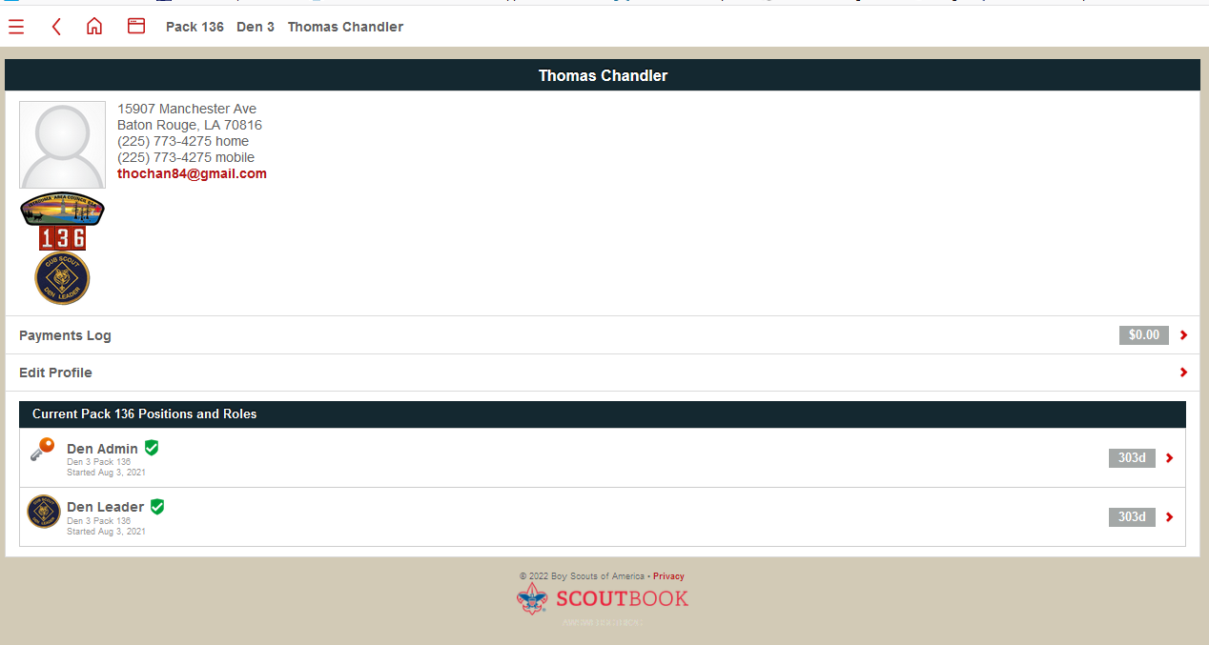
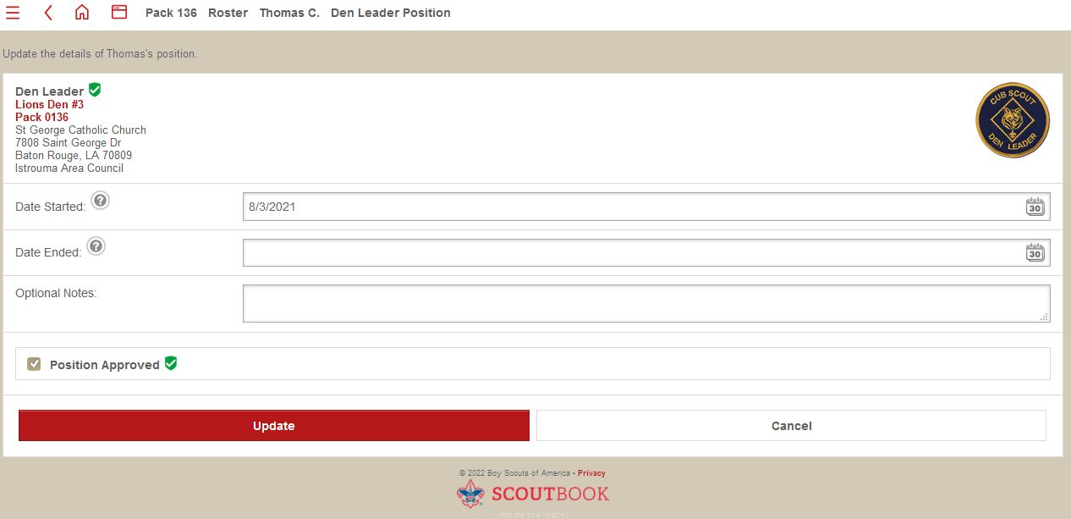
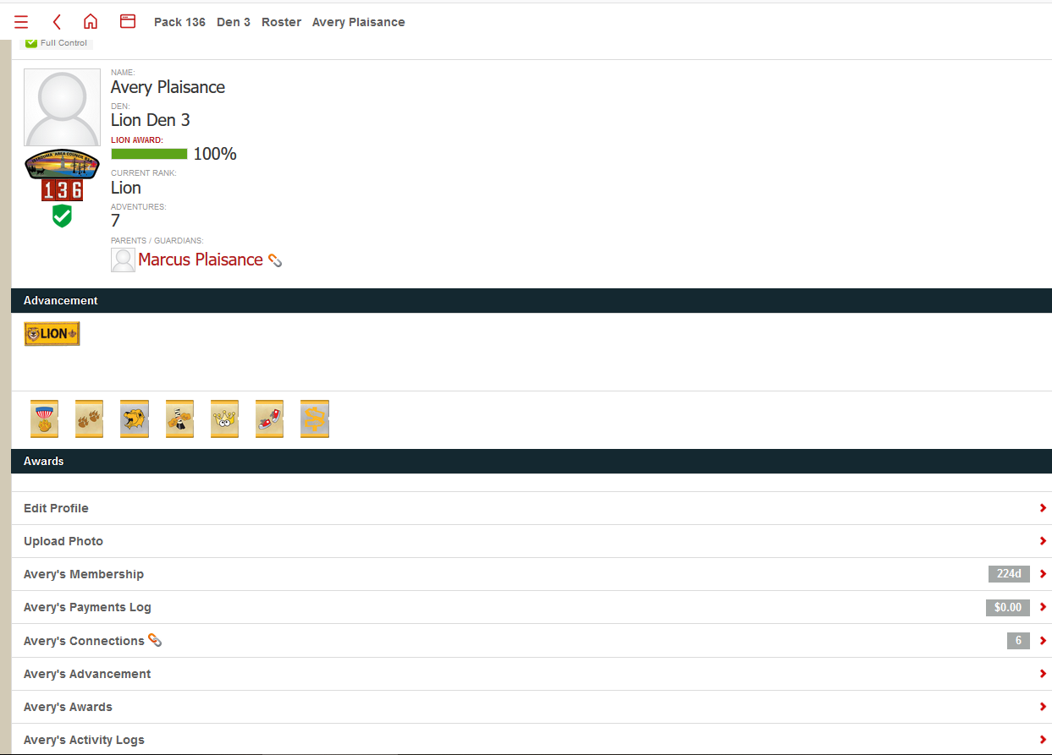

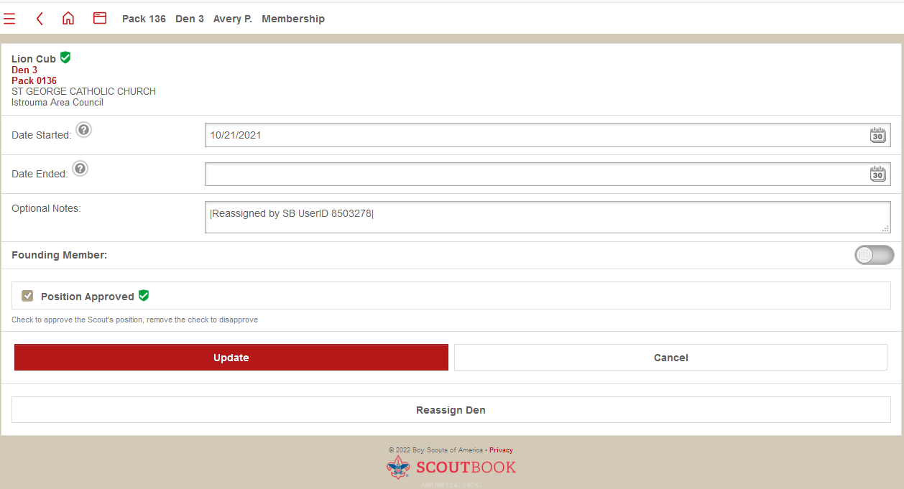

- How to add advancement to individual scout (Click on the Scout’s name to open individual record, Click on “Advancement,” Then click on the scout’s current active level. Click on the requirement or elective, and select the checkbox next to the activities completed. Select the date completed, and the checkbox next to “approved/recorded”.)
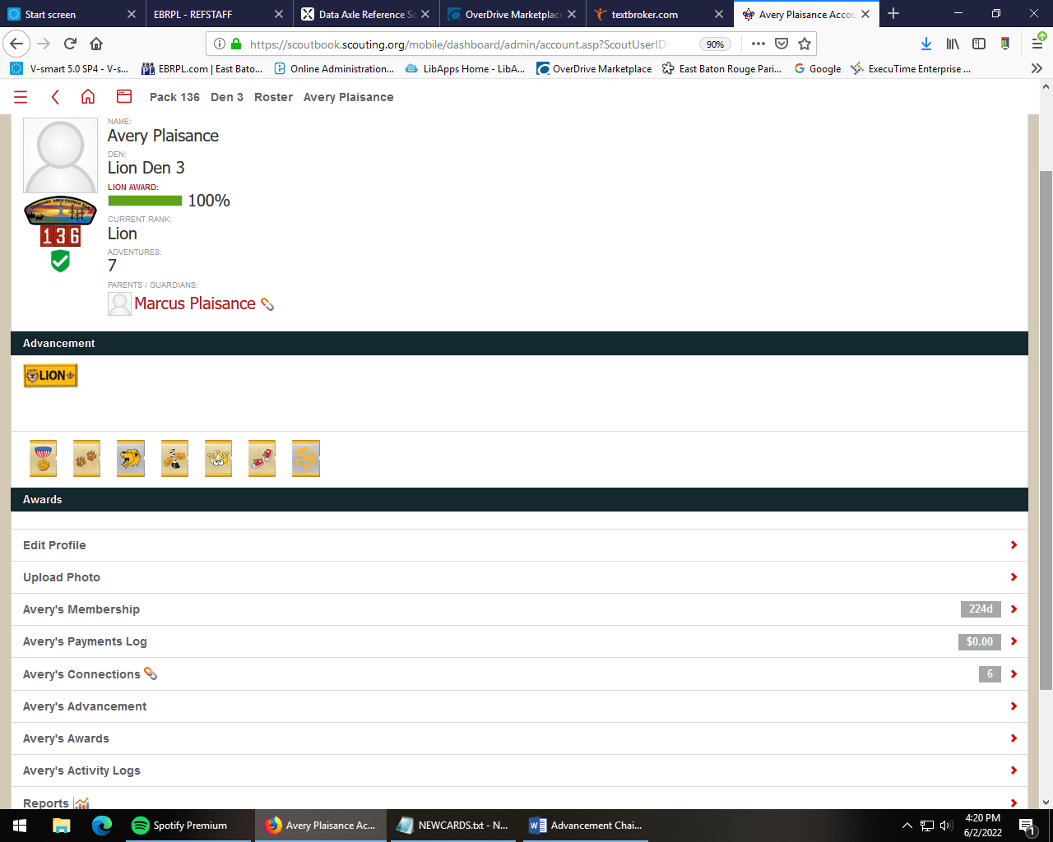



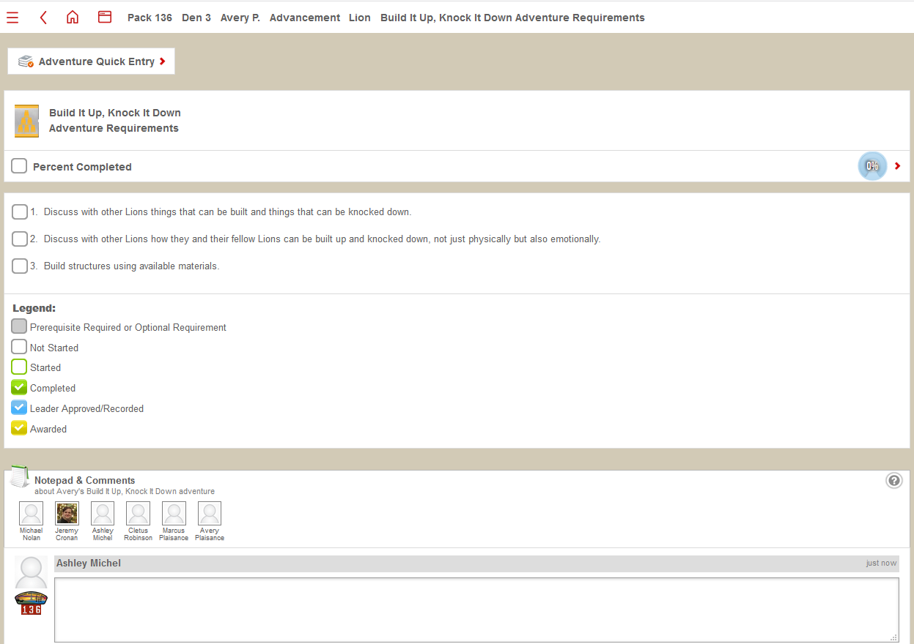
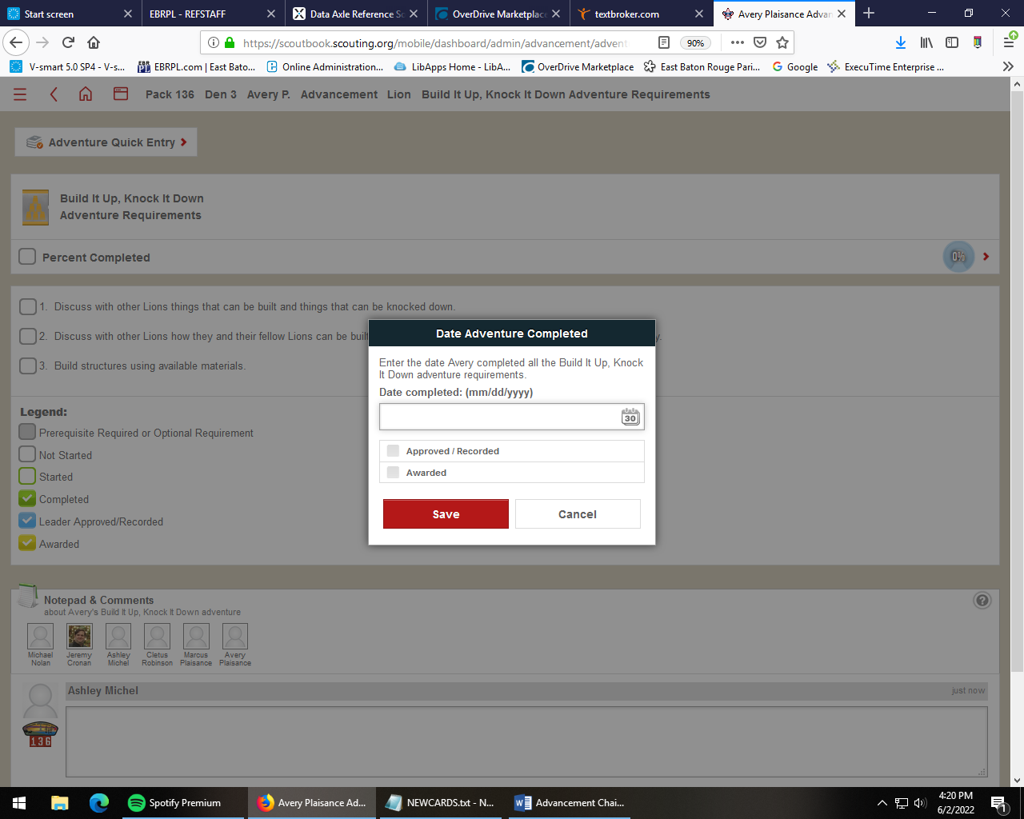

- How to add advancement to multiple scouts (For an award (NOVA, Summertime Activity) from the unit dashboard, click on “Quick Entry” and select “Enter Awards” Choose the award, and select the completed requirements. Then select the checkbox next to the names of scouts who completed the activities. Enter in the date completed.

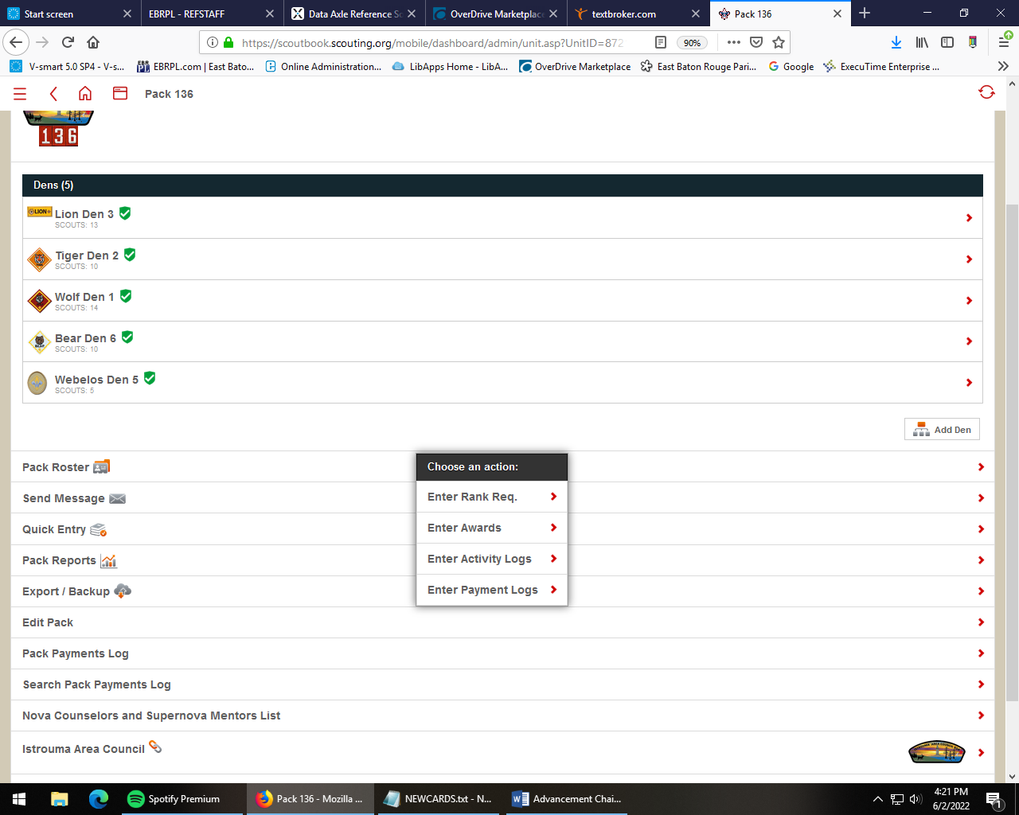

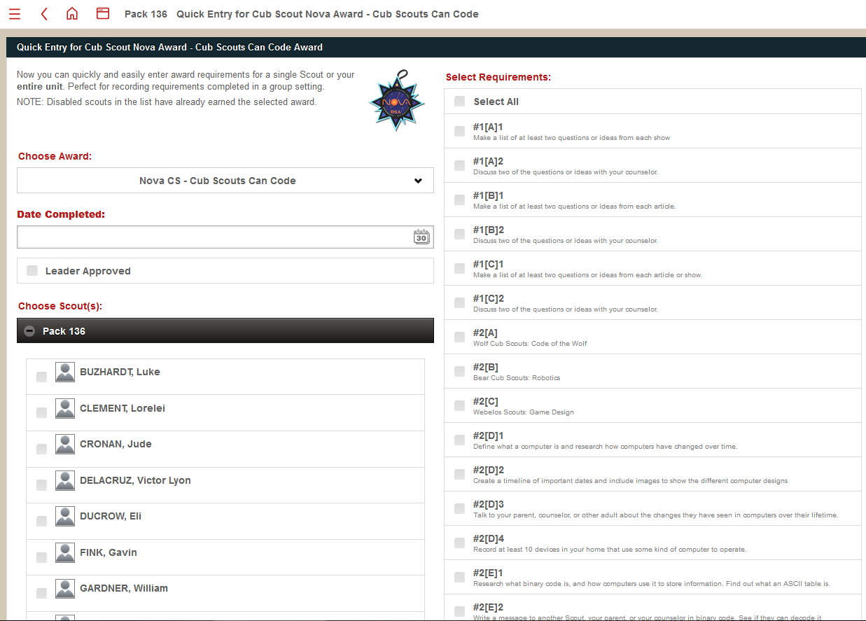
To enter requirements for advancement, click on the den from the unit dashboard, then select “Quick entry,” choose “enter adventures,” and choose the correct requirement. Check the checkbox next to the activities completed, and the names of the scouts who completed them. Enter in the date of completion, and click the red “save” button.


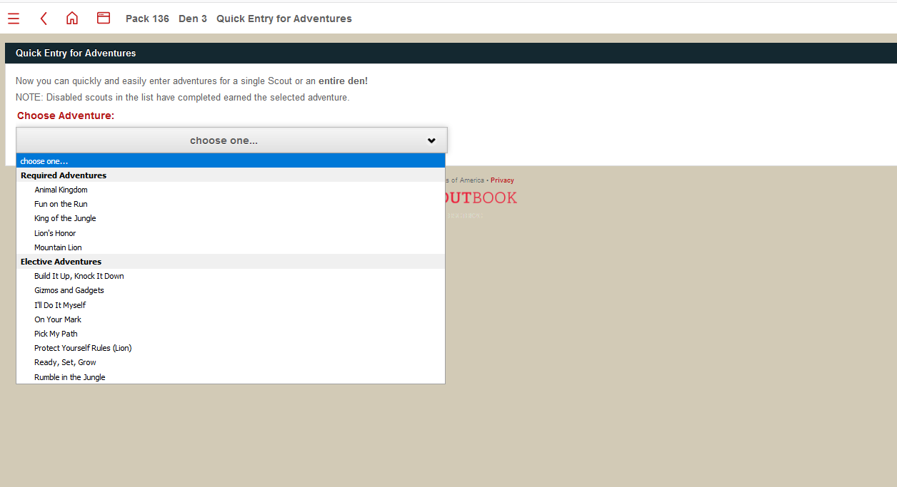
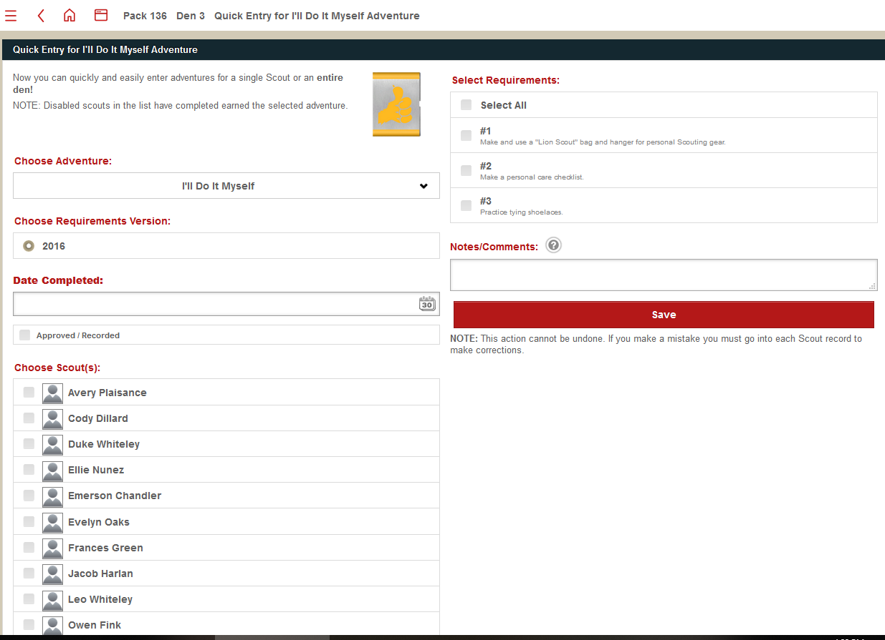
- Where to find awards (Click on Scout name, scroll down to bottom where is says “Scout’s name Awards”, click on that and select the award the scout is working on to enter completed requirements.)
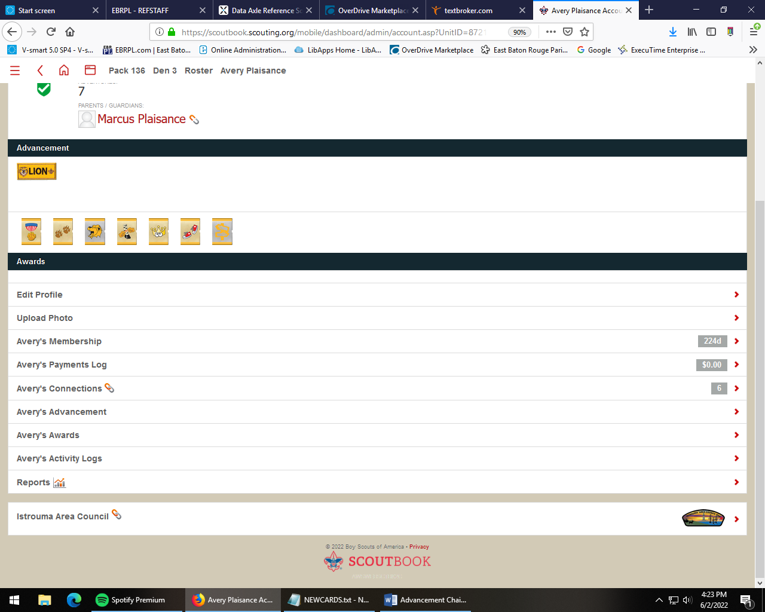

- Adding service hours and hike miles (Click on Scout’s profile, scroll down to bottom and click on “Scout’s activity logs.” This will bounce you to the national website, enter in camping hours and hikes in that record)
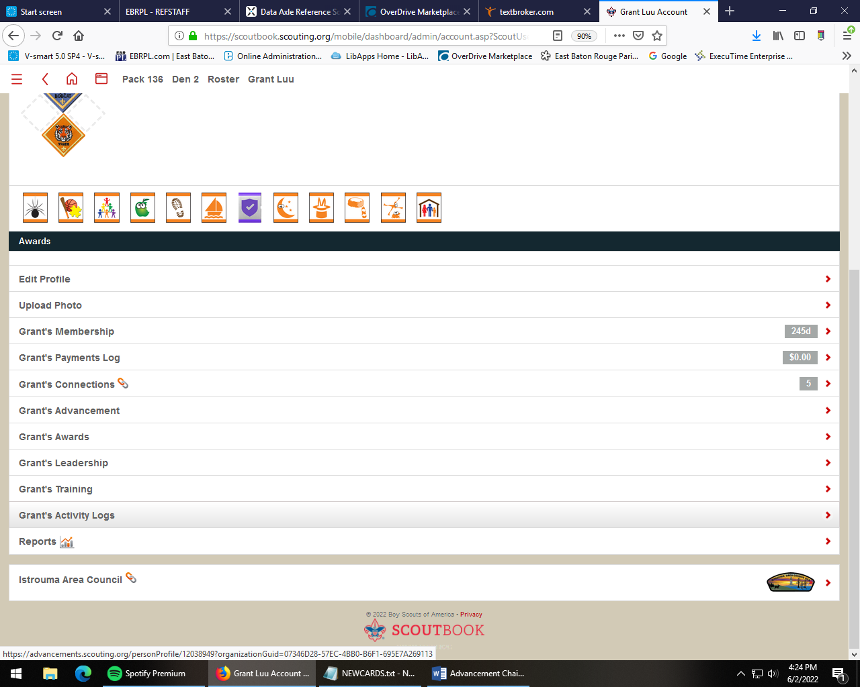
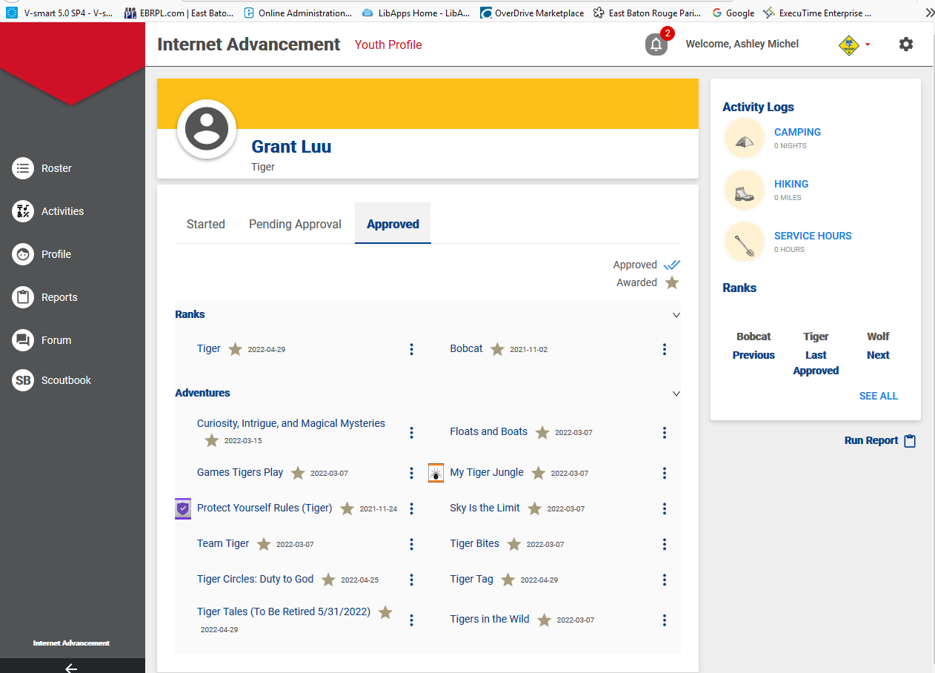

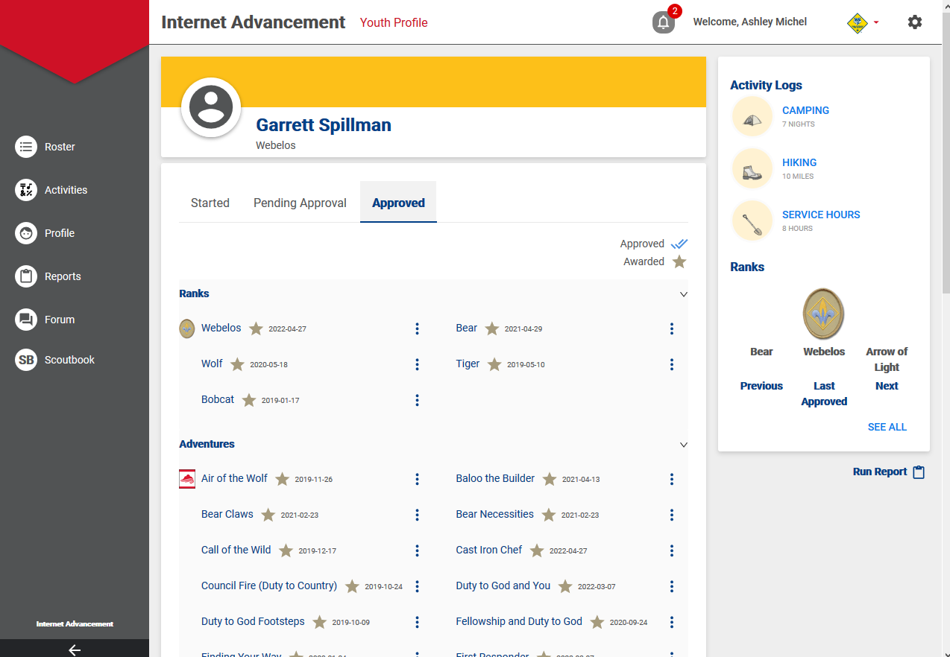
- Address Payments log, keeping track of payments (Click on scout name, scroll to the bottom and click on “Pack payments log.” Click “Add” to record a payment)

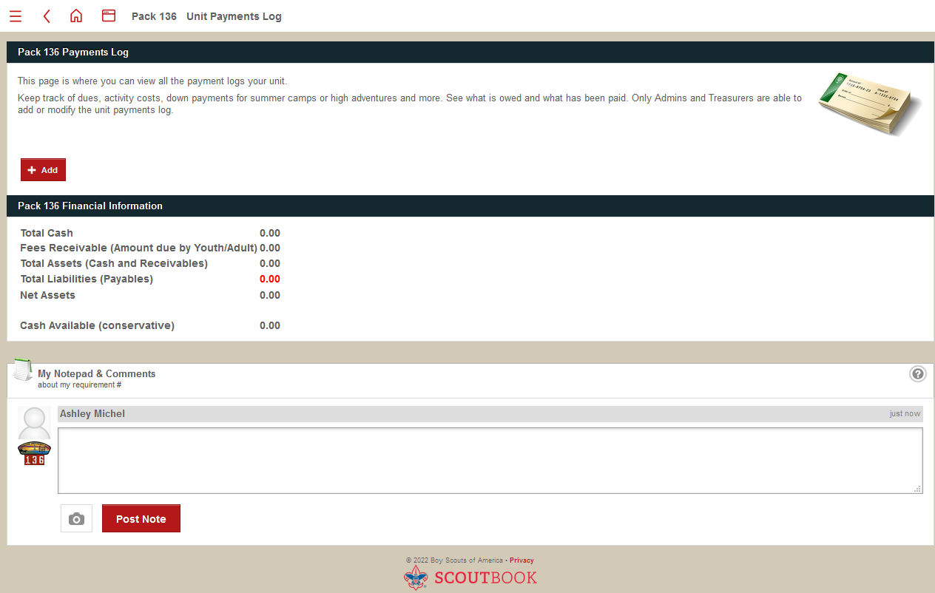
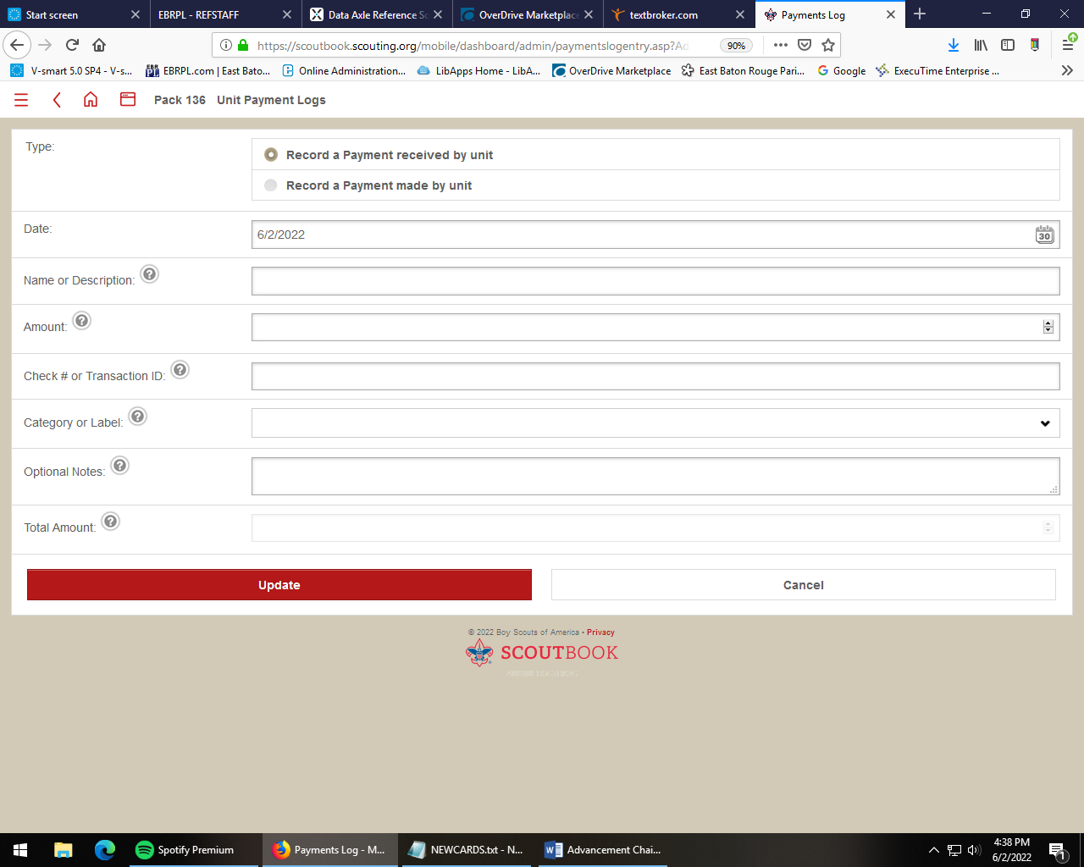

- Scout leadership area (If a scout holds a leadership position, such as Denner, this can be recorded in their record as well. Click on “Scout Leadership” under scout profile,
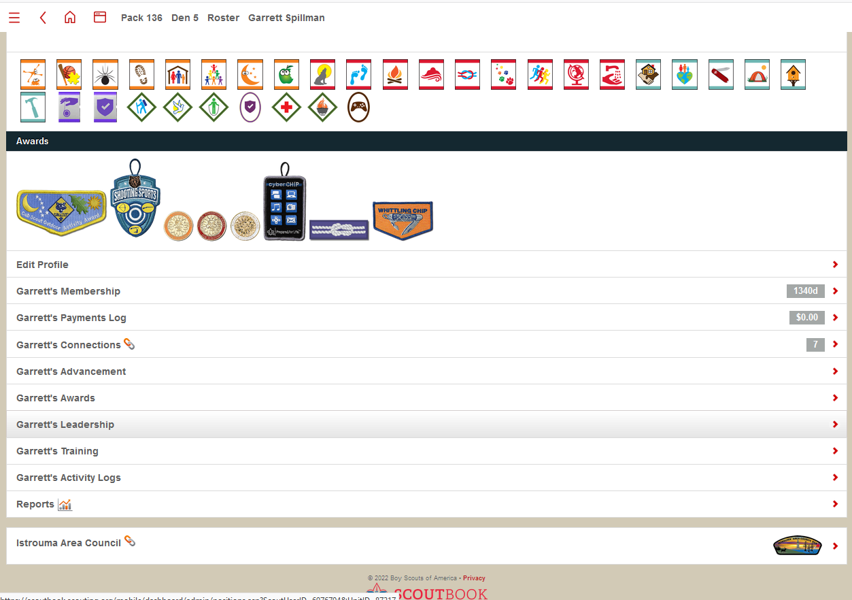

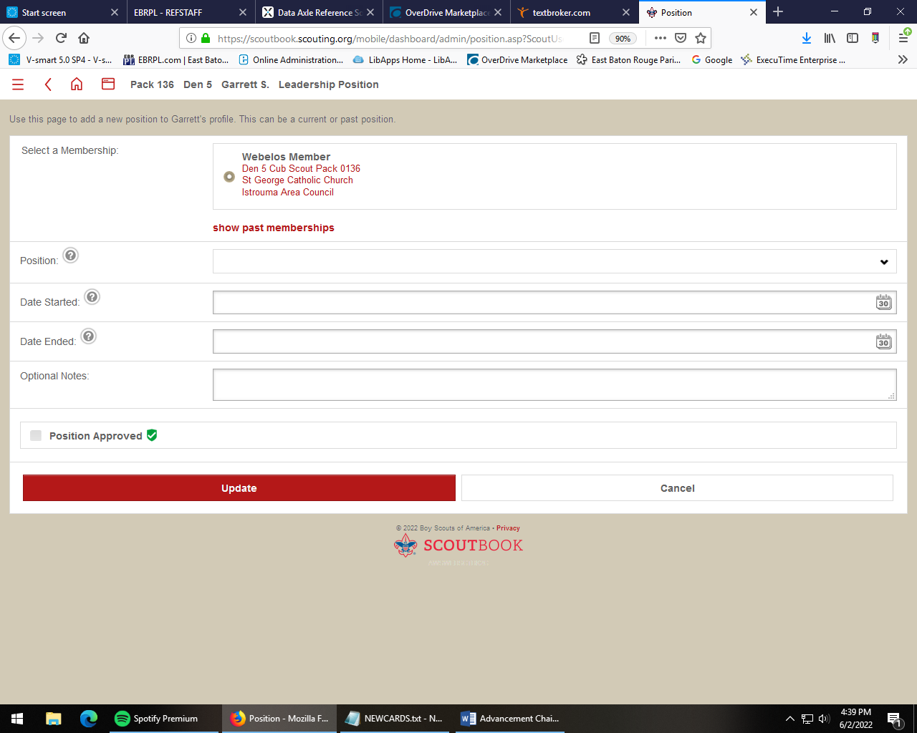
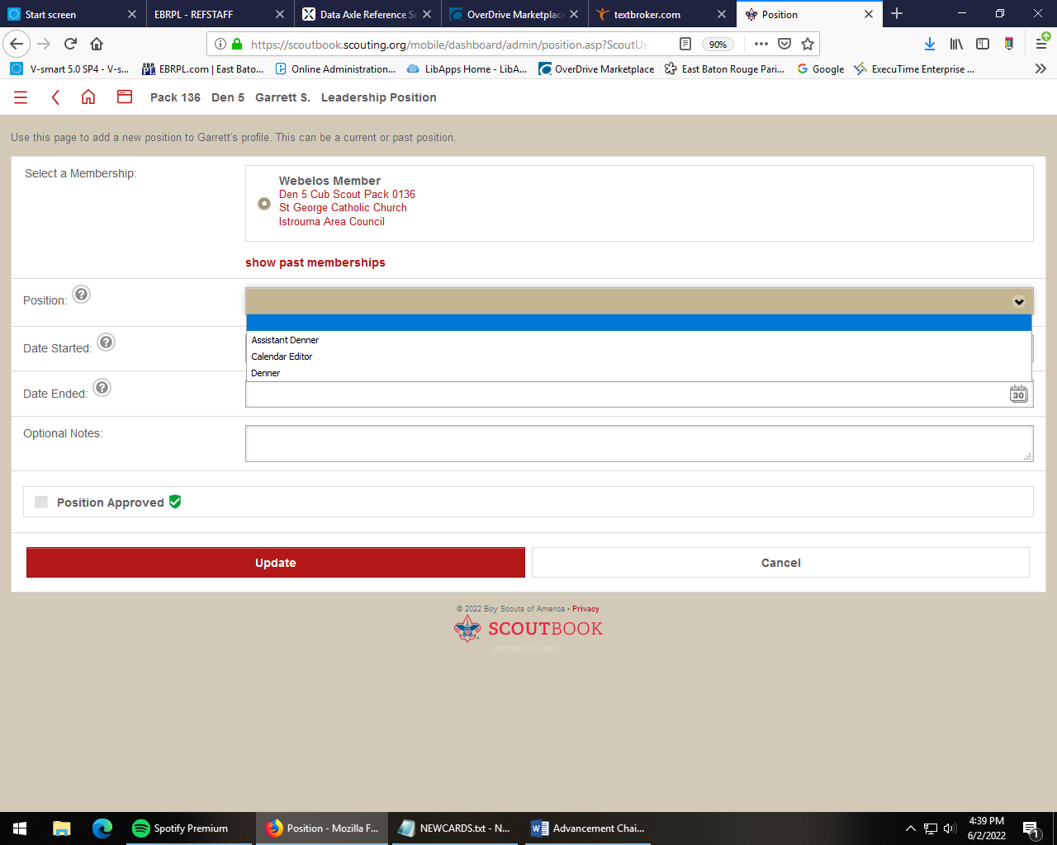

- Be aware that not all achievements carry over into awards
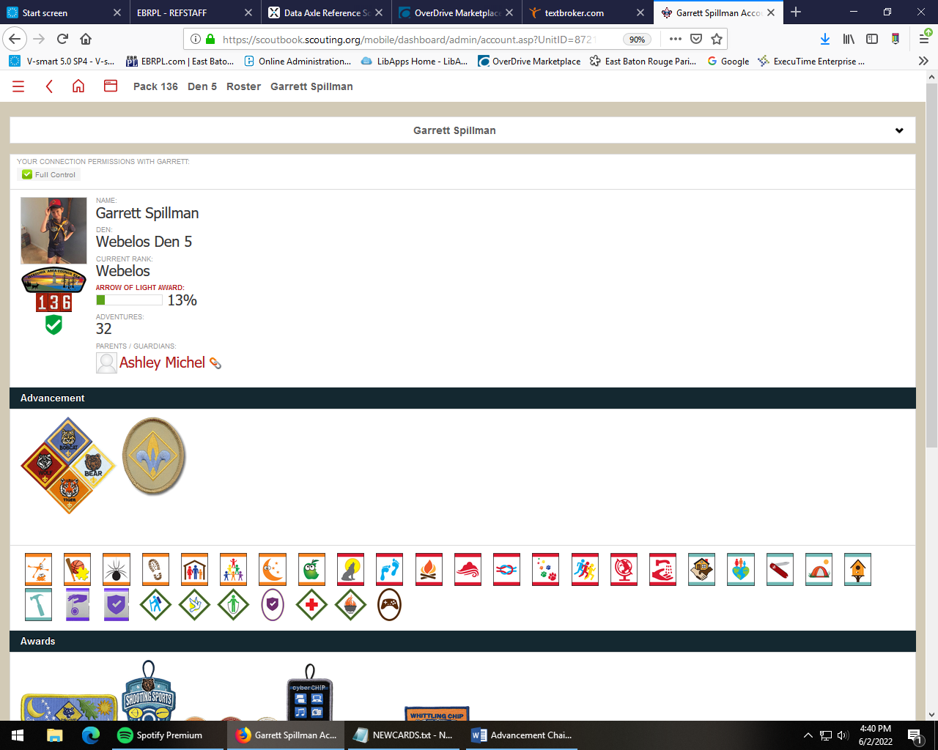
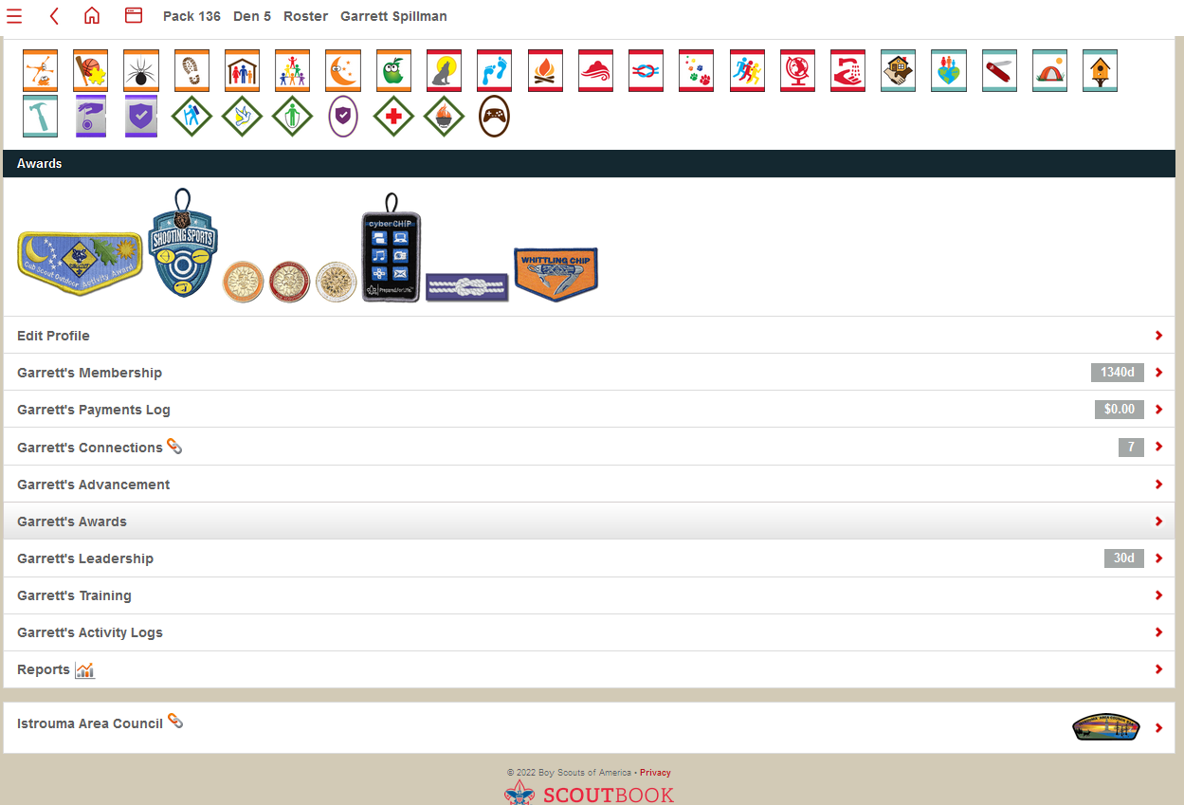



- Running Reports (From the unit Dashboard, scroll to the bottom and click on “Unit Reports.” Choose the report you want to run.

To create a purchase order report for rank patches at the Scout Store, first run a “Needs Purchasing” report, which will generate a list of all requirement belt loops and rank patches earned. Select the checkbox next to each item that needs to be purchased. Click “Add to open PO.” Then click “Save and Update.” Click on the “Advancement Report PDF” to print a copy.
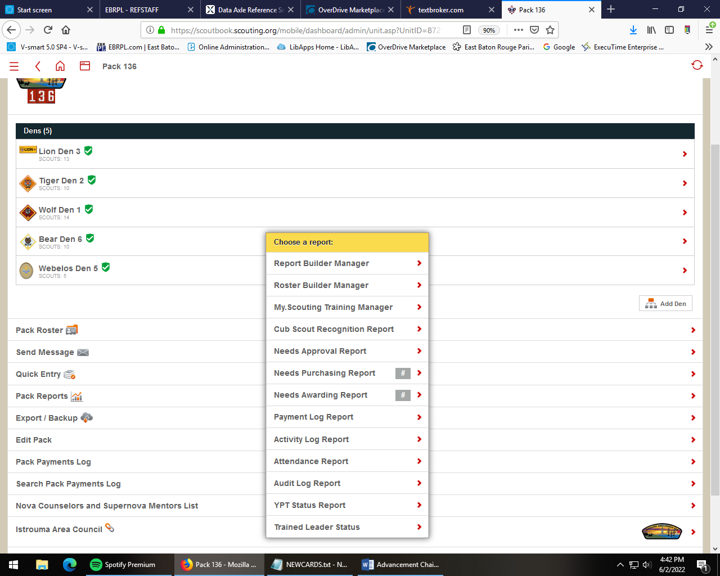

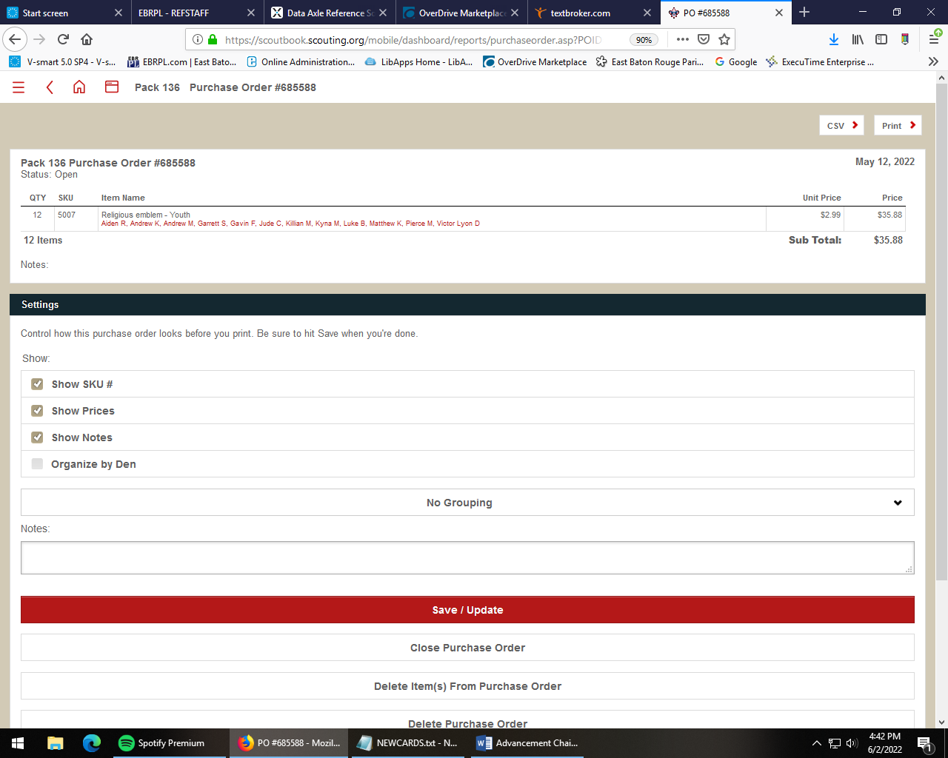

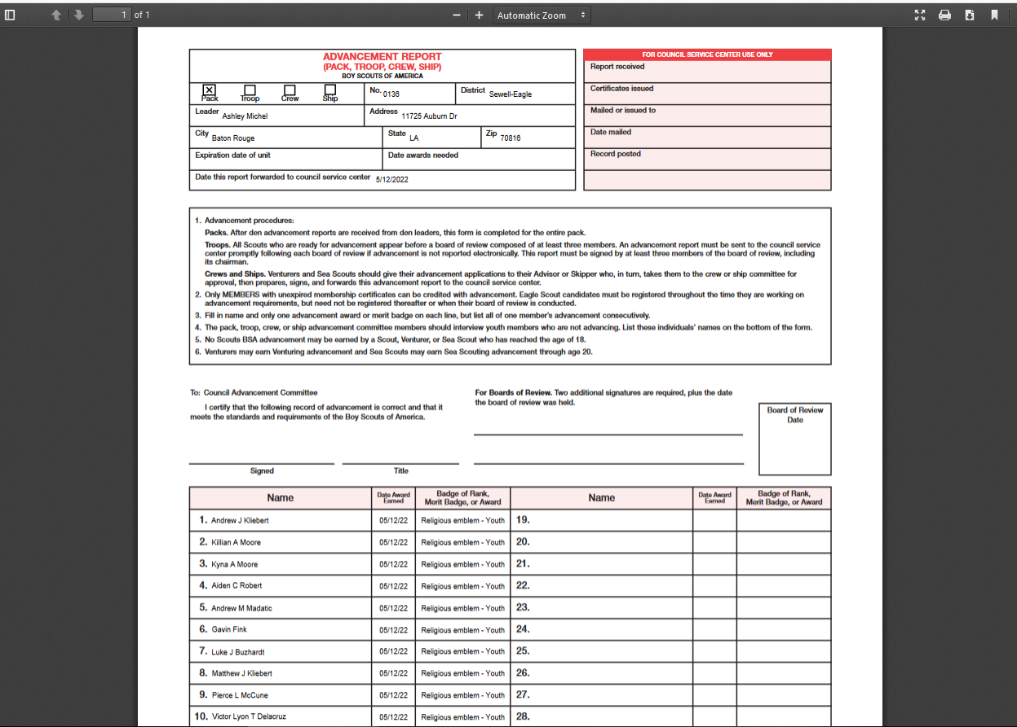
- Approval and awarding reports (Run these reports the same as above. Select the items that need Advancement Chair approval, or which have been awarded, and click “save.”)
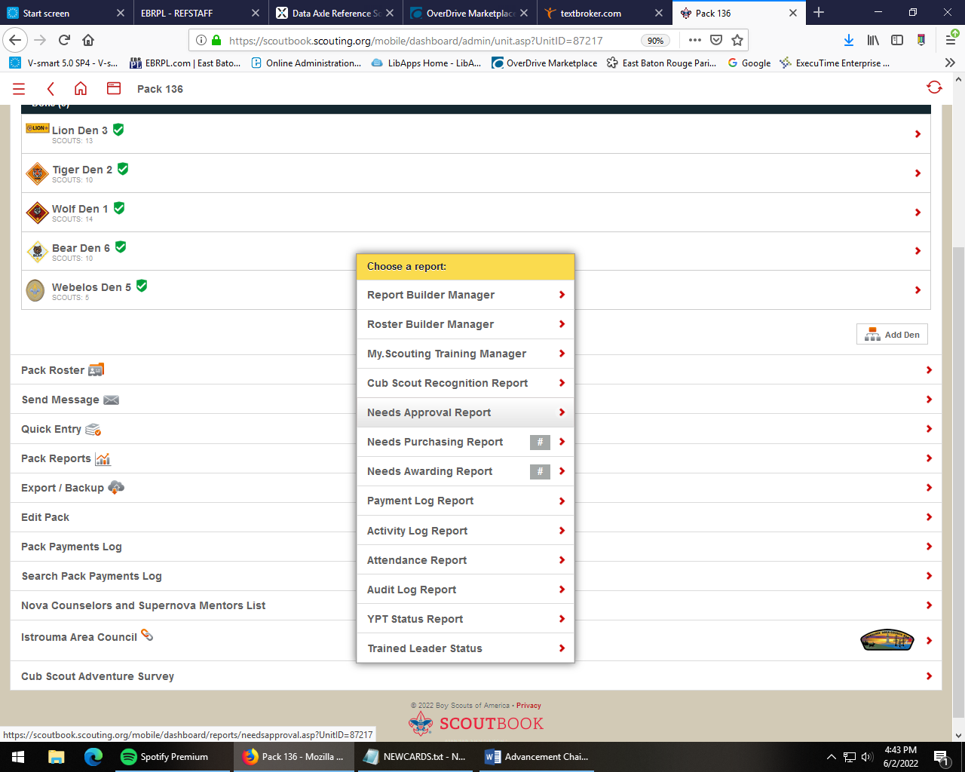


- “What scouts still need to do” reports. Run “Report Builder” to create a custom report. Click “Design” next to unit name. Use the report builder wizard to create a report that will show the uncompleted requirements for each scout in the unit.

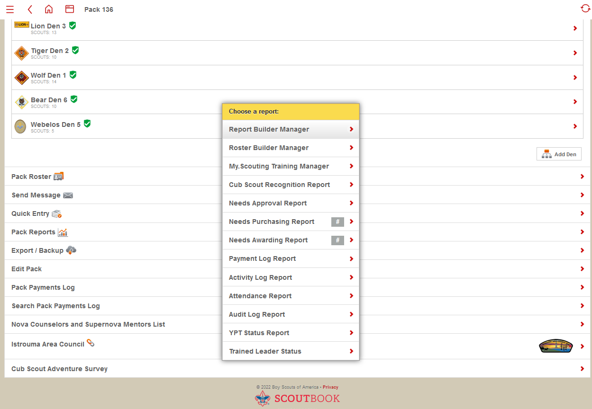
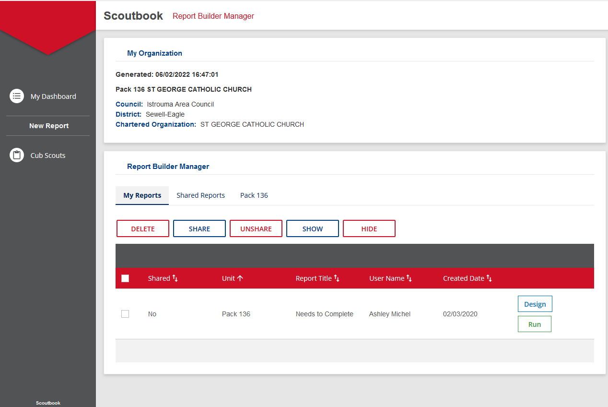
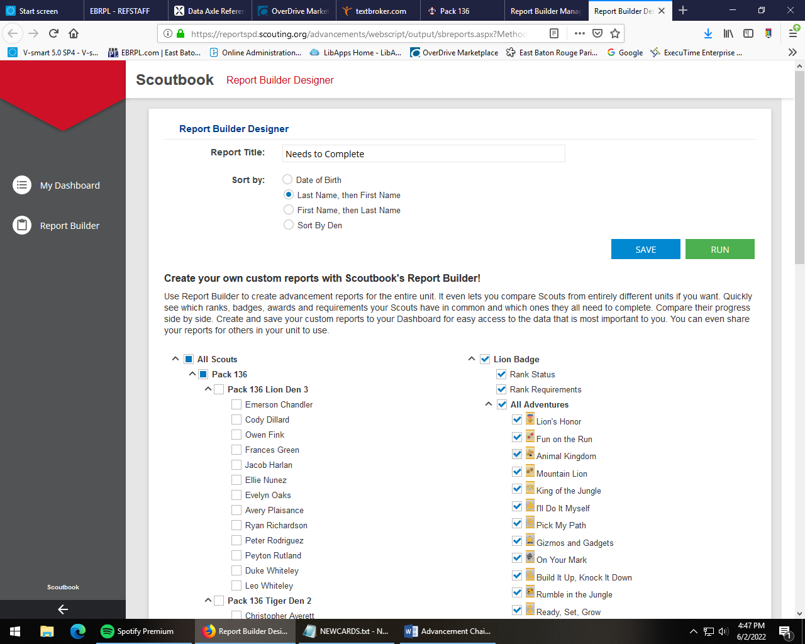
- Calendar (Events) From your Dashboard, click on “Events,” then “Create a New Event.” Choose your audience (Entire unit, single den or patrol, parents only….) and click “set.” Choose your Event Type. Set event specifics like time, location, and be sure to click on “set” after each one, otherwise Scoutbook will default back to the previous times and locations where a similar event was held. Choose the “invitees” from the scroll menu. Set a reminder if you want Scoutbook to email all the invitees a reminder. Type in any event details to appear to everyone in the description, and note that only appear to administrators. Click “Save.” On the calendar, events for different units or dens/patrols will show up in different colors.


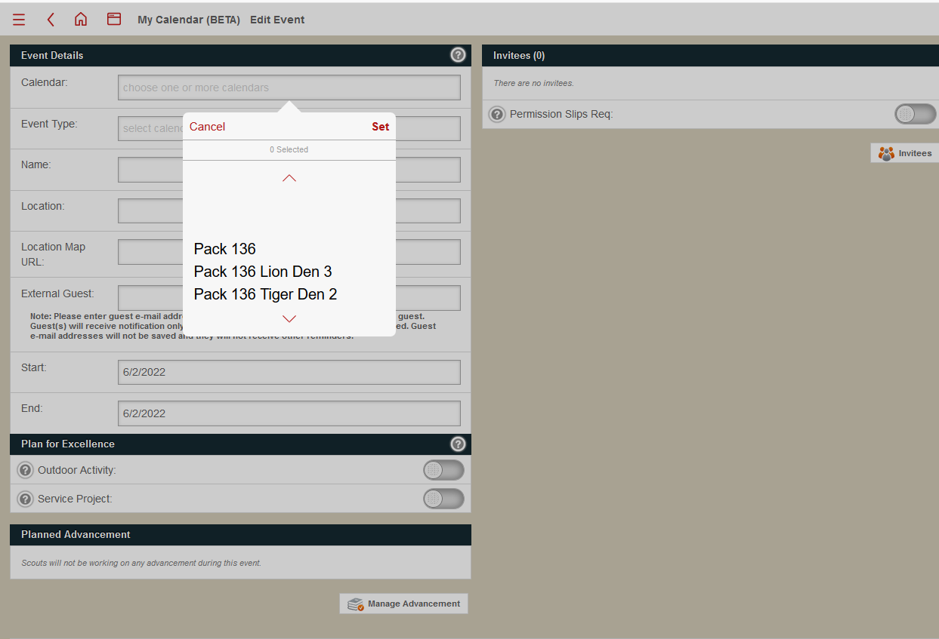
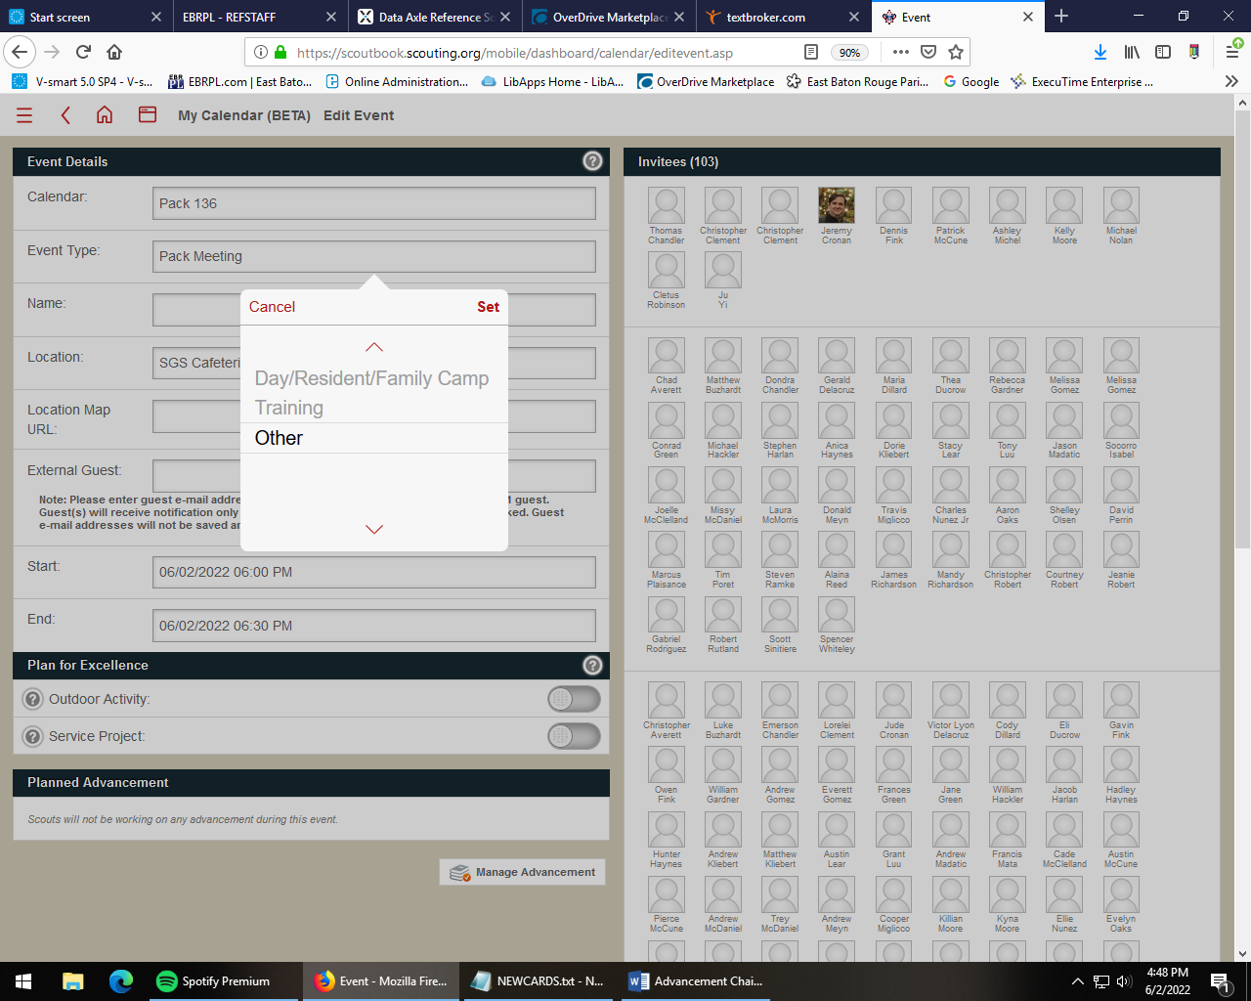
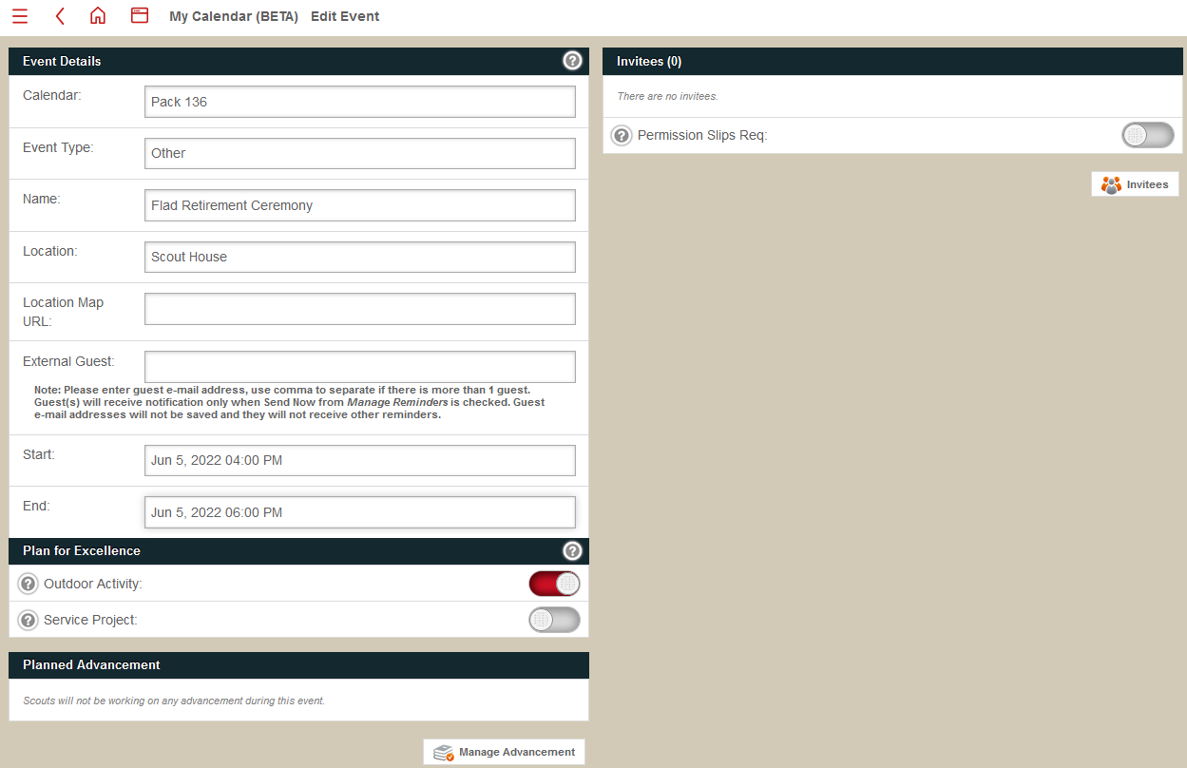
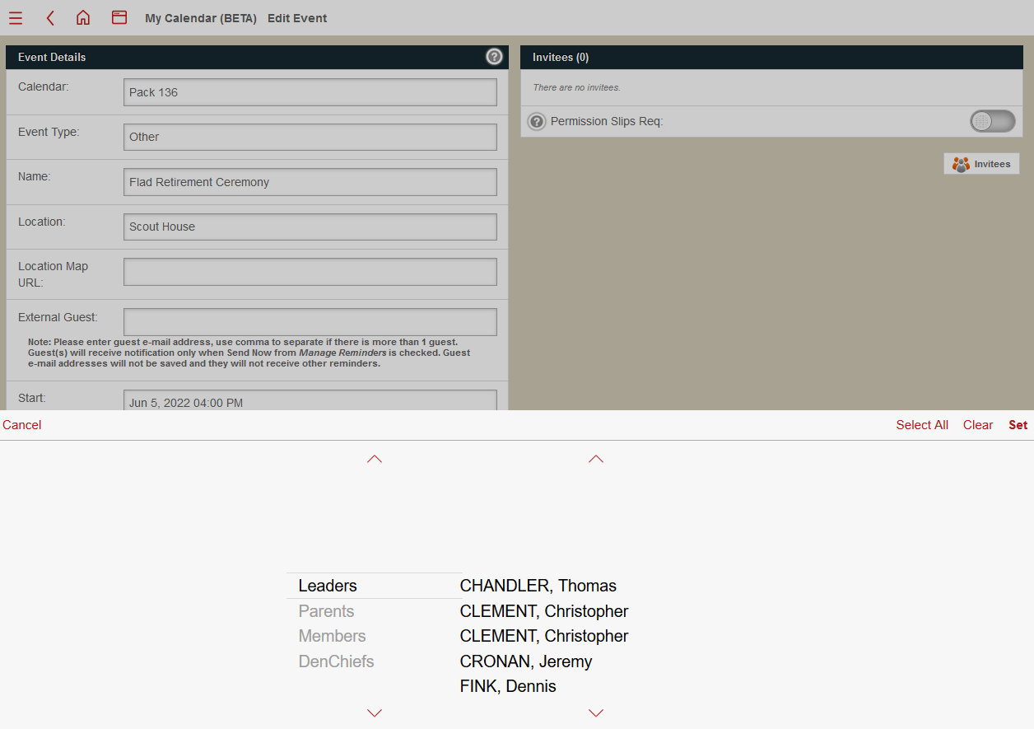
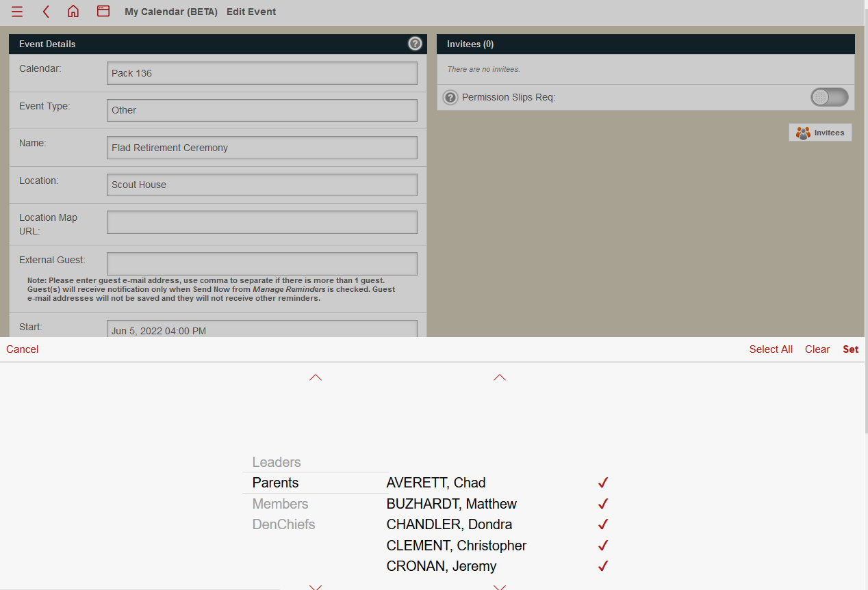
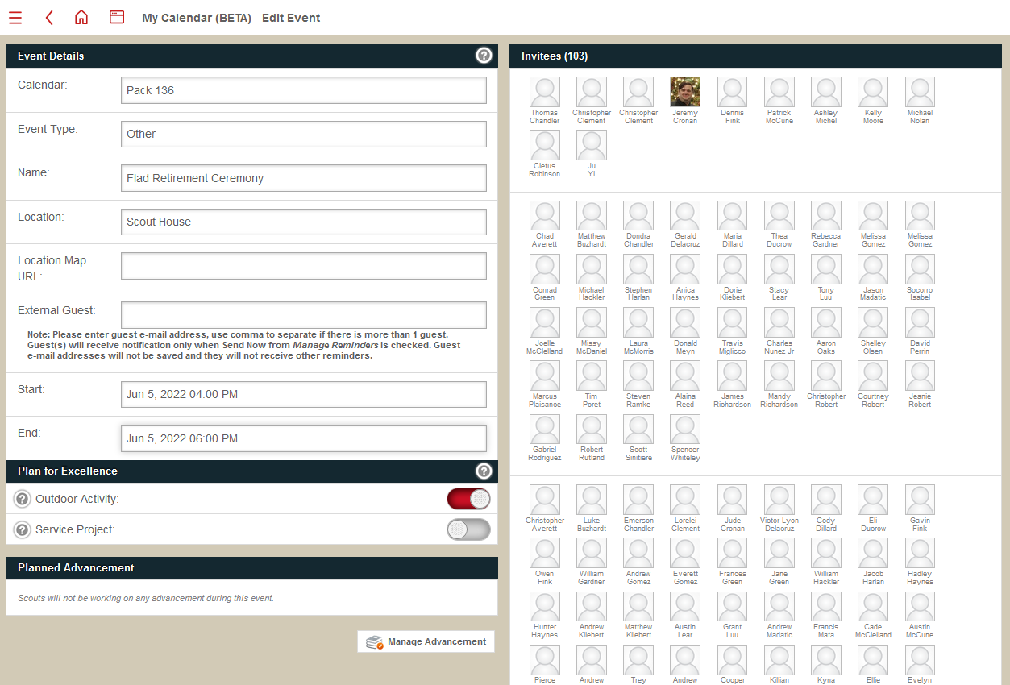
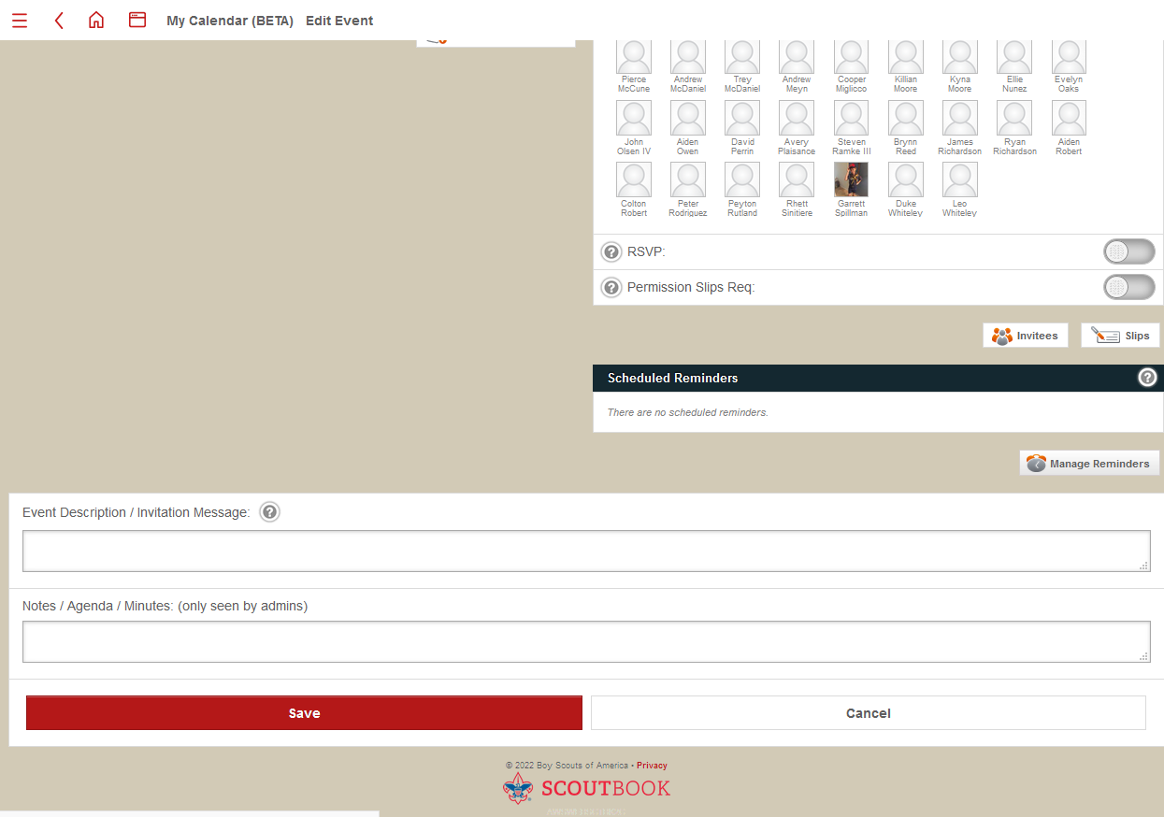
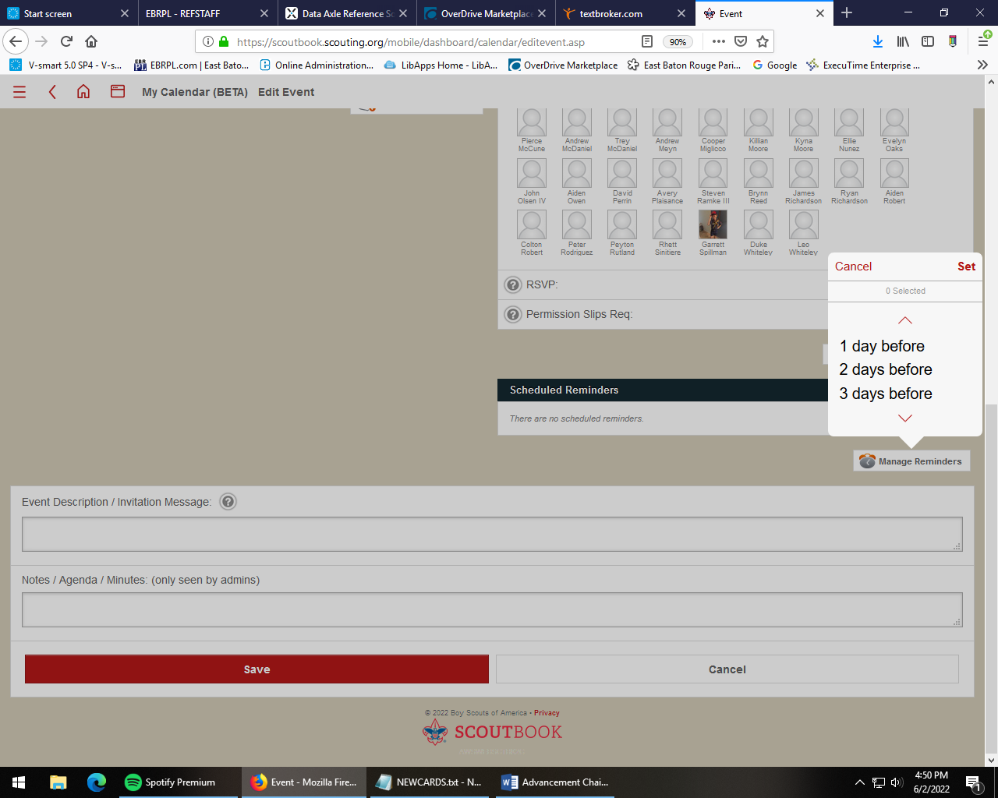
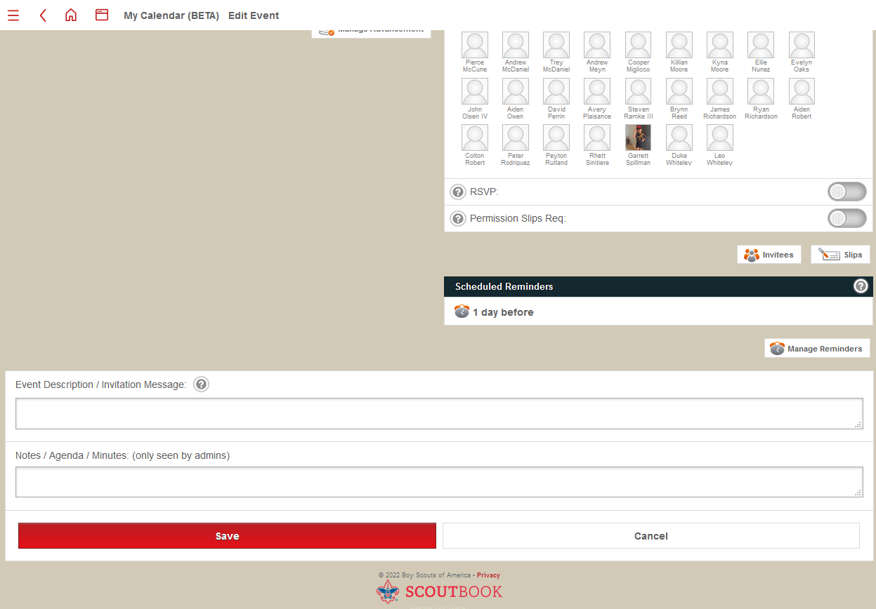

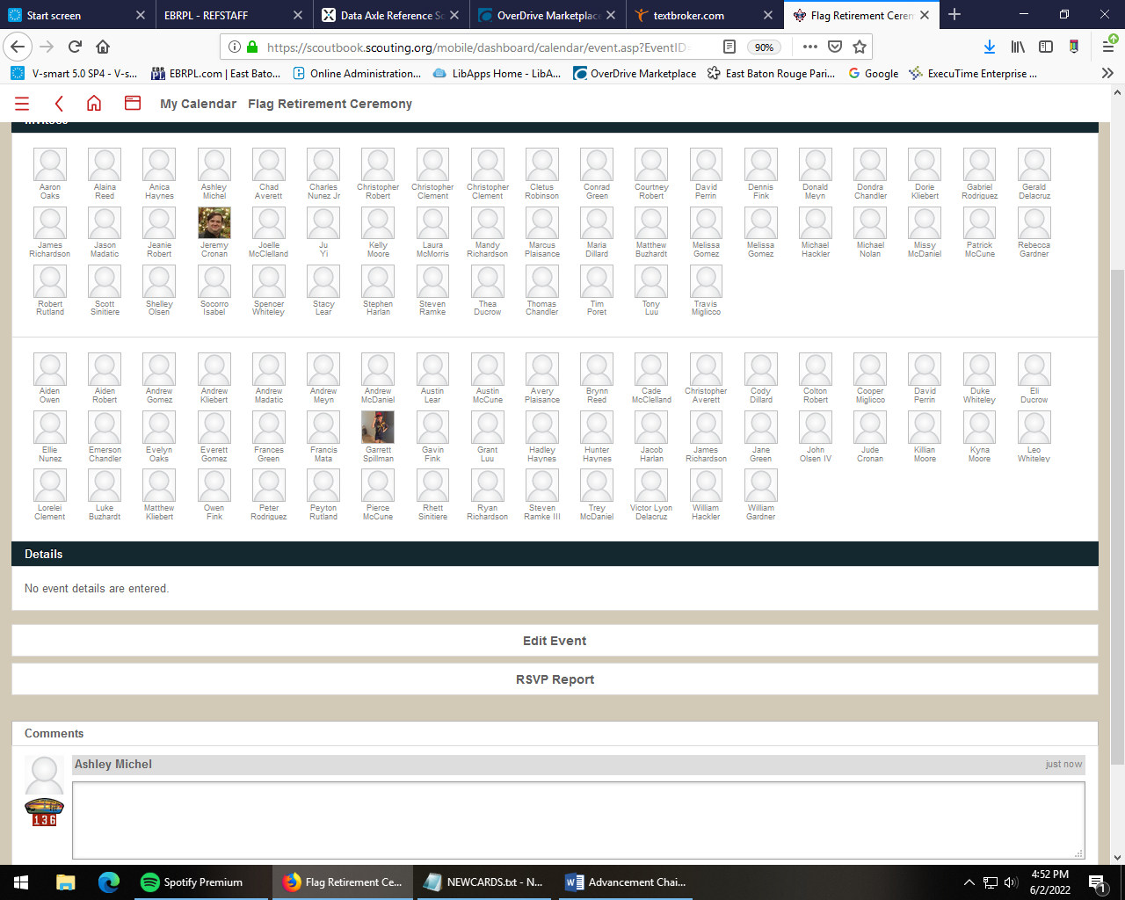



- How to delete dens (Click on the den, then at the bottom, click “manage den.” Click on “Disapprove den” and then “Update.”


- Messages (From your dashboard, click on “Messages,” then “Send Message.” Select the unit, and then choose recipients from that unit. Type the message in the field, choose “send bcc” to hide everyone’s email addresses, and then click “Send Message.”


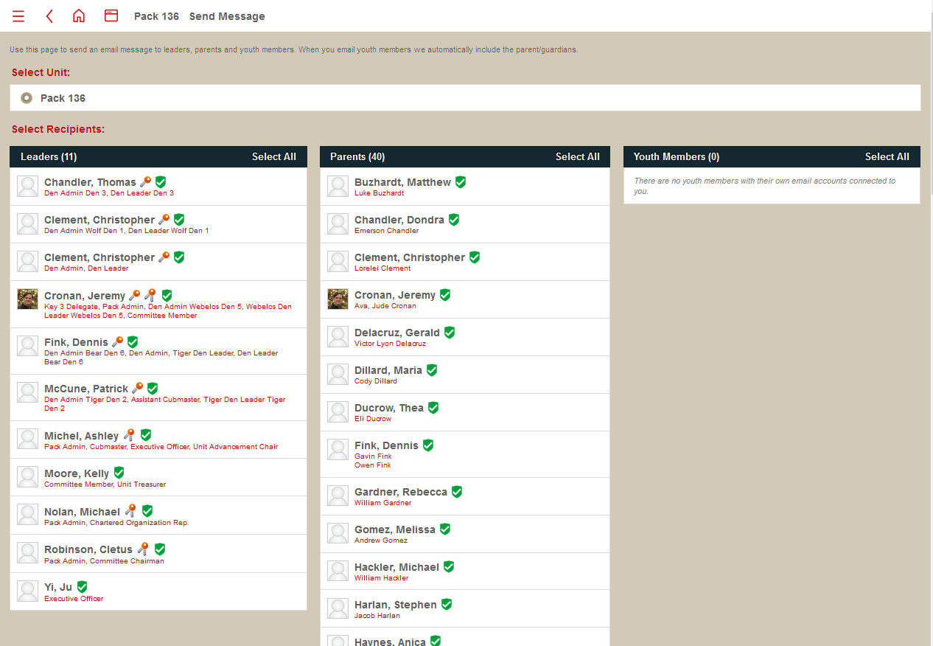

- Be familiar with Internet Advancement version (From your dashboard, click on Internet Advancement to bring up the Online records from National. The same functions can be done in IA as in Scoutbook, some prefer one interface over the other.)

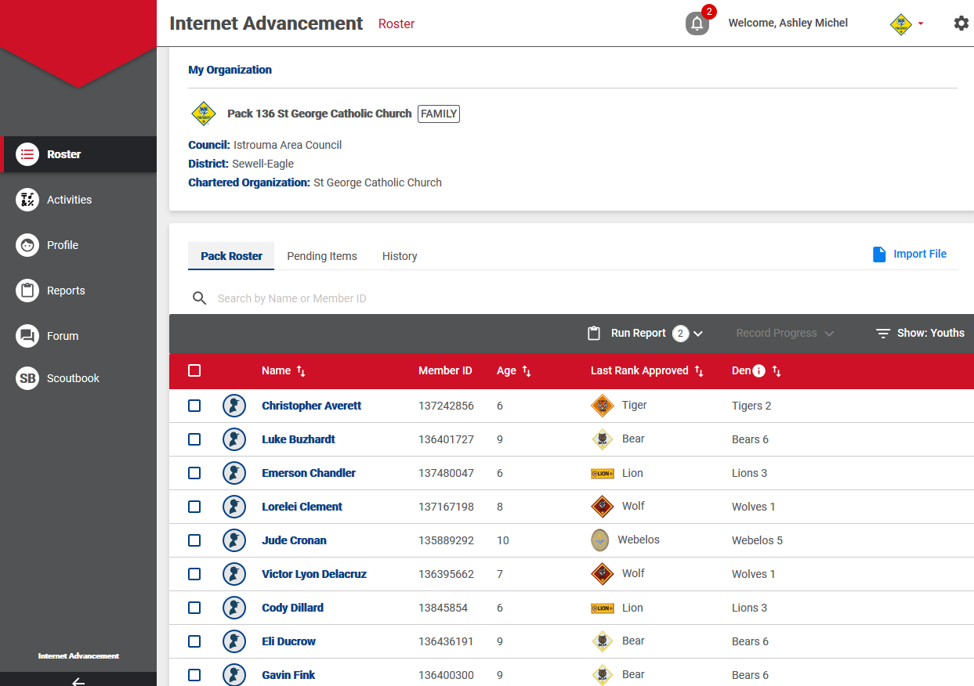
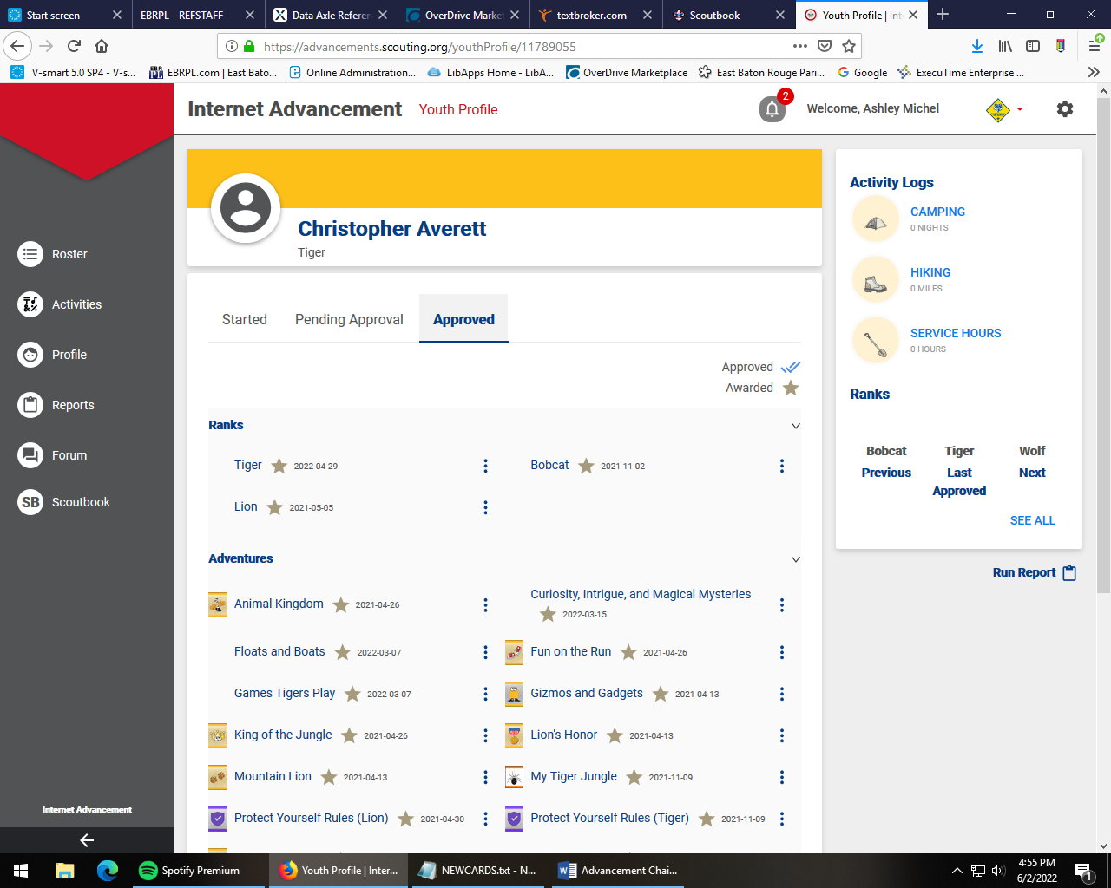
- Pack Roster (To see all of the registered scouts and leaders for a unit, click on Unit (Pack or Troop) Roster from the unit dashboard. This will bring up all registered participants. If someone is not appearing on the roster, they are not assigned to the unit in National. They may need to fill out a new application.)


- Manage Connections (To manage which adult leader has authority over a scout’s record, this can be done either from the connections manager on the unit dashboard, or from within the scout’s record individually. From the pack connections, click on the scout’s name. From the scout’s record, click on “scout’s connections.” From there, select which adults will have access to the scout’s records.)


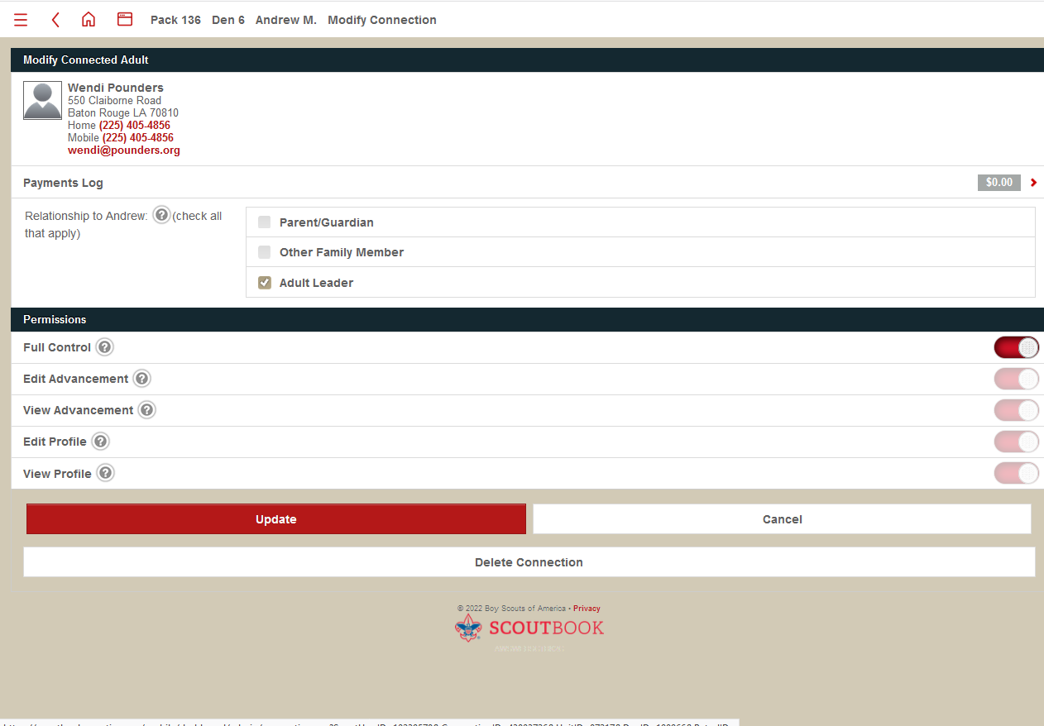

APPENDIX 7 Blue and Gold

Audience participation
BOBBY WANTS TO BE A CUB SCOUT

LIONS: Ro-aarrrrr!
TIGERS: Growwlllll!
WOLVES: Ahhh-oooooo!
BEARS: Grrrrr!
WEBELOS: Loyal Scouts!
AOLs: Cheer, clap

Bobby was out for a walk one day near his home. As he walked along, he met a LION who, along with a partner, seemed to be searching for something. Bobby asked the LION what they were doing. "We are in search of the TIGER trail," the LION replied. "I need to find the way so I can become a TIGER."

That's odd, thought Bobby. A LION becoming a TIGER? What an imagination the LION had! Bobby continued on his walk. In a few minutes, he came upon a TIGER. The TIGER appeared to be reading a book. bobby asked the TIGER what he was doing. The TIGER said that he was trying to become a WOLF.

Bobby laughed. Whoever heard of a TIGER changing into a WOLF? He continued along the way. Soon he met a WOLF. The WOLF was working on a woodworking project. "What are you trying to become?" laughed Bobby."I'm going to become a BEAR," the WOLF said.

How strange, thought Bobby. A LION who wants to be a TIGER, a TIGER who wants to be a WOLF, and a WOLF who wants to be a BEAR. Maybe I can find a BEAR who wants to be something else too!

Sure enough, soon he met a BEAR who was busy packing for a camping trip with his family. "And what are you trying to become, big BEAR?" The BEAR said "I'm going to be a WEBELOS."

"What's a WEBELOS?" Bobby asked. So the BEAR explained to Bobby how he could become a Cub Scout. First, he could be a LION Cub. Then he would become a TIGER, then a WOLF, then a BEAR, and then a WEBELOS Scout. He might be able to earn the ARROW OF LIGHT, the highest award in Cub Scouting. This was Lord Baden-Powell's legacy, left to the children of the world who wanted to become Scouts.

Bobby said "Thank you!" to the BEAR. Then he ran back past the WOLF, past the TIGER and the LION. He ran right out of the woods and straight home. He wanted to tell his parents that he wanted to join Cub Scouting, so he could become a LION Cub, a TIGER, then a WOLF, then a BEAR, and then a WEBELOS Scout -- and maybe even earn the ARROW OF LIGHT! And even today, over a hundred years later, just like Bobby and thousands of other children worldwide, we walk the Cub Scout trail with Akela, through the ranks, up the mountain path, in the footsteps of Baden-Powell and all who have gone before!

Resource Links

https://www.boyscouttrail.com/cub-scouts/progress_towards_ranks.asp
http://pack353.net/wp-content/uploads/2020/06/353-committee-handbook-1.pdf
https://s6a0b9ed108b81298.jimcontent.com/download/version/1480691687/module/14556491625/name/Pack%201459%20Handbook%20-%202016.pdf
https://www.scouting.org/programs/cub-scouts/pack-committee-resources/
http://commissioner-bsa.org/kit/Troop%20Committee%20Guidebook%2034505.pdf
https://stlbsa.org/wp-content/uploads/2020/06/2019-Den-Leader-guide-1.pdf
http://cubscoutpack332.weebly.com/pack-332-improvement-survey.html
https://www.tetonscouts.org/unit-leaders/cub-scouts/resources/59469

Den and Pack Meeting Ideas — Sam Houston Area Council (samhoustonbsa.org)
https://www.samhoustonbsa.org/pack-meetings
https://www.scoutleaders.com/packs/east-baton-rouge-parish-louisiana

