Activity Bead Totem Program

The activity bead totem program was started in the 1950s by the Great Rivers Council, and was intended for scouts at the Troop level to encourage meeting and activity attendance. The idea behind it is that while scouts are working on merit badges, which of course they display on their person once earned, that other visual representations serve as a motivator to keep the scout going in between earning badges. The colored beads on a custom leather medallion are a visual representation of smaller, though just as important, achievements. The practice evolved and migrated down to the Cub Scout level, culminating in the Tiger Beads program that was phased out in 2015 in favor of the belt loop program, which serves a similar purpose. Still, many units, both Packs and Troops, still make use of this program, and can serve as a great motivator especially for younger scouts. While belt loops are awarded at Den meetings following the completion of an Adventure, beads can be awarded at any time, such as Pack meetings when the scout’s name is called out and recognized for an Achievement, during Pack events where attendees get a special bead for attending, campouts for doing work such as firewood gathering and water patrol or cleanup, or for a reward for demonstrating an aspect of the Scout Oath or Law, such as helping out a friend or neighbor or doing a good deed. Totems worn on right pocket of shirt.
Example Bead Totem Used by Pack 136 (2013)
- Each rank gets a pipe cleaner of its color (Tigers = orange, Bears = blue)
- A bead of the same color is awarded for every Requirements fulfilled. A different color awarded for electives. Requirements and Electives go on the same strand for the rank.
- A purple pipe cleaner is attached at the start of every Scouting year.
- Specialized beads for Pack events, activities and recognition awarded by Cubmaster and Den leaders through year in addition to rank beads.
- Scouts with the highest number of beads for current rank and extra activities in May get a prize or special recognition.
- Large arrowhead bead for major recognition (religious emblem, summer camp)
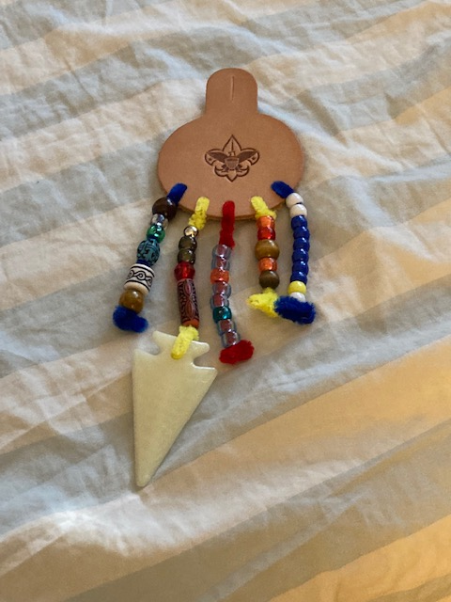
Bead Totem as instructed by ASM Kayla Matens

Original Bead Program
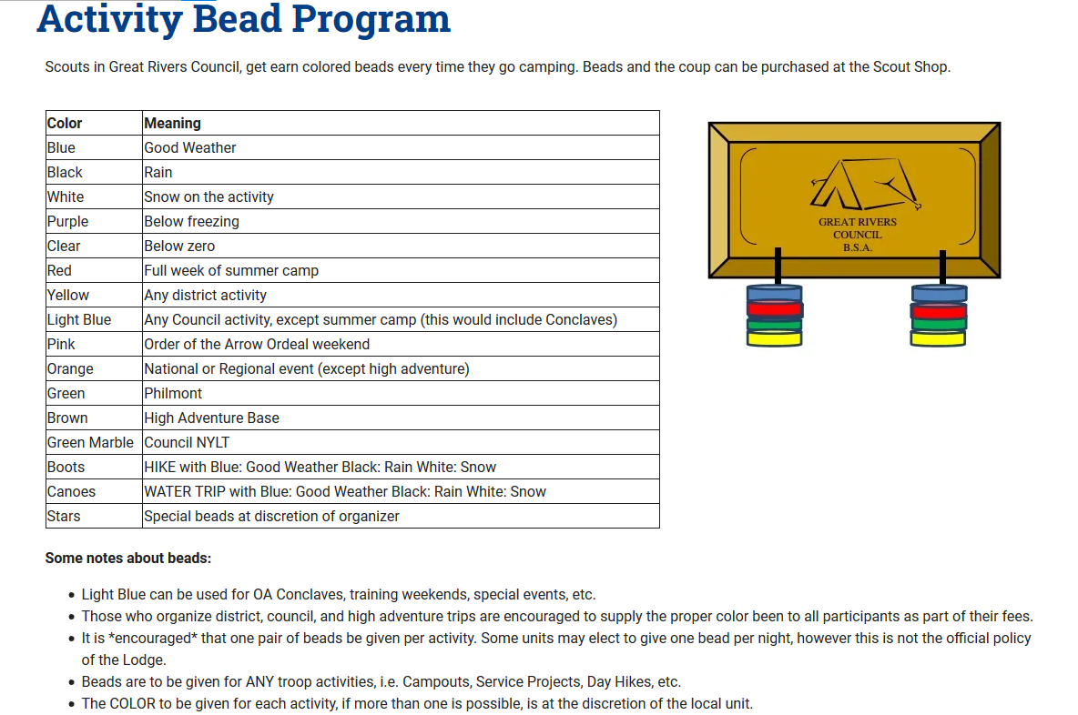

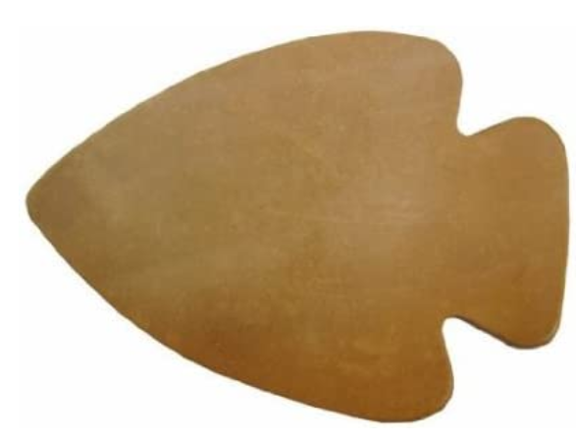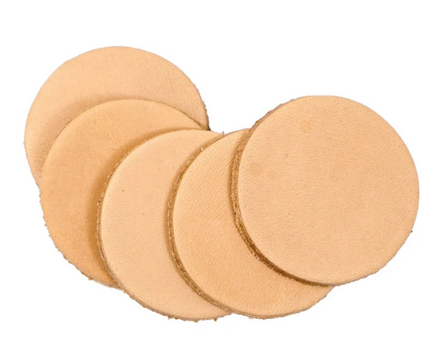
Leather blanks can be had from Hobby Lobby or Etsy, pre-made with Pack number with some left for personalized decorating, holes punched ahead of time, and cord and pipe cleaners included for the scout to attach.

Sample Bead Totems
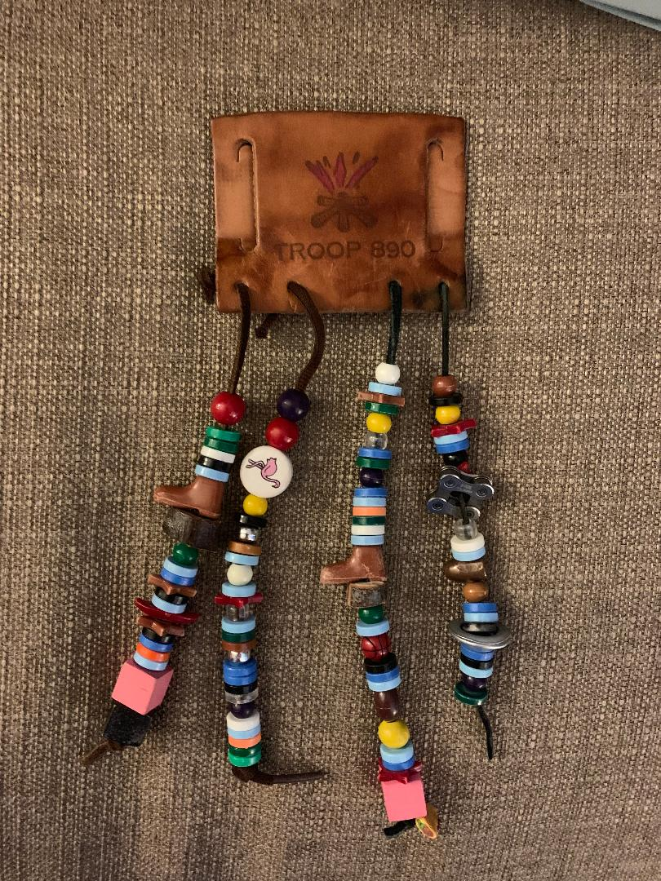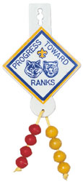
Troop Level Bead totem Older Cub Scout Totem
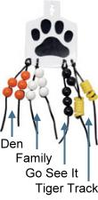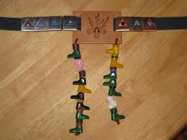
Tiger Level Beads Cub Scout Beads with Belt Loops

Suggested Cub Scout Bead Color Awards

Required Adventure | 1 bead per rank color (Lion = yellow, Tiger = orange, Wolf = red, Bear = light blue, Webelos = wood, AOL = forest green
Electives | Purple
Pack meeting | Gold
Den meeting | Dark blue
Pack event | Designer or wood shape
Pack campout | White
Hike | Clear green
Water activity | Clear blue
Campout chore (clean up, firewood gathering) | Clear yellow
Perform skit or song | Clear red
District activity | Circle
Summer camp | Arrowhead
Den campout | Square
Do a good deed | Turquois
3.5 or above on report card (or note from teacher stating best effort) | Star
Polar Bear campout | Iridescent white
Service project | Heart
Fundraiser | Designer bead or clear orange

FOR LEADERS
The activity bead totem is meant to foster creativity and participation in scouting. It began originally as a program for Troop Scouts to earn visual reminders of achievements and skill mastery in between earning merit badges, and grew into a program for both Cub Scouts and BSA Scouts. Although entirely optional, those who utilize the program find it is great fun, the kids love it, and it is very successful in encouraging participation. As the Den leader, it is up to you to decide when a bead is deserved for any activity not outline in the chart, and remember that the Cub Scout motto is “Do your best,” so effort should be rewarded as well.

- Pass out the totem kits to each scout. Inside each kit is a leather medallion, several pipe cleaners, and a length of cord.
- Explain the program to the scouts and remind them that while the beads are meant to be fun, scouting is about growing as a person, and that we should be doing the activities for the skills we learn, not just the beads.
- Provide the scouts with materials to decorate the medallions. Scouts should write their name somewhere on the medallion, and some sort of indication of their rank. (Draw a Lion or a Tiger, or a bear claw, for example) They can be as simple or as elaborate as they want.
- The cord ties at the top and is meant to allow the medallion to be worn over a button on the right side of the shirt, or for the Lions, on a belt loop. Have the parents help the scout secure it.
- Each rank starts with a pipe cleaner the color of that rank (Lions = Yellow, Tigers = Orange, Wolves = Red, Bears = Light Blue, Webelos = Light brown, Arrow of Light = Forest Green) On this pipe cleaner, Scouts will wear beads of the same color for every requirement they complete towards their rank.
- The second pipe cleaner Dark Blue and Scouts are awarded a yellow bead on this length for every Pack meeting they attend.
- The third and fourth pipe cleaners are Yellow, and scouts are awarded a Dark Blue bead for every den meeting they attend.
- The fifth pipe cleaner is purple, and it is on this length that scouts are awarded specialty beads given out at pack events, campouts, hikes, or service projects.

Included in the Leader’s kit are a select number of beads to hand our when you feel it is appropriate. Pack leaders will hand out beads at pack events. If there are any questions, please email pack136.stgeorge@gmail.com

For Scouts
Your Activity Bead Totem
This is a fun program to help you keep track of your journey through your rank in Cub Scouts! This craft allows you to construct your own activity bead totem to be worn on your uniform. You earn beads for your activities and accomplishments, along with your achievement belt loops and rank patch.
- First decorate the leather medallion. Put your name on it somewhere, and maybe draw the animal of your rank or some other art.
- Tie the cord through the top hole. This will go over the button on your right shirt pocket.
- Tie the pipe cleaners on in this order = Your rank color (Lions = Yellow, Tigers = Orange, Wolves = Red, Bears = Light Blue, Webelos = Light brown, Arrow of Light = Forest Green), Dark Blue, Yellow, Yellow, Purple.
- A single bead goes on your rank line for every requirement you complete, one on the dark blue line for every pack meeting you attend, one on the yellow lines for every den meeting you attend, and one on the purple line for every Pack event or campout or special event you attend.
